

Complex Pack Replenishment

Version Control

Rev | Date | Author | Description
6 | 20 Mar 2013 | Costas Malamas, Dimitris Atmatzidis, Fenia Kaklidou, Kostas Karayannis | First complete draft
7 | 21 Mar 2013 | Costas Malamas, Dimitris Atmatzidis | Added AP hold back quantity interfaces and constraint in Initial Allocation, Minor Modifications to Replenishment Section (Labelling, Measure Descriptions and corresponding Mock Ups)
8 | 26 Mar 2013 | Dimitris Atmatzidis  Fenia Kaklidou | Modifications to Replenishment Section (Labelling, Measure Descriptions and corresponding Mock Ups)  Modifications to “Store Order Approval” Alert Formula for Fashion and Seasonal Basics (Error: Reference source not found) and the description of “RDC Order Approval” Alert (Error: Reference source not found)
9 | 9 Apr 2013 | Costas Malamas | Incorporated LMG feedback and modifications based on the CSD development
10 | 22 Apr 2013 | Dimitris Atmatzidis, Kostas Karayannis | Season added as a Dynamic hierarchy by Department. Added Season->Week mapping measure.
11 | 13 Jun 2013 | Costas Malamas | Changes due to CR 1, RDC Allocation Cross-Docking and some other minor changes
14 | 25 June 2014 | Spyros Agrafiotis, Dimitris Atmatzidis | Modifications to accommodate updates since last draft

Contents
Version Control 2
Contents 3
1 Introduction 9
1.1 Functional Overview 9
1.2 Project Overview 10
1.3 Scope 10
2 Solution Architecture 12
2.1 Hierarchies 12
2.1.1 Calendar Hierarchy 12
2.1.2 Product Hierarchy 13
2.1.3 Location Hierarchy 14
2.1.4 Purchase Order Hierarchy 15
2.1.5 RDC Hierarchy 15
2.1.6 CDC Hierarchy 16
2.1.7 Requirements and Decisions 16
2.1.8 Assumptions 19
2.2 Interfaces 20
2.2.1 Interface List 20
2.3 Sales Data 26
2.3.1 Requirements and Decisions 26
2.3.2 Assumptions 27
2.4 Attributes 27
2.5 Requirements and Decisions 28
2.6 Assumptions 29
3 Assortment Planning Dependencies 31
3.1 Size Profile Optimization 32
3.1.1 Requirements and Decisions 33
3.2 Interfaces from Assortment Planning 33
3.3 Requirements and Decisions 33
3.4 Assumptions 33
4 Preprocessing 35
4.1 Pass 1 – Non-Typical Days 35
4.2 Pass 2 – Outliers 35
4.3 Pass 3 – Lost Sales 36
4.4 Pass 4 – For Seasonal Basics and Short Lifecycle Products only 36
4.5 Preprocessing for Fashion and Seasonal Basic Products 36
4.6 Requirements and Decisions 37
4.7 Assumptions 37
5 Forecasting Process 38
5.1 Assortment Planning Inputs 39
5.2 Baseline Demand 39
5.2.1 Pre-AP Baseline Calculation 40
5.2.2 Requirements and Decisions 41
5.3 Promotions 41
5.3.1 Assumptions 42
5.4 Pricing 43
5.5 Day Events 43
5.6 Reactivity (Bayesian Forecasting) 45
5.7 New Items & Stores 45
5.7.1 Requirements and Decisions 46
5.7.2 Assumptions 46
5.8 Day-of-Week Profile 47
5.9 Requirements and Decisions 47
5.10 Assumptions 48
6 Supply Chain Constraints 50
6.1 PO Management 50
6.1.1 Requirements and Decisions 51
6.2 Pack Definitions 51
6.2.1 Requirements and Decisions 52
6.2.2 Assumptions 52
6.3 Pack Breakdown 53
6.3.1 Requirements and Decisions 53
7 Allocation Process 55
7.1 Initial Allocation Process 55
7.2 Allocation Workbook 57
7.2.1 Pack Initial Allocation 59
7.2.2 Singles Initial Allocation 62
7.2.3 RDC Packs Review 64
7.2.4 RDC Singles Review 66
7.2.5 Allocation Source Data 67
7.2.6 Store Inventory 67
7.2.7 Store Allocation Parameters 67
7.2.8 Packing Parameters 68
7.3 Distribution Requirements 69
7.4 Requirements and Decisions 70
7.5 Assumptions 73
8 Replenishment Process 75
8.1 Replenishment Process 75
8.1.1 Replenishment Methods and Parameters 77
8.2 RDC Replenishment Workbook 79
8.2.1 RDC Pack Replenishment Review 80
8.2.2 RDC Singles Order Review 81
8.2.3 Orders Review 82
8.2.4 RDC Order Approval Alert 83
8.2.5 RDC/CDC out of Stock Alerts Review 83
8.2.6 CDC Inventory 83
8.2.7 Pack Order Approval 84
8.2.8 RDC Pack Replenishment Review 84
8.2.9 Replenishment Source Data 84
8.2.10 CDC Singles Inventory 84
8.2.11 Singles Order Approval 84
8.2.12 RDC Singles Order Review 85
8.2.13 Replenishment Source Data 85
8.2.14 RDC Cover Method/Source CDC 1 85
8.2.15 CDC to RDC Lead Time 85
8.2.16 Cost 85
8.2.17 Pack Eligibility 85
8.2.18 Pack Configuration 85
8.2.19 Calculation Parameters 86
8.2.20 Calculation Results 86
8.3 Store Replenishment Workbook 86
8.3.1 Pack Replenishment Review 88
8.3.2 Singles Order Review 89
8.3.3 Order Review 90
8.3.4 Store Order Approval – Alert 91
8.3.5 RDC Inventory 91
8.3.6 Pack Order Approval 92
8.3.7 Calculation Results 92
8.3.8 RDC Singles Inventory 93
8.3.9 Singles Order Approval 93
8.3.10 Logistic Parameters 94
8.3.11 Pack Eligibility 94
8.3.12 Pack Configuration 94
8.3.13 Replenishment Source Data 94
8.3.14 Calculation Parameters 95
8.4 In Season Review 95
8.4.1 RDC Parameters 97
8.4.2 Over/Under Stock Review 98
8.4.3 RDC Target Date Validation 99
8.4.4 CDC Target Date Validation 99
8.4.5 Store Parameters 99
8.4.6 PO Recommendation 100
8.4.7 In-Season Review Alerts 101
8.5 Stock Flows 101
8.5.1 Supplier to CDC (2.a) 103
8.5.2 Supplier to RDC (2.b) 103
8.5.3 CDC to RDC (1.a) 104
8.5.4 Secondary CDC to RDC (1.b) 104
8.5.5 Tertiary CDC to RDC (1.c) 104
8.5.6 RDC to store (0.a) 104
8.5.7 Store to RDC (0.b) 105
8.6 Requirements and Decisions 105
8.7 Assumptions 107
9 Alerts 109
9.1 Store Order Approval 110
9.2 RDC Order Approval 110
9.3 Fast Option 111
9.4 Slow Option 112
9.5 Late Receipt At RDC 113
9.6 New Item 113
9.7 New Store 114
9.8 High Forecast For Basics 114
9.9 CDC Out Of Stock 115
9.10 RDC Out of Stock 115
9.11 New Allocation Required 116
9.12 Basics Out Of Stock 117
9.13 Allocation Held Back Stock 117
9.14 Requirements and Decisions 118
10 Workflow 120
10.1 Demand Forecasting process 120
10.2 Allocation and Replenishment Workflow 121
10.3 Workbooks and partitioning 122
10.4 Parameter Settings 124
10.4.1 Forecast and Preprocessing Parameters 124
10.4.2 Logistic Parameters 124
10.4.3 Replenishment Parameters 125
10.5 Sales Review 126
10.6 Performance Evaluation 127
10.7 Security Permissions 129
10.8 Requirements and Decisions 129
11 Risks 131

Introduction
This document describes the functional requirements for the Complex Pack Replenishment (CPR) project of Landmark Group (LMG). These requirements were identified through a series of work sessions with business users and IT representatives from all LMG concepts with a particular focus on the launch concepts: Max, Splash, Shoe Mart and Shoe Express.
As part of the wider Landmark planning roadmap, CPR will have dependencies on other Oracle Planning modules that are either already in-place (Merchandise Financial Planning) or will be deployed shortly after CPR itself (Assortment Planning, Location Planning). Where needed, this document will describe CPR dependencies to these applications (especially Assortment Planning) so that they can be considered during their respective projects.

Functional Overview
Landmark has selected the Oracle Retail Predictive Application Server (RPAS) as a strategic platform for their planning needs. The CPR project aims to provide a solution for Allocation and Replenishment of both complex packs and singles throughout the Landmark supply chain. To meet the Landmark requirements the CPR project will deploy the following software solutions as a single project stream:
- Oracle Retail Demand Forecasting (RDF): This standard Oracle module will be responsible for calculating lost sales based on actual sales history, determining the historical baseline demand, the effect of external factors on demand and forecasting future demand.
- Veltio Allocation, Packing and Execution (APX) as an add-on to the Oracle RDF configuration. This module, provided by Veltio will add allocation and distribution functionality given specific supply chain constraints based on LMG practices as well as replenishment functionality. As per Landmark policy, APX will only be responsible for the calculation of order quantities: actual execution of these orders will still be handled by RMS.
- Oracle Retail Size Profile Optimization (SPO) as a separate installation which will be tightly integrated with the RDF/APX configuration. This solution provides calculated size profiles and optimizes pre-pack configurations for use by Assortment Planning.
The figure below shows the overall Landmark Planning foot print.
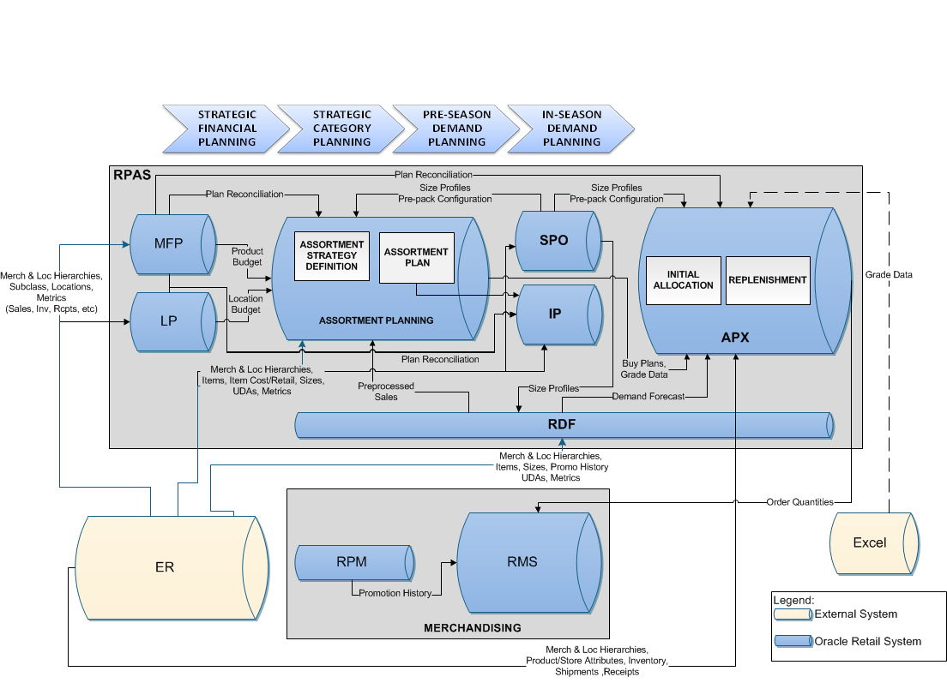
Figure 1-1 Landmark Planning Footprint

Project Overview
The CPR project timeline is expected as shown below
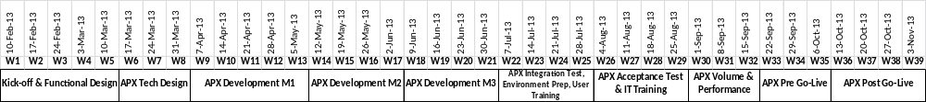
Figure 1-2 CPR Timeline

Scope
This document describes the functional requirements for the RDF and APX modules of CPR only. The following are considered to be within the scope of this document:
- Functional requirements for APX and RDF
- High-level data and integration requirements for external systems
- APX and RDF workflow behavior and access policies
Conversely, the following topics are out of scope for this document:
- Technical and configuration specifications for APX or RDF; these will be described in detail in a separate document, the “CPR Configuration Specification Document” (CSD).
- Detailed interface and integration specifications for external systems; these will also be described in the CSD document as above.
- Functional requirements for Size Profile Optimization. These will be identified in separate functional design sessions with Landmark users and will be documented in the “SPO Functional Requirements” document
- Expected business benefits will be documented separately in the “Performance Targets” document for CPR.

Solution Architecture

Hierarchies
The structure of the hierarchies of the Complex Pack Replenishment configuration is described in this Section as it has been discussed and agreed during the Functional Design sessions. The three core hierarchies are Calendar, Product and Location. The structure of the hierarchies cannot be changed after Go-Live.

Calendar Hierarchy
The Calendar hierarchy consists of, apart from the core branch, an alternate branch that contains the Trading Calendar that is used by Landmark (Figure 2-3). This alternate branch is above Week. Week of Year and Day of Week are alternate branches above Week and Day respectively and are necessary for Seasonality reasons. Four User Maintained Groups will be available above Week level, along with another user-maintained dimension, Event that will be used to group together long-running events like Ramadan. The core branch of the Calendar hierarchy will follow seasonality constraints to enable the forecasting algorithms of the RDF module (e.g. 52 weeks per year). Season will be configured by Department as a Dynamic hierarchy.

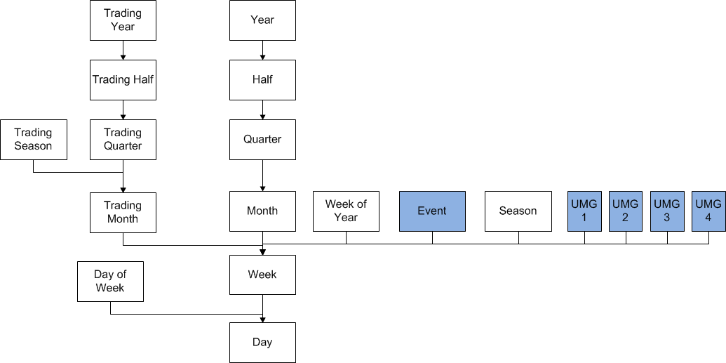
Figure 2-3 Calendar Hierarchy

Product Hierarchy
The Product hierarchy consists, apart from the core branch, of an alternate branch above SKU level that mirrors the core branch starting from Pack Group and containing all the levels above Option (Figure 2-4Figure 2-4 Product Hierarchy). Above the Option and Pack Group levels four User Maintained Groups will be defined. Planner, also a user defined dimension, will be an alternate rollup above Subclass, both in the primary and alternate branches. Product type will be an alternate rollup above Pack group and Option to differentiate system behavior (see Section Forecasting Process5). Constraint group will also be configured above Pack group and Option to help with the allocation process (see Section 7.1 item a)

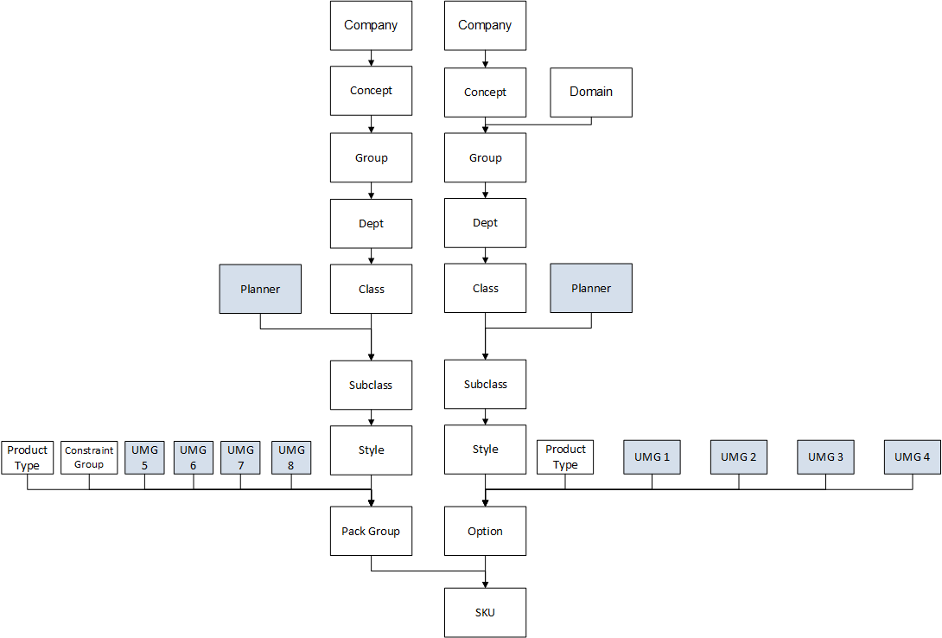
Figure 2-4 Product Hierarchy

Location Hierarchy
The main branch of the Location hierarchy consists of six levels (Figure 2-5Figure 2-5 Location Hierarchy). Above Store, which is the lowest level of the Location hierarchy, there are two alternate rollups, Grade and RDC. RDC rolls up to CDC and Concept. Grade will be provided at Subclass/Store level from Assortment Planning. Before Assortment Planning becomes available, Landmark will provide store grades in a comma separated file. Grade will be a dynamic hierarchy by Subclass. Training Documentation that explains that the Grade level can only be used if grading is consistent for all the subclasses of a store within the same workbook will be prepared by Veltio and explained to the users of the system during the training.
Finally, four User Maintained Groups will be available above Store.

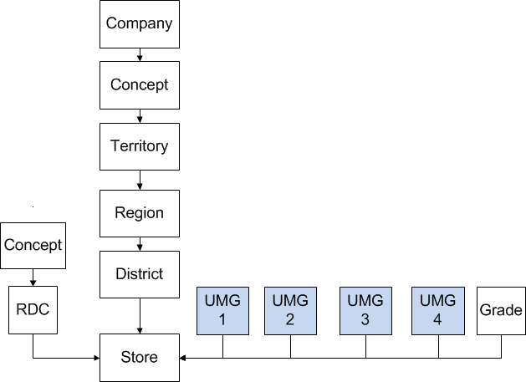
Figure 2-5 Location Hierarchy

Purchase Order Hierarchy
The core branch of the Purchase Order Hierarchy has three main levels Purchase Order, Supplier and All Purchase Orders (Figure 2-6Figure 2-6 Purchase Order Hierarchy). Above Purchase Order there are two alternate rollups Earliest Shipment Date and Latest Shipment Date, which are available in RMS and will be provided to the system.

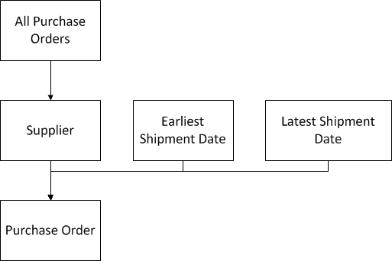
Figure 2-6 Purchase Order Hierarchy

RDC Hierarchy
The RDC hierarchy is a single two-level tree that consists of RDC at the lowest level and Concept at the top (Figure 2-7).

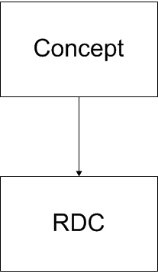
Figure 2-7 RDC Hierarchy

CDC Hierarchy
The CDC hierarchy is a single two-level tree, with CDC rolling up to Concept (Figure 2-8).
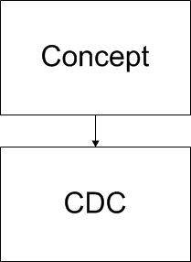
Figure 2-8 CDC Hierarchy

Requirements and Decisions

Log # | Description
117 | Calendar:  Calendar will be provided by Veltio
316 | Constraint group will be an alternate roll up above Option and Pack Group in product hierarchy. Fixture and brand will be the constraint groups used for Max and Splash respectively. A worksheet should be created in Replenishment parameters, where the users will define the capacity of the constraint groups per store. Fixture will also be a SKU attribute.
110 | Location:  Main Branch:  Company => Concept => Territory => Region => District => Store  Store Rollups:  Grade, UMG1, UMG2, UMG3, UMG4  Concept => CDC => RDC  Grade:  - Store roll-up in the Location Hierarchy  - It will be provided at subclass/store level as excel upload  - Training Documentation that explains that grade can be used only if grading is consistent for all subclasses of a store within the same WB
101 | Sizing inputs will be provided by the attendees:  Total number of stores/SKUs for 5-year growth estimation  Total number of CDCs/RDCs for 5-year growth estimation  The answers in Sheet "Sizing Input"
111 | Grade will be a dynamic hierarchy
113 | All the hierarchy decisions will be confirmed
114 | Product:  Main Branch:  Company => Concept => Group => Department => Class => Subclass => Style => Option => SKU  SKU Rollup:  Pack Group  Subclass Rollup:  Planner (UMG)  Options Rollup:  Product Type (UDA), Constraint Group, UMG1, UMG2, UMG3, UMG4  Pack Group Rollups:  All levels of the main branch above option will be added as mirror branch above Pack group:  Company => Concept => Group => Department => Class => Subclass => Style  Alternate Pack Group rollups: Product Type (UDA), Constraint Group, UMG5, UMG6, UMG7, UMG8  Class Rollup: Planner (UMG)  "No Group Type":  will not be an alternate branch above Group
115 | Calendar:  Main Branch:  Year => Half => Quarter => Month => Week => Day  Day Rollup:  Day of Week, Season  Week Rollup:  Week of Year, Event, UMG1, UMG2, UMG3, UMG4  Trading Year => Trading Half => Trading Quarter => Trading Month  Trading Month Rollup:  Trading Season  -> The Calendar will contain 52 weeks per year
119 | Purchase Order:  Main Branch:  All Purchase Orders => Supplier => Purchase Order  Alternate Branch:  Earliest Shipment Date, Latest Shipment Date  -> RMS has the Earliest and the Latest Shipment Dates per Purchasing Order
120 | RDC:  Main Branch:  Concept => Primary CDC => RDC  CDC:  Concept => CDC
359 | In Calendar Hier keep Event but make it UMG.
372 | Season is to be a dynamic dimension that would be defined by Department as per MFP. New interface required
413 | Both APX and SPO have a requirement for temporary (aka Placeholder) stores to be fed in using the AP Excel template. Users will be able to edit these values in APX & SPO
509 | RMS requires that for RDC cross-docking, the ASN template needs to be modified as follows:  * Instead of a PO number an "Allocation Number" needs to be included  * The ASN number should be null  For allocation of ASNs shipped directly to RDCs, the template remains as is (PO# and ASN# included)
510 | To satisfy #509, the RDC ASN feeds (Packs/Singles) need to be modified to include the "Allocation Number" that is created by RMS/WMS at the time the ASN is raised. APX will then associate this Alloc Number with the ASN and use it in the ASN Allocation feed, as specified in #510
511 | The ASN allocation templates produced by APX need to include the number of (non-header) records in the filename of the exported file
554 | "Multiple Primary CDCs per RDC:  Some RDCs have multiple primary CDCs differentiated by product Group (? Option? LMG to confirm). To accommodate this CPR needs to modify both inbound and outbound interfaces so that stock is accounted properly and that transfer orders are sent to the correct CDC"
555 | Location Hierarchy details must be modified in the design document, RDC to concept link.
565 | Business data validation, label usability on seasons, grades, attributes (product description must have size, attributes must be present).
566 | Hierarchy data validation for 5 concepts and full extraction to be provided (Data Validation + UAT).
590 | For Pilot Go-Live - RDC and CDC will be restricted based on the following conditions.  1) To stop initial allocation calculations for RDC which are not live, Sourcing method will not be setup and also CDC ranking will not be mapped between RDC and CDC.  2) To stop replenishments for RDC which are not live in APX, Sourcing method will not be setup and also CDC ranking will not be mapped between RDC and CDC.  3) To stop replenishments for RDC which are live in APX, CDC to RDC threshold will be setup to a minimum level so that always user should verify the system generated order quantity and manually approve the Replenishement orders for RDC live territories.
591 | For Pilot Go-Live restriction to one department
592 | APX Order Exports Sample: Based on the discussion the files for transfers is correct and the files for the ASN based allocation needs to be split based on the logic of single ASN/ from location (wh) in a file. Filename: APX_LOGISTICSASNBASEDALLOCUPLOAD-ldomID_noofrecords_ASNID_FROMLOCATIONIDTIMESTAMP.csv

Assumptions

Log # | Description
3 | Stock in stores will be provided per week
25 | Centre point might be a candidate alternate branch in the location hierarchy
86 | Shipments info data source, receipts are available at all levels  (T-1)
98 | physical CDCs:  - CDC1-2 (Jebel Ali serves all territories - Facilities)  - CDC3 (Aqaba -Jordan- serves Lebanon, North Africa Turkey, Iraq)  - CDC4 (Dammam serves Saudi Arabia)  - CDC5 (Jeddah serves Saudi Arabia)
118 | Calendar:  The Trading Calendar will be provided to Veltio by LMG
125 | Hierarchy structure cannot be changed after the Go-Live
353 | The interfaces are at the moment T-2, by June all interfaces will be T-1
358 | Trading calendar will not need Adj Ly or any other mapping for APX.
497 | Event and capacity holding have been removed from store attributes.
508 | There are no CDC cross-docking quantities included the CDC Receipts feed, CDC OH feed and the CDC Shipment feed

Interfaces
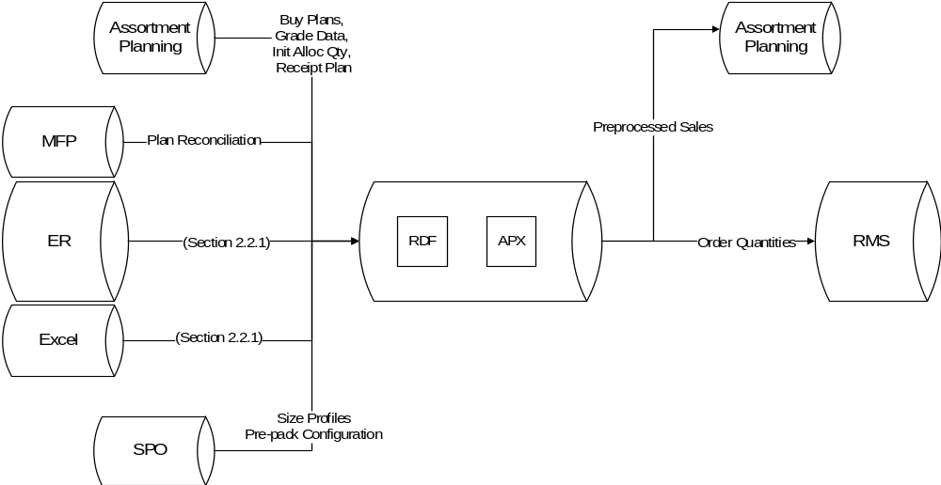
Figure 2-9 Interfaces for APX and RDF System

Interface List

Interface | Frequency | Level of data | IF ID | System | In/Out
Season Start Date Override (After AP Deployment) | Weekly | SKU/Store | IF 102 | AP | Inbound
Season End Date Override (After AP Deployment) | Weekly | SKU/Store | IF 103 | AP | Inbound
End of Period Inventory | One-Off | Week/SKU/Store | IF 104 | ER | Inbound
Size Rank | Weekly | Size | IF 104 | ER | Inbound
SKU to Master Size Map | Weekly | SKU | IF 106 | ER | Inbound
SKU to Attribute Code Map | Weekly | SKU | IF 107 | ER | Inbound
Sub-size Range Assignment (At territory level) | Weekly | Option/Territory/Subsize Range | IF 108 | ER | Inbound
Sub-size Range | Weekly | Option/Store/Subsize Range | IF 109 | AP | Inbound
AP Initial Allocation Quantity (After AP deployment) | Weekly | Option/Store | IF 111 | AP | Inbound
CDC Parking Percentage (After AP deployment) | Weekly | Option/Store | IF 112 | AP | Inbound
Hold Initial Allocation (After AP deployment) | Weekly | Option/Store | IF 113 | AP | Inbound
AP Buying Plan (Before AP deployment) | Weekly | Week/Option/Store | IF 118 | Excel | Inbound
AP Initial Allocation Quantity (Before AP deployment) | Weekly | Option/Store | IF 118 | Excel | Inbound
CDC Parking Percentage (Before AP deployment) | Weekly | Option/Store | IF 118 | Excel | Inbound
RDC/CDC mapping for delayed stores (Before AP deployment) | Weekly | Store | IF 119 | Excel | Inbound
AP Buying Plan | Weekly | Week/SKU/Store | IF01 | AP | Inbound
AP Initial Allocation Quantities | Weekly | SKU/Store | IF02 | AP | Inbound
AP Receipt Plan | Weekly | Week/SKU/Store | IF03 | AP | Inbound
AP Store Grade | Weekly | Subclass/Store | IF04 | AP | Inbound
Buying Quantities | TBD | Option/Store | IF06 | Excel | Inbound
CDC ASN Packs | Daily | Pack/CDC/PO/ASN | IF07 | ER | Inbound
CDC ASN Singles | Daily | SKU/CDC/PO/ASN | IF08 | ER | Inbound
Total CDC PO Quantity | Weekly | Pack/CDC/PO | IF11 | ER | Inbound
AP Buying Plan (After AP deployment) | Weekly | Week/Option/Store | IF110 | AP | Inbound
Total CDC PO Quantity Singles | Weekly | SKU/CDC/PO | IF12 | ER | Inbound
CDC Receipts Packs | Daily | Day/Pack/CDC | IF13 | ER | Inbound
CDC Receipts Singles | Daily | Day/SKU/CDC | IF14 | ER | Inbound
CDC Reserved For Pre-Allocation Packs | Daily | Day/Pack/CDC | IF15 | ER | Inbound
CDC Reserved For Pre-Allocation Singles | Daily | Day/SKU/CDC | IF16 | ER | Inbound
CDC Shipments Packs | Daily | Day/Pack/CDC/RDC | IF17 | ER | Inbound
CDC Shipments Singles | Daily | Day/SKU/CDC/RDC | IF18 | ER | Inbound
CDC Stock on Hand Packs | Daily | Pack/CDC | IF19 | ER | Inbound
CDC Stock on Hand Singles | Daily | SKU/CDC | IF20 | ER | Inbound
Clearance Daily Sales | Daily | Day/SKU/Store | IF21 | ER | Inbound
Complex Pack Quantity | Weekly | SKU/Pack | IF22 | ER | Inbound
Cost | Weekly | SKU/Territory | IF23 | ER | Inbound
Current Price | Daily | SKU/Store | IF24 | ER | Inbound
Initial Allocation Quantities | TBD | Option/Store | IF25 | Excel | Inbound
MFP Receipt CP Quantities | Weekly | Week/Subclass/Territory | IF26 | MFP | Inbound
MFP Receipt CP Retail | Weekly | Week/Subclass/Territory | IF27 | MFP | Inbound
MFP Sales CP Quantities | Weekly | Week/Subclass/Territory | IF28 | MFP | Inbound
MFP Sales CP Retail | Weekly | Week/Subclass/Territory | IF29 | MFP | Inbound
Original Price | Weekly | SKU/Store | IF30 | ER | Inbound
Price Change | Daily | Day/SKU/Store | IF34 | ER | Inbound
Promotion Daily Sales | Daily | Day/SKU/Store | IF36 | ER | Inbound
Promotion IDs, Start&End Dates | Daily | SKU/Store | IF37 | ER | Inbound
RDC ASN Packs | Daily | Pack/RDC/PO/ASN | IF38 | ER | Inbound
RDC ASN Singles | Daily | SKU/RDC/PO/ASN | IF39 | ER | Inbound
Total RDC PO Quantity | Weekly | Pack/RDC/PO | IF44 | ER | Inbound
Total RDC PO Quantity Singles | Weekly | SKU/RDC/PO | IF45 | ER | Inbound
RDC Receipts Packs | Daily | Day/Pack/RDC | IF46 | ER | Inbound
RDC Receipts Singles | Daily | Day/SKU/RDC | IF47 | ER | Inbound
RDC Shipments Packs Allocation | Daily | Day/Pack/RDC/Store | IF48 | ER | Inbound
RDC Shipments Singles Allocation | Daily | Day/SKU/RDC/Store | IF49 | ER | Inbound
RDC Stock On Hand Packs | Daily | Pack/RDC | IF50 | ER | Inbound
RDC Stock On Hand Singles | Daily | SKU/RDC | IF51 | ER | Inbound
Regular Daily Sales | Daily | Day/SKU/Store | IF52 | ER | Inbound
Regular Weekly Sales | Weekly | Week/SKU/Store | IF53 | ER | Inbound
Store Grade | TBD | Subclass/Store | IF58 | Excel | Inbound
Store Open Date | Weekly | Store | IF61 | ER | Inbound
Store Receipts | Daily | Day/SKU/Store | IF62 | ER | Inbound
Store Stock On Hand | Weekly | SKU/Store | IF63 | ER | Inbound
Markdown Start Date | Daily | Sku/Store | IF64 | ER | Inbound
Preprocessed Sales | Daily | Day/SKU/Store | IF66 | AP | Outbound
Transfer Order from CDC to RDC Packs | Daily | Day/Pack/CDC/RDC | IF72 | RMS | Outbound
Transfer Order from CDC to RDC Singles | Daily | Day/SKU/CDC/RDC | IF73 | RMS | Outbound
Transfer Order from RDC to Store Packs | Daily | Day/Pack/RDC/Store | IF74 | RMS | Outbound
Transfer Order from RDC to Store Singles | Daily | Day/SKU/RDC/Store | IF75 | RMS | Outbound
Allocation Order from RDC to Store Packs | Daily | Day/Pack/RDC/Store | IF76 | RMS | Outbound
Allocation Order from RDC to Store Singles | Daily | Day/SKU/RDC/Store | IF77 | RMS | Outbound
PO Attributes | Weekly | PO | IF78 | ER | Inbound
SKU Attributes | Weekly | SKU | IF79 | ER | Inbound
Store Attributes | Weekly | Store | IF80 | ER | Inbound
Week -> Season Mapping | Weekly | Week/Department | IF81 | ER | Inbound
Approved Forecast | Daily | Day/SKU/Store | IF82 | RMS | Outbound
RDC Shipments Packs Replenishment | Daily | Day/Pack/RDC/Store | IF83 | ER | Inbound
RDC Shipments Singles Replenishment | Daily | Day/SKU/RDC/Store | IF84 | ER | Inbound
Cancelled Approved ASN Quantity Singles | Daily | Sku/RDC/PO/ASN | IF85 | ER | Inbound
Cancelled Approved ASN Quantity Packs | Daily | Pack/RDC/PO/ASN | IF86 | ER | Inbound
Open CDC PO Quantity | Weekly | Pack/CDC/PO | IF87 | ER | Inbound
Open CDC PO Quantity Singles | Weekly | SKU/CDC/PO | IF88 | ER | Inbound
Open RDC PO Quantity | Weekly | Pack/RDC/PO | IF89 | ER | Inbound
Open RDC PO Quantity Singles | Weekly | SKU/RDC/PO | IF90 | ER | Inbound
RDC Containers Packs | Daily | Pack/RDC/PO/ContainerID/AllocationNumber | IF91 | ER | Inbound
RDC Containers Singles | Daily | SKU/RDC/PO/ContainerID/AllocationNumber | IF92 | ER | Inbound
RDC Mapping for Delayed Stores | Weekly | District | IF92 | Excel | Inbound
CDC Mapping for Delayed Stores | Weekly | District | IF93 | Excel | Inbound

Table 2-1 Preliminary list of interfaces
Notes:
- There is no data interface for store returns. A store return will show up in APX as stock correction, where stock is reduced at the store and added to the In Transit stock of the RDC.
- A PO cancelation will mean that the cancelled PO will not show up in the next day’s PO hierarchy data feed.
- APX will be given the ER version of the POs which includes split quantities for pre allocated RDCs.
- CDC Stock on Hand will not include pre-allocated stock which is cross-docked for RDCs
- Cost 2 will be utilized to calculate ROI.
- APX expects different feeds for packs and singles where applicable.
- For each export, RPAS will export up to 4 measures (Singles/RDC, Singles/CDC, Packs/RDC, Packs/CDC) which will then be combined into one feed.
- Interfaces IF06, IF 25 and IF 58 will be in place until Assortment Planning (AP) has gone live, at which point they will be replaced by Interfaces 1, 2 and 5.

Sales Data
Sales data will be loaded daily from external systems (ER) to APX. Sales will be delivered as Regular, Promotional or Clearance as per availability, at Day/SKU/Store Level (T-1). The sales will be provided separately on weekly basis at weekly level for the last week. For Seasonal Basics and 365 products the cleaned Sales should be provided to AP.
In cases where the sales have not been posted for the latest load date, CPR should use the forecast to estimate the missing Sales Data.
CPR should consider as the On Sale Date of each SKU at a store the earliest date of Sale of the Style Color of the SKU at the store.

Requirements and Decisions

Log # | Description
39 | On Sales Day will defined as the earliest date one SKU of a Style-Color is sold in the store
131 | For Seasonal Basics and Short lifecycle products, the system will keep two separate Sales histories:  1. Total Adjusted Sales which, past the Markdown Start Date, will include Clearance Sales  2. Historical Baseline Demand which will replace Markdown sales with the Approved Forecast at the Markdown Start Date and will reflects the Lifecycle behavior of the products  This requires the Markdown Start Date to be interfaced from RPM.
142 | There are cases where the sales are not correctly recorded. For these cases, the forecast should be used instead of the sales. There is a flag raised in case of missed records according to CTS.
175 | For Seasonal Basics and 365 products the cleaned Sales should be provided to AP
221 | Initial Allocation (Units) will be provided from AP to APX at SKU/Store level
222 | Receipt Plan from AP will be provided from AP to APX as SKU/store/week level only for review reasons
560 | Detailed status of data issues (missing, inconsistency and correctness issues). Full list to be provided.
561 | Interfaced data validation and delivery.

Assumptions

Log # | Description
99 | 40% of the SKUs have low ROS
127 | ER will provide Regular/Promotion/Clearance Daily Sales SKU/Store/Day(T-1)  Stocks are available at week level for all Tiers in ER  Out of stock is available at week level for all Tiers not available at ER  Transfers among all Tiers are registered daily at ER
128 | RPM (feeds RMS) has Markdown Start Date at SKU/Store level and should be confirmed
205 | All the input data for APX will come from ER
216 | The sales will be provided separately on weekly basis at weekly level for the last week
26 | Two years of history data will be provided
562 | Prerequisites for UAT and Go-live  -1 Department  -UAE  - for 1 month period

Attributes
Attributes are properties of a specific dimension of a hierarchy. They are used for conveying information about the positions of the dimensions and for sorting. During the design of APX, it was decided that attributes will be defined for dimensions of the Product, Location and PO hierarchies.
Product Attributes | Location Attributes | PO Attributes
Season Code | Grading at Dept and Class Level | PO Earliest Shipment Date
Phase ID | Size Grade | PO Latest Shipment Date
Group | Location (Mall/High Street/Standalone) | PO Supplier
Product-Type | Demographics cluster | PO Supplier Cost (PO Currency)
Themes/Story-Name | Climate
Material/Made of/Fabric
Manufacturer (ID-only)
Colours
Product Style
Price Point
Fashionability
Brands
Option/Assortment Grade
Product Classification
Climate
Length Code
Table 2-2 Product, Location and PO attributes

Note: The PO dimension attributes can actually be properties of the purchase order or the SKUs in that purchase order. In the latter case, the PO dimension attribute will show a comma-separated concatenation of the values of that property for all SKUs in that purchase order.

Requirements and Decisions

Log # | Description
12 | AP Buying Plan as executed now in excel will be provided as input for APX until AP is implemented > agree on the mechanics
13 | Sizing inputs will be provided by the attendees:  Total number of stores/SKUs for 5-year growth estimation  Total number of CDCs/RDCs for 5-year growth estimation  The answers in Sheet "Sizing Input"
76 | The MFP budget should be available in APX for review reasons
189 | A differentiator for 365, Seasonal and Fashion items will be provided to APX and will be standard among concepts.  Discussed with LMIT:  Product Type is needed for APX, which currently is not there (some concepts use as UDA, some use as Season. Does not have a standard practice). The Product Type currently used in Landmark is as follows:  -365  -Never out of stock  -Autumn, Winter, Spring  The way to provide it to APX will be specified by LMIT.
193 | For all Items the de-causalized baseline history will be fed to AP from APX
194 | Input from current AP process for Fashion and Seasonal products  from RMS:  PO level Option/Pack/RDC Qty  or SKU/RDC Qty  from Excel:  Option/Store Qty % by RDC  Option: Phase Start/End
195 | The PO Qty should be enforced to the Option/Store Qty by using the % provided
200 | Export the Baseline calculated for Seasonal product to AP
206 | Forecast and Plan (reporting) should be fed to ER?  LMIT should define whether the plan and forecast (reporting) can be integrated in ER or another system will handle them. To be decided later.
273 | When a PO is cancelled, it will not show in the feed from ER. Initial allocation should be cancelled. The PO will be flagged as cancelled.
305 | Cost 2 in AED should be used for ROI calculation and should be provided by ER/RMS team
343 | MFP Sales CP in retail value and Qty, MFP Receipt CP in retail value and Qty with weekly update should be available as interfaces
540 | Pre-AP Buying plan will be rounded to nearest integer value

Assumptions
Log # | Description
19 | OOS flags possible available on a weekly basis  RMS and WMS
21 | ER sends T-1 Data
22 | Product is turned approximately 3 times a year. This is to be taken into consideration for sizing
179 | Reports from APX to ER/BI will be defined after Go-Live
209 | For Stock on Hand for singles should not include the pack quantities, but only the single quantities
214 | If a PO does not appear in the list of the daily provided orders will be considered cancelled
215 | The window of the sales (delta) provided by ER will be the last 3 days at SKU/Store/Day level starting backwards from today
238 | MFP has partition dimension at Concept
241 | There is a transfer ID associated with each shipment/receipt
298 | Allocation Order:  Transfer order from RDC to store  CDC to RDC transfers for allocation are regular transfer orders  The allocation orders are uploaded using dedicated csv files
299 | Allocation can be done before the receipt of the stock  The ASN is sent from the supplier before receipt at the CDC or RDC  For cdc->rdc transfer a Bill Of Landing (BOL) is raised  ASN has PO info, BOL doesn’t
300 | CDC SOH will not include pre-allocated stock which is cross-docked for RDCs
301 | We need the ER version of the PO, with split qtys for pre allocated RDCs

Assortment Planning Dependencies
Landmark plans to deploy Oracle Retail Assortment Planning (AP) shortly after the deployment of CPR. Since the two solutions will be tightly coupled, this Section provides information on the CPR dependencies to AP.
Assortment Planning will interact with Size Profile Optimization (SPO), Merchandise Financial Planning (MFP), Location Planning (LP) and APX (Figure 3-10). SPO will provide to AP the optimized Sizes Profiles and the Prepack configuration by merchandise area. The Merchandise and the Location Plan Targets from MFP and LP respectively will be reconciled with the Buy Plan in several steps within the AP process. APX will take as input from AP the Buy Plan, the Grade Data, the Initial Allocation Quantities assigned to the stores and the Receipt Plan. RDF will feed historical baseline demand (see Section 4) to AP. The Baseline Lifecycle for Fashion and Seasonal Basic products as defined by RDF will be exported to AP.

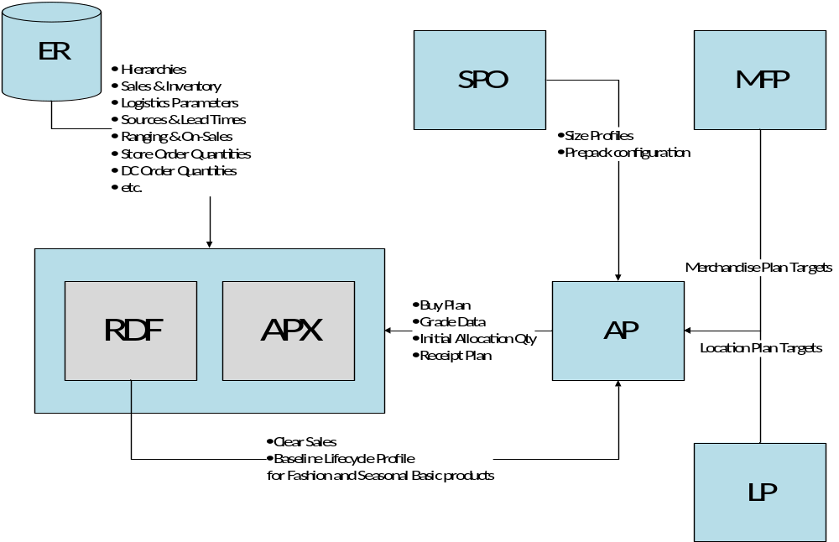
Figure 3-10 High level Interaction Diagram

In more detail, Assortment Planning Process consists of five mains steps (Figure 3-11)
- Store Clustering
- Assortment Strategy
- Assortment Creation
- Buy Plan Generation
- Size Level Buy Plan
AP will provide great flexibility in the Store Grading phase, as the Planners will be able to choose the number, the type and the ranges of the store clustering criteria at the appropriate merchandise level. The Grade Data at subclass and store level will also be fed to APX in order to integrate them in the Allocation and the Replenishment process. In the Assortment Strategy and the Buy Plan Generation step the Working Plan is reconciled against the MFP Targets and the Location Plan. After the creation of the Buy Plan at Option/Week/Store level, SPO will provide to AP the optimized Size profiles and the Pack ratios that will be applied to the existing plan in order to publish the final Buy Plan at SKU/Week/Store level. According to the suggested pack configuration and the size ratios the units of the Buy Plan will be rounded and the Purchase Order will be raised.

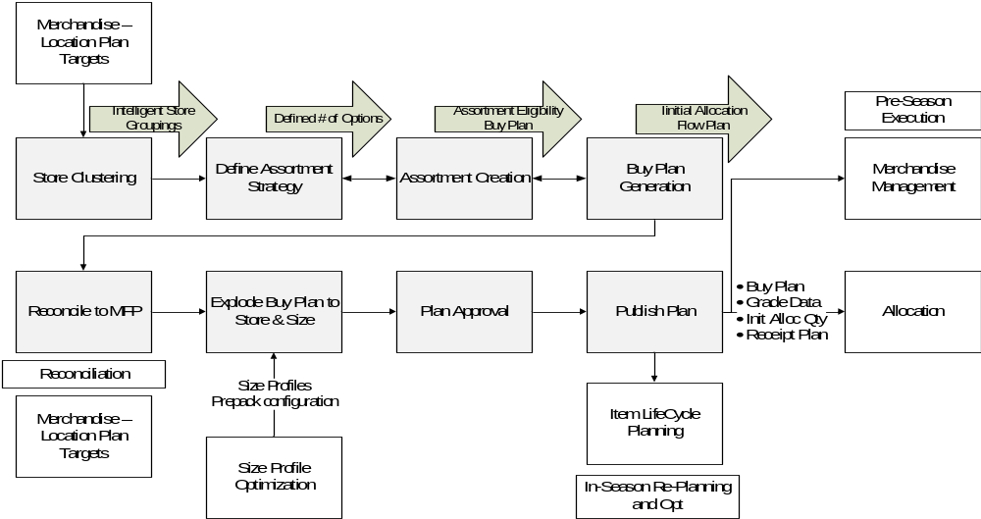
Figure 3-11 Assortment Planning Dependencies

Size Profile Optimization
SPO creates optimal profiles of size distribution and prepacks by merchandise area for each store and at higher levels of aggregation on both the merchandise and store dimensions. SPO enhances the analytical selection of merchandise at size-level by determining optimized size profile and creating prepacks to match them. The optimized Size Profiles and the Prepack configuration from SPO will help Assortment Planning to translate options, or similar aggregate level plans into optimal orders or buy quantities by SKU at the store level.

Requirements and Decisions

Log # | Description
252 | Different styles within a pack in SPO - This will be decided during SPO design.

Interfaces from Assortment Planning
Assortment Planning will provide as input to CPR:
- Buy Plan at SKU/Store/Week level
- Receipt Plan at SKU/Store/Week Level
- Initialization of allocation parameters such as Safety stock (weeks) & Initial Allocation % at SKU/Store level
- Grade Data at subclass/store level
The Buy Plan of Fashion and Seasonal Basic products will be used as a pre-season demand forecast in the CPR forecasting process, since they are new items with no sales history on which a true demand forecast could be based. For 365 products the Buy Plan from AP will not be taken into consideration in CPR process (see Section 5.1).
The Receipt Plan as determined in the AP will be used in the CPR workflow for review reasons only. The Initial Allocation for Fashion and Seasonal Basic products will be based on the quantities suggested by AP at SKU/Store level. Store Grading will be integrated in the Allocation and Replenishment process based on the Grade Data at Subclass/Store level from AP.

Requirements and Decisions

Log # | Description
90 | RMS can take as input the packs by AP
181 | For 365 products the input from AP will not be taken into consideration

Assumptions

Log # | Description
57 | Short Lifecycle products will not use promotional forecasting. AP will be used.
100 | Space Concerns will be handled in AP

Preprocessing
Oracle Retail Demand Forecasting (RDF) includes a “Preprocessing” module that tries to calculate the actual historical consumer demand, based on sales data. Preprocessing will adjust historical data upward to account for sales that may have been lost to e.g. out-of-stock conditions, or it may bring down historical sales to remove one-off peaks caused, e.g. by weather or bulk-buys.
Landmark requires that in their RDF implementation historical data are preprocessed in four separate steps, each enhancing the results of the previous step:
- Non-Typical Events
- Outliers
- Lost Sales
- For Seasonal Basics and Short Lifecycle Products only
Preprocessing sales correction will be computed at daily level.
The complete requirements for each Preprocessing step are detailed below.
Landmark requires that all user-maintained parameters defined in the Sections below be managed by RDF users in a new custom workbook template, Preprocessing Parameters Maintenance. The parameters should be grouped by functionality. These parameters, if defined at below the domain level, will have domain-level default settings that can be overridden at the specific Subclass/Store (also see Section 10.4.1).
Further, Landmark requires that no Preprocessing Adjustment may bring Total Adjusted Sales to below zero.

Pass 1 – Non-Typical Days
This first preprocessing step will use a user maintained indicator at Item/Store/Day to trigger the calculation. This factor will be maintained in the Sales Review Workbook (see Section 10.5).
- If the indicator is True, sales history will be corrected so that it matches the approved demand forecast times a user-maintained factor, managed by RDF users in the Preprocessing Parameters Maintenance Workbook.
- The Item/Store/Day that will be corrected will be excluded from any calculations in the next steps

Pass 2 – Outliers
In this step, RDF will calculate the Forecast Average Absolute Percentage Error for the last X Lead Times.
- If Sales exceed Y times the Forecast Average Absolute Percentage Error and they are higher than a minimum volume threshold Z we correct the Sales back to the threshold defined by Y.
- All parameters will be managed by RDF users in the Preprocessing Maintenance Workbook (see Section 10.4.1).
The Item/Store/Week that will be corrected will be excluded from any calculations in the next step. Note: that this approach will not be applied during Markdown periods.

Pass 3 – Lost Sales
In this step, RDF will calculate an out-of-stock indicator, since the RMS out-of-stock indicator is relevant only for the day of the download. Landmark requires that the out-of-stock indicator should be registered at SKU/store/day level.
- Whether the projected Stock On Hand for any day of the week falls below a percentage threshold X of the average stock level over the last Y Lead times, the indicator will be true.
- Where the above indicator is true we will correct the sales with a Retek Median over the last Z weeks.
- All parameters will be managed by RDF users in the Preprocessing Maintenance Workbook (see Section 10.4.1).
- If the SKU/Store is on Markdown and no stock is left in the supply chain, no correction will take place.
- Stock-outs will be detected from APX projected inventory so should be quite accurate.

Pass 4 – For Seasonal Basics and Short Lifecycle Products only
In this step, RDF will calculate a ‘short lifecycle item on markdown period’ indicator. This indicator will be calculated at day/SKU/store level. When this indicator is true, sales history will be set equal to the approved demand forecast (no correction will be applied).

Preprocessing for Fashion and Seasonal Basic Products
For Seasonal Basics and Short lifecycle products, Landmark requires that the system will keep two separate Sales histories:
- Total Adjusted Sales which, past the Markdown Start Date, will include Clearance Sales. This measure will be used to calculate promotional forecast as well as price and promotion elasticity (see Section 5.3). It will also be used to drive the short-term forecast reactivity (Section 5.6).
- Historical Baseline Demand which will replace Markdown sales with the Approved Forecast at the Markdown Start Date and will reflect the Lifecycle behavior of the products. This measure will be used to calculate the Baseline demand (see Section 5.2).
This requires the Markdown Start Date to be interfaced from RPM (see Section 2.2.1).

Requirements and Decisions

Log # | Description
140 | Pass 2 Outliers:  - We calculate the Forecast Average Absolute Percentage Error for the last X Lead Times.  - If Sales exceed Y times MAPE and they are higher than a minimum volume threshold we correct the Sales back to the threshold defined by Y.  - In both cases, the Item/Store/Week that will be corrected will be excluded from any calculations in the next step.  This approach cannot be applied for Markdowns
141 | Pass 3: Lost Sales  - We calculate an out-of-stock indicator:  Whether the projected Stock on Hand for any day of the week falls below a percentage threshold X of the average stock level over the last Y Lead times.  - Where the above indicator is true we will correct the sales with a Retek Median over the last Z weeks  - If the SKU/Store is on Markdown and no stock is left in the supply chain, no correction will take place.
144 | PP2LeadTime 2 options:  - Default value  - Override
145 | PP3LeadTime 2 options:  - Default value  - Override
330 | Preprocessing parameters will be set at SKU/Store, default values at Subclass/RDC
414 | Position Query Definition functionality for Sales Review Workbook is not required.
523 | Export cloned sales to SPO from APX

Assumptions

Log # | Description

Forecasting Process
Landmark requires that the forecasting approach differentiates between Basic (365) items, Fashion items and Seasonal Basics.
Oracle RDF splits the calculation of demand forecasts into two separate components: a Baseline Demand that reflects the underlying consumer demand for a product in the absence of external factors (such as promotions, markdowns or temporary events) and Causal Uplifts which reflect the incremental demand caused by such external factors.
Three types of external factors have been identified by Landmark:
- Promotions
- Pricing changes, which could be part of a promotion or not
- Day Events, which include Holidays and other predictable events such as pay days
  - In addition to the baseline demand and external causal factors, Oracle RDF also provides the capability of Reactive Forecasting (Bayesian method) which adjusts the statistical forecast to account for short term variability in demand (transient, intra-week demand changes) and which will be used to drive replenishment. This is particularly useful for items with a defined lifecycle and for which the forecast is not based on actual sales history for the same product and must be adjusted as soon as possible in order to match the true underlying consumer demand. Bayesian will also be used to adjust forecasts within markdown periods.

For all of the above forecast components, Landmark has identified different requirements for the three major product types. Table 5-3 below summarizes the different approaches.

 | Basics (365) | Seasonal Basics | Fashion
Assortment Planning | - No Buying Plan  - No Initial Allocation | - Buying Plan  - Initial Allocation
Baseline | Automatic Seasonality | With AP:  - AP Buying Plan at SKU/Store/Week  Before AP:  - Initial Allocation at Option/Store  - Total PO Quantity  - Phase Start/End  - Size Profile  - Lifecycle Profile
Promotions | Required | Nice-to-have | Not Required
Pricing | Required | Required | Required
Holidays / Day Events | Required | Some Day Events | Not Required
Reactivity | Not Required | Required and additionally:  - Not used during Promotion Periods  - Reset for Markdown Periods
Table 5-3 Summary of Forecasting Approach
The Sections below detail the LMG requirements for each facet of this approach.

Assortment Planning Inputs
Fashion and Seasonal Basics items have no sales history on which the CPR forecasting process can base a true demand forecast. Therefore, pre-season demand forecast will be based on the buying plan set up by the LMG Planning users in the Assortment Planning process.
The Assortment Planning process as currently practiced in LMG provides the following:
- A total Buy quantity for an option
- A per-store initial Allocation quantity or a per-store initial Allocation percentage with respect to the total Buy Quantity for each option
Start and End dates for the phase(s) for which the item is planned to be put on sale
- Buy Quantity information will be spread down to a week level, using a selling profile calculated by default at a subclass/territory level and the Start and End Dates of the planning season. This pattern will be used as the AP Buy Plan until AP Buy Plan is given directly by the Assortment Planning Solution.
As discussed in the Introduction 1, LMG will deploy Oracle Retail Assortment Planning (AP) following CPR deployment and roll-out. After AP is deployed it will provide --as described in Section 5.1— a complete Buying Plan for each new Seasonal or Fashion item at the SKU/Store/Week level. CPR will also expect AP to provide a SKU/Store initial Allocation Quantity that is based on the Buying Plan. Historical baseline will be fed to AP for future buy plan calculations and will be used to automatically determine seasonality for basic and seasonal items.

Baseline Demand
As discussed above, Oracle RDF splits the calculation of demand forecasts into two separate components: a Baseline Demand that reflects the underlying consumer demand for a product in the absence of external factors and Causal Uplifts which reflect the incremental demand caused by such external factors.
For the calculation of Baseline Demand, Landmark requires that is calculated differently depending on the product type.
For Basic items, the built-in RDF Automatic Source-Level forecasting facility will be used which can determine a statistically robust seasonal baseline. In order to do this, RDF compares the seasonality at multiple levels of aggregations and determines the one that is closest to the recent sales history for the item. Landmark requires that the following levels be used as candidates for this seasonality search:
- SKU/Territory
- Subclass/Territory
- Class/Territory
- Department/Territory
- Subclass/Store
- Class/Store
- Department/Store
For Fashion and Seasonal items the baseline demand will be based on the Buying plan created by Assortment Planning (AP) at a SKU/Store/Week level when that is available, following AP deployment. Prior to the AP Buying plan being available, CPR should create a compatible Buying Plan, using the information currently produced by Landmark business processes and which will be available within CPR, detailed in the following Section.

Pre-AP Baseline Calculation
Until AP provides a SKU/Store/Week level Buying Plan to CPR, a compatible baseline demand should be calculated using the information already created by the current LMG assortment planning process and the data that will be available in CPR modules, as follows:
- The Total PO Quantity will be provided to CPR as part of the permanent PO information interface at the SKU level (see Section 2.2). This PO quantity should be available for each option for which an initial allocation plan is provided (see items below).
- The Initial Allocation plan will be uploaded to CPR in a to-be-defined Microsoft Excel template at the Option/Store level (see Section 2.2). I.e. the Excel template should contain the initial allocation quantities in units for a number of options, for all stores which are to receive each option in the template. Using the PO Quantity as a guide, the Initial Allocation plan will be spread from Option/Store to SKU/Store using a size ratio per RDC (Territory).
- The Buy Quantity per phase will also be uploaded to CPR in the Excel template defined above at the Option/Store level, along with the Phase Start and End dates.
- The Phase Start and End dates should also be provided to CPR through the same Excel template described in Step (ii) above.
- Finally, a Lifecycle Profile will be created automatically in the CPR APX module: this profile will be calculated using the preprocessed sales history of items within a predefined lifecycle level. LMG users should be able to set this level per Option/Store to be one of two available levels: either Subclass/Territory or Class/Territory. This setting assumes that the lifecycle shape remains fairly constant from season to season for options within the same Subclass/Territory or Class/Territory.
- The Buy Quantity, Phase Start/End dates and the Lifecycle Profile –items (iii), (iv) and (v) above—will be combined and spread at the SKU/Store/Week level using the per-RDC size distribution of the PO Quantity –item (i) above—in order to create a Buy Plan equivalent to what AP will produce when it becomes available.
All of the above information should be available right after a Purchase Order has been raised.

Requirements and Decisions
Log # | Description
42 | The source levels for forecasting:  Approved Levels G1 :SKU/Territory, Subclass/Territory, Class/Territory, Department/Territory, Subclass/Store, Class/Store, Department/Store
108 | The source levels for forecasting approved by Group2:  SKU/Territory, Subclass/Territory, Class/Territory, Department/Territory, Subclass/Store, Class/Store, Department/Store

Promotions
Oracle RDF, which will be a CPR module, can identify the effect of external factors such as promotions on demand via its Causal Forecasting capability, given a set of conditions:
    - The promotion has a statistically identifiable effect on demand
    - The promotion has occurred before in the historical sales of each item
The second condition is particularly challenging for new, short-lifecycle items. In order to improve the likelihood that a promotion can be tracked in the item history, best practice is to identify the major promotion mechanics that are used by the business (e.g. discount, display, coupon, etc.) as separate, traceable causal factors in RDF. This significantly increases the chances of at least one mechanic for each promotion has occurred in the item history.
In particular, price changes, either temporary (as a Discount promotion mechanic), permanent (as a regular price change) or as a clearance strategy (markdowns) are typically treated separately in the Causal Forecasting module of RDF and, thus, are discussed in the following Section.
However, for short lifecycle items, such as Fashion items or Seasonal Basics, finding appropriate instances of any promotion mechanic in the past, that will also have a similar effect of demand for a new item is challenging at best. Further, planners should be aware of most promotional activity on new items prior the launch of such items and should be including their effect in the Buying plan produced in the Assortment Planning process.
Because of the above, Landmark does not require that Fashion items be included in the RDF Causal Forecasting process. Further, Seasonal Basics may also be excluded from that process if Veltio does not identify significant promotional effects on the sample data that will be used for development and tuning purposes during CPR deployment.
If a SKU/Store does not exhibit a significant promotion effect, then RDF should fall back to the average effect of the respective Class/Region (using its Causal Hier feature).
With regards to Basic (365) products, Landmark has identified two major mechanics in group-wide merchandising promotions. Table 5-4 Landmark Promotion Mechanics below lists these mechanics along with the promotions which exhibit significant effects for Basic products.

Mechanic | Merchandising Promotions
Multi-Buy | - Amount / Multi-Buy  - B2G1  - Cascade / Threshold  - Discount / Threshold  - Fixed Price / Threshold  - Fixed Price / Multi-Buy | - Gift Voucher  - Manual  - Merch Free / Threshold  - Multi Buy  - Multi Freq / Threshold  - Gift with Purchase  - Simple Promotions Fixed Size  - Simple Promotions Percent
Table 5-4 Landmark Promotion Mechanics
Landmark considers the following promotion mechanics as not significant enough for them to be part of the Causal Forecasting process:
    - Loyalty cards

Assumptions

Log # | Description
43 | Promotion history is available, RPM is used but not for all Territories
44 | Planning-future promotions are going through RPM, but not for all territories
46 | Advertisements are done in the beginning and in the middle of the collection
47 | Three seasons in a year, two flows > Six campaigns per year
48 | 4 times per year clearance sales and regular promotions
132 | Promotions like Media Buys are not registered in any system
176 | The lowest level the pricing promos are applied is Option/Region

Pricing
As discussed in the previous Section, pricing changes will also be considered in the RDF module of CPR as part of its Causal Forecasting capability. For this reason, the original retail price of each item along with the change prices at each store will be imported into CPR (see Section 2.2).
Three separate price behaviors should be captured by RDF in order to determine their effect on demand both in history and within the forecast horizon:
    - Regular (permanent) price changes
    - Temporary price changes as part of a Discount promotion mechanic
    - Permanent price changes as part of a Markdown event
All of the above behaviors should be identifiable by RDF given the retail price of each SKU/Store for each Week that it has been on sale in the past and the planned retail price for the future.
This assumes that RPM/ER should be able to provide CPR the following:
    - Retail price both for the past and for the future at a SKU/Store/Day level (see Section 2.2 and 11)
    - An indicator, at a SKU/Store level for when a line has entered a Markdown period.
Landmark expects that RDF may not detect price elasticity for individual SKU/Store combinations, given the short lifecycle of lot of Fashion items (approx. 10 weeks). For that reason, Landmark requires that price elasticity be calculation at a higher level, i.e. Subclass/Region where price behavior is expected to be similar between items and stores. If no significant price elasticity is detected at that level, RDF should automatically fall back to a Class/Region level elasticity as a second and final option.
In order to reduce the influence of low-selling items in the calculation of price elasticity, the above elasticities (at Subclass/Region and Class/Region) should be combined by weighing each SKU/Store by its average Rate of Sale (ROS).
New items or stores should inherit the combined elasticity of their Subclass/Region, unless they have built up a significant price elasticity of their own.
Landmark should be able to override the price elasticity per SKU/Store.

Day Events
Similar to Promotions in the above Section , RDF should also be able to identify the event of specific day events such as holidays or pay days on the baseline demand.
As for Promotions, Landmark does not require that Day Event effects be identified in Fashion items, as it is expected that Planners will take into account such effects during the creation of the AP Buying plan for such items.
Seasonal Basics may also have an identifiable effect only for specific holidays that fall within their life cycle limits.
As for Promotions, if a SKU/Store does not exhibit a significant promotion effect, then RDF should fall back to the average effect of the respective Class/Region (using its Causal Hier feature).
In an RDF workbook Landmark users will be able to set the days of the following Day Events:

- Payroll day
- Ramadan
- EID (EID al-Fitr)
- EID AL HAJ (Eid al-Adha)
- Second EID
- National Holiday
- Back to School
- Summer Season sale
- Autumn Winter Sale
- Crazy Offer
- Spring Season sale
- Local Shopping Festival
- Before vacation starts
- Start of school vacations
Table 5-5 below lists the day events that will be automatically defined by Veltio according to Landmark’s specifications:
Day/Event Description | Intersection | Dates | Relevant Region
National Day | Country/Day | 2nd December | Territory Specific
New Year | Country/Day | 1st January | All Regions
Christmas | Country/Day | 25th December | UAE, Lebanon
Prophet’s birthday | Country/Day | 24th Jan | All Regions
Valentine’s day | Country/Day | 14th Feb | All Regions
Arabic Mother’s day | Country/Day | 21st March | All Regions
Easter Sunday | Country/Day | 31st March | Lebanon
Israa & Miaraj Night | Country/Day | 6th June | All Regions
Father’s day | Country/Day | 16th June | All Regions
Arafat Day | Country/Day | 14th Oct | All Regions
Halloween day | Country/Day | 31st Oct | UAE, Lebanon
Islamic New Year | Country/Day | 4th Nov | All Regions
Muhammad's Birthday | Country/Day | 24th Jan | All Regions
Gitex Dubai | Country/Day | 29th Sep-6th Oct | UAE
Vacation | Country/Day | 16TH - 25TH FEB / 20TH -29TH MAR/ 5TH JUNE- 8TH JULY | All Regions
Table 5-5 Day Events

Reactivity (Bayesian Forecasting)
Landmark requires that CPR also utilizes the Bayesian Forecasting RDF feature which adjusts an existing forecast or plan based on recent sales events. Typically Bayesian makes use of a Bayesian window setting which controls the length of time over which it considers sales events to create its adjustment of the pre-existing plan.
Landmark does not expect that the Bayesian correction will be useful for Basic items and does not require that it be used to adjust their forecast.
For Fashion and Seasonal items, Landmark requests that the Bayesian correction be used using the On Sale Date of each SKU/Store as the beginning of the Bayesian training window according with best practice with two exceptions:
    - That Bayesian reactivity be turned off altogether during promotional periods (other than markdowns, see below) and reinstated after their completion
    - The training window (and thus the Bayesian reactivity) be reset to match the beginning of the markdown period, triggered by the Markdown Start Date (see Section 2.2.1).

New Items & Stores
New Items and new Stores will not have a statistically generated forecast by RDF. Landmark expects new items to be planned via two options:
    - For most new items, their assortment and sales plans will be introduced via the Assortment Planning Buy Plan (see Section 5.1).
    - For new SKU/Store combinations that do not have a plan interfaced from AP an alert must be raised (see Sections 9.6, ) to allow CPR users to set up the new Item or Store via the standard RDF Product and Location Cloning Administration mechanism. This case includes both completely new Items and Items whose assortment was expanded after the AP Buy Plan was created.
For new Stores, Landmark assumes that their initial allocation quantities have been reserved at their respective RDC or CDC (see Section 7, Allocation Process) and that replenishment for them will be done from existing stock. Again, for Stores that do not have a complete AP Buy Plan, the standard RDF Cloning functionality will be used.
The RDF Cloning feature allows the definition of up to three parent items or locations for a new item or store respectively. These parent settings should be defined at the following levels:
    - Parents of new SKUs should be adjustable for each Store.
    - Parents of new Stores should be adjustable by Subclass.
For non-sales or Buying Plan information, such as allocation and replenishment settings and other setup information, Landmark requires that only the first Parent Item or Store be used in order to avoid invalid settings for cloned Items and Stores.
When a new item is set up in a new store, the new store process should take precedence.

Requirements and Decisions

Log # | Description
152 | Replace Item: The New items that are ordered should have a Buy Plan assigned. In case there is a New Item w/o Plan, an alert will be raised. > Cloning  Same thing will hold for expansion of range of an item to more stores
153 | The replenishment of the new stores is done based on the existing stock. Only if the store-opening is planned early enough, the AP will have included the needed quantities for this store. > Cloning Functionality will be used
155 | When a new item is set up in a new store, the new store process will happen first
158 | The levels of Cloning administration should be defined (Group 1).  - New SKUs at store (Max, Splash)  - New Stores at subclass level (Max), class (Splash)
159 | The levels of Cloning are defined (Group 2):  - New SKUs at store level  - New Stores at subclass level
183 | For the new 365 products the RDF New Item/Cloning procedure will be used
309 | All AP sets of new stores can be cloned from the first parent store

Assumptions

Log # | Description
31 | 90% of the products are New items and will be configured by New Item Setup
32 | 6-7 weeks is a typical duration of Lifecycle of a product

Day-of-Week Profile
The APX module of CPR requires projecting the weekly demand forecast to the daily level in order to create intra-week transfer orders. Landmark requires that the highest level used in the day-of-week profile should be Country because weekends are different among countries and it has not detected any other variation in the day-of-week sales patterns between products or stores of the same Country.

Requirements and Decisions

Log # | Description
45 | Promotion strategies are different between concepts
139 | The forecast should reflect the Markdown sales increase
201 | Bayesian correction will be applied both for Fashion and Seasonal products
204 | A fallback elasticity for pricing should be provided for Max as an alternative (Uplift-Discount curve)
163 | Causal Fallback intersection is defined Class/Region
166 | Causal Fallback intersection should be Class/Region
172 | Causal Source intersection should be finalized. The suggestion is Subclass/Region
173 | Causal Source intersection should be finalized. The suggestion is Subclass/Region
331 | Forecasting Parameters will be set at SKU/Store, default values at Subclass/RDC
180 | No promotions to be used for Fashion Items Forecasting
191 | We are not using Bayesian for Basic items
196 | The lifecycle level calculation should be at subclass/territory(Max)  class/territory (Splash)
202 | The Bayesian correction should be turned off during promotion periods for Seasonal and Fashion products
203 | For Markdown periods the Bayesian training window will be reset for Fashion and Seasonal products
242 | Markdown elasticity source level will be subclass/region and fallback level class/region
255 | For Seasonal Products for the calculation of the baseline the same approach as for Fashion products will be applied
256 | For Fashion and Seasonal Items:  The average Markdown elasticity of all the SKUs per size at subclass/region level weighted by the ROS of the SKUs will be applied to all new items within the subclass/region of the same size  Sum(MD*ROS)[at SKU in Subclass/Region] / Sum(ROS)
146 | In the location hierarchy, the highest level used in the day-of-week profile should be Country, because the weekends are different among countries.
357 | RDF-corrected sales data (forecast) input required in MFP & LP
395 | At least 12 months forecast for RDF for Basic Items so that SPO can build a proper prepack plan
516 | For Fashion/Seasonal items, move the entire forecast backwards/forwards based on the actual OnSD of each Option/Store along with the APStart and End Dates

Assumptions

Log # | Description
51 | Common approach is to have a separate Forecast within MFP and not using RDF
129 | For 365 products only Regular & Promotional Sales will be taken into consideration in Forecast
160 | Loyalty will not be taken into consideration in promotions
161 | Clearance and Price change will not be taken into consideration in promotions as a separate factor to retail price
185 | For Fashion/Seasonal Items one option appears only in 1 phase.
186 | The lifecycle duration for fashion products of a subclass is the same
187 | The ROS of the fashion items should be calculated until the 70-80% of the total quantity of the item is sold. Assuming that the 20-30% remaining stock will be sold at clearance price. This should be taken into consideration in the lifecycle profile calculation for fashion items.
190 | Seasonal and Fashion products differentiate only in the lifecycle duration. They are both new items that appear only in one Season (Collection)
197 | The calculated lifecycle duration should be at least as long as the phase duration of the option
248 | There are long and short lifecycle items within a season for seasonal basics products, these will have different SKU/Option IDs and will be treated differently
253 | Do not have season, use two periods to split a year
366 | For Splash different lifecycles within each subclass according to phase.
415 | Basics forecast horizon will be 18 months
412 | Seasonal Basics may span multiple phases with same Option ID but different SKU IDs.

Supply Chain Constraints
Landmark’s as-is business process within the extended supply chain environment inherently constrains the CPR functional behavior. This Section provides information on these constraints and the way CPR will handle such particularities.
The APX module of CPR will handle several types of constraints including Purchase Order management, Pack Definitions, Pack Breakdown and other Supply Chain constraints.

PO Management
Within the current Landmark business process, the Supplier will send to the CDCs pre-allocated and crossed-docked stock, as well as held back allocation stock for new stores and buffer stock for replenishment. The PO data quantities imported into CPR from ER/RMS include the quantities that will cross-dock to the RDCs while the PO in-Transit quantities in ER from the Supplier to the CDC define separately the quantity that will be kept in the CDC, and the Allocation quantities that will cross-dock to the RDCs. Therefore, APX will need Shipments, Receipts, and Pre-allocated Stock feed at CDC.
The held back allocation stock will be kept in the CDC until: a) the new stores are able to receive, at which point it will be transferred to the RDC and then shipped to the store via Allocation Order, or b) until these quantities are released and become available for replenishment to existing stores. The quantities will be added to the replenishment stock of the CDC. The replenishment stock will be split among the RDCs served by each CDC based on the need of the corresponding stores.
The current Landmark process requires that the Supplier will also send to the RDCs allocation stock for existing and new stores and replenishment stock. According to the Initial Allocation process of APX a portion of the PO quantity received in the RDC will be sent as allocation stock to the existing stores. The remainder of the PO quantity reflecting held back allocation stock, will be kept in the RDC until the new stores are able to receive and will be shipped via Allocation Order or until these quantities are released and become available for replenishment to existing stores. The PO quantity percentage reflecting replenishment stock will be split among the stores served by the RDC based on their ROIs according to the Distribution process described in Section 7.2.
When a Supplier shipment is received at the RDC, Landmark requires that it’s either:
- Put into RDC stock for replenishment purposes or later picking
- Cross-docked directly to Stores
To accommodate both Allocation mechanisms, CPR should allow for the following:
- When approving Allocation orders (by Option/Store), allow users to create Allocation Orders not only from RDC Stock On-Hand (SOH) quantity but also Cross-Docking Allocation Orders for the “active” ASN Quantity for the same RDC and PO.
- The above Cross-Docking Allocation orders will be tied to the “active” ASN quantity which is defined as the shipment which, for each RDC/Option/PO combination:
  - Has the earliest shipment date, and
  - Has not been received by an RDC
  - Does not have an Allocation Order issued against it by CPR
- Thus, Store Allocation orders will be sent to WMS immediately upon planner approval and remain tied to a particular ASN. This mirrors the current WMS process and will allow the cross-docking process for initial allocation.
- As soon as CPR users approve an Allocation Order against a particular ASN, CPR will send that Allocation order to WMS which should then mark that ASN as “allocated” and send to CPR the next “active” ASN quantity for the same RDC/Option/PO combination, i.e. the next earliest, non-received and non-allocated shipment.
- Allocation Orders using RDC Stock-on-Hand should be sent as regular Transfer Orders to the Stores.
Purchase Orders for local basic items is out of scope for the CPR system. They will be handled by manually managing the forecast.
Landmark suggests that after the PO is shipped, the delivery CDC or RDC cannot be changed. Stock flows for PO quantities are described in Section 8.5.

Requirements and Decisions

Log # | Description
10 | RMS makes the official order to the vendors – Fundamental LMG rule
344 | Local Basic Purchase orders will be handled by managing the forecast manually
409 | ASN to Receipt times are around 23 days for China, 7 days for India

Pack Definitions
Landmark requires that SKU IDs will be specified at PO creation and will be permanent. The planning team will decide the ratios of the SKUs within a pack. The ratios will be given as an input to RMS. Currently, Landmark uses Pre-Packs comprised of Single Style, Single Color, Multiple Size Packs with Varying Size Profiles (constituting a Complex Pack), as shown below (Error: Reference source not found).
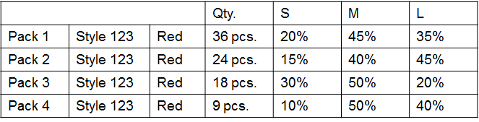
Figure 6-12 Pre-Pack Definition
Landmark requires a maximum number of 29 packs within a Complex Pack –this number can easily be changed post-go-live. Different countries will have different sizes which will be handled as different packs. The number of packs within a PO could change, but the pack ratios of a PO should remain the same. In case a new pack type is added, Landmark requires that a new PO should be raised.
Pack IDs will come to the APX module of CPR from ER and will be unique. The APX module of CPR will also receive the Pack Sizes and Size Ratios for each Pack via the final PO quantities ordered (interface IF22 from ER, Section 2.2.1). APX will treat these Complex Packs as Pack Groups, hence processed in a cohesive manner: Replenishment Quantity reconciliation with the override user-entered values, Cover method selection and processing, RDC and Store Pack Order Approval will all be done at Pack Group Level.

Requirements and Decisions

Log # | Description
30 | Options per country have different size ratios
36 | Measure that will indicate the type of the pack (Pack 6A, Pack 6B) will make the use of packs easier (See the example is Sheet "Pack Type Label").  The way to interface this measure should be defined.
104 | Different countries have different sizes and they will be handled as different packs

Assumptions

Log # | Description
14 | LMG Definitions:  Complex pack > 1 style, 1 color, multiple sizes  Item > SKU  Option > Style Color  Singles > eaches
15 | Only complex packs is used by Max and Splash
16 | Maximum number of packs is 7 within a complex pack
91 | The planning team decides the ratios of the SKUs within a pack.  The ratios are given as input to RMS.
92 | The SKU ID is created at the latest on PO creation and never changes
271 | Pack Source system: ER  Pack IDs are unique
272 | The number of packs can change, but the pack ratios of a PO do not change.  If a new pack type is added, a new PO should be added.

Pack Breakdown
During design, transition from Packs to Singles was discussed for the stock flows mentioned in Section 8.5. Landmark suggested that the majority of the concepts currently in-scope will have a consistent approach to stock handling throughout the supply chain, as shown below (Figure 6-13). The APX module of CPR will generate the corresponding Transfer and Allocation Orders either in Packs or Singles depending on the Concept process shown below (Figure 6-13).
However, Landmark requires that for the Shoe Mart and Shoe Express concepts, replenishment stock arrives at the RDCs in packs where a breakdown process and the appropriate stock corrections take place. Hence, Landmark requires that APX generates the CDC→RDC Transfer Orders for these concepts in packs and the RDC→Store transfer orders in singles.
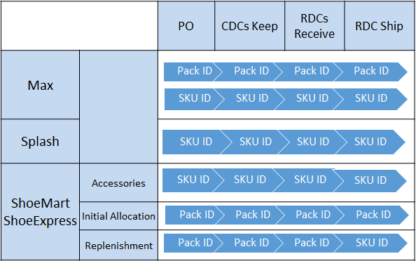
Figure 6-13 Transition from Packs to Singles
In order to accommodate this behavior, a special flag “Replenish Stores only in Singles” will be available in the Logistic Parameters Workbook by RDC. When this flag is set to True, APX will convert all RDC Stock on Hand to singles and send only Transfer Orders in singles from this RDC. RMS/WMS will be responsible for updating the RDC stock on hand after the pack breakdown and for executing the transfer orders.

Requirements and Decisions

Log # | Description
210 | It should be investigated how to handle pack breakdown
94 | APX will not order pack breakdowns
275 | The flag that will indicate the pack breakdown for all the existing packs in the RDC should be in Replenishment Parameter Maintenance. All the transfer orders out of this RDC will be in singles. > TBC until we clarify the way the registration of packs and singles is done in RMS

Allocation Process
The APX module of CPR will be responsible for undertaking the initial allocation of stock to stores, given the supply chain constraints of the previous Section.
This Section describes the Landmark Allocation process in context and the APX fit, the main Allocation process within APX and the distribution requirements that should be used within the Allocation calculations.

Initial Allocation Process
In the CPR Functional Design sessions, Landmark described their required functional process for Initial Allocation, as well as a draft representation of how that process should be reflected within the APX workbooks of CPR.

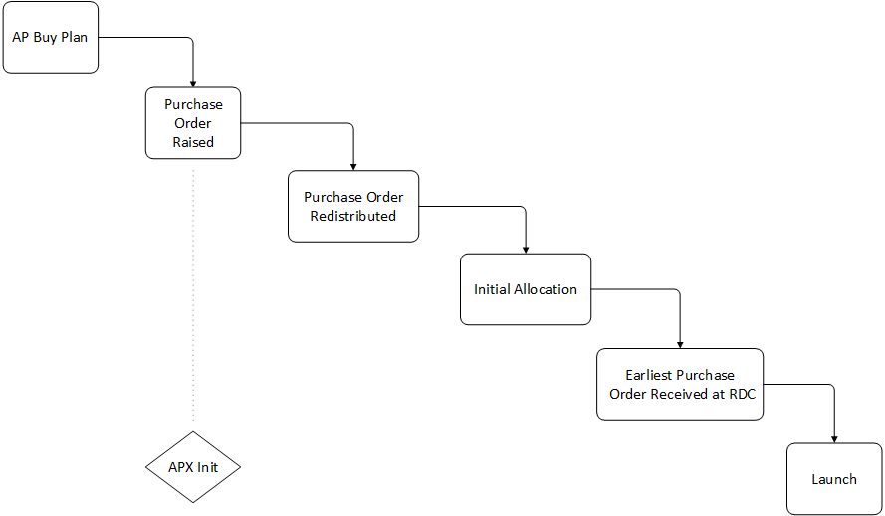
Figure 4-14 Landmark pre-season process
Functionally, the LMG Allocation process can be split into the following steps, in chronological order (displayed in the figure above):
- Initial Allocation Plan: during the assortment planning stage, planners will create an initial allocation plan for each Option/Store. After Oracle Assortment Planning is deployed, this Allocation Plan will be defined at SKU/Store, with a planned allocation quantity (in units) per SKU/Store. With AP in place, planners will also define a Holdback Quantity per SKU/Store. Before AP becomes available, the Holdback Quantity will be calculated by the comparison between the total PO quantity and the total AP allocation quantity. After the PO has been raised users will be able to update the Initial Allocation Plan using total PO Quantity as a top-level constraint to create the final Allocation plan to be executed when stock arrives.
- Purchase Order (PO): Following the initial allocation plan, the Buying team will create one or more Purchase Orders (POs) to cover the total allocation quantity requested by the planners plus any required buffer stock. Landmark required that this process must occur within the Oracle Retail Merchandising System (RMS). RMS will provide at least the following information for each PO which will be interfaced into CPR :
  - If applicable, final pack configuration for the pre-packs that the Supplier will provide to LMG under the PO, i.e. quantity per SKU that will be bundled into each Pack. At this point, the RMS-provided SKU and Pack IDs will be final and can be used to track the stock after it is received by Landmark and to create allocation and transfer orders within its supply chain.
  - Quantity per SKU or Pack that was bought under the PO and the expected receipt point (CDC or RDC).
  - CFS cross-docking will be transparent to CPR and thus out of scope.
- PO Re-distribution: After the PO has been raised but before it is shipped by the Supplier, Landmark may be able to arrange re-distribution of the PO quantities among its receipt points (i.e. CDCs and/or RDCs). For this phase, CPR should provide a guideline on the best distribution per SKU and RDC only. Further logistical considerations, such as whether to have the suppliers ship stock to RDCs directly, route it through CDCs, or cross-dock it at CDCs, will be left up to the Logistics team at Landmark and are out of scope for CPR.
- PO Shipment: When the PO stock is shipped, CPR will reserve the required quanity for pending cross-dock allocations. This point is when the stock enters CPR scope and needs to be tracked by the APX module.
- PO Receipt: When the PO stock is received at the CDCs and/or RDCs it should be appropriately split between allocation and replenishment stock.
- Initial Allocation: Following shipment and/or receipt of PO stock, the APX module of CPR will suggest Allocation Order quantities to the Landmark business users who will then review them and potentially release them for Allocation. Within Initial Allocation, two main concepts must be addressed by APX:
  - Allocation quantities will be released manually by APX users depending on stock on-hand at the distribution centers (orders will be executed next business day), or active ASNs in case of RDC cross-docking as described below, and at the assortment of products that can be send together at the same time –e.g. products that belong to the same collection or flow. Further, for some concepts (Max, Splash, others) the set and quantity of products that will be allocated should follow store-level constraints, such as display capacity or category-management issues. These will be addressed by the “Constraint Group” dimension in the product hierarchy (see Solution Architecture Document Section 2.1.2) and the definition of a “Constrained Capacity” quantity at the Store/ConstraintGroup level in the Replenishment Parameters Workbook (see Section Error: Reference source not found). This information will then be visible in the Initial Allocation Workbook to guide Allocation decisions (see next Section) as well as being used by Alerts to initiate the business process (see Section Error: Reference source not found).
  - Landmark may include Store locations in their initial allocation plans whose opening is delayed or for which the final location may be still undetermined at the time of the original assortment plan. For these locations, APX should:
    - Allow users to create temporary (placeholder) stores which will be assigned the planned allocation quantities. Users should be able to copy and paste these allocation quantities from the temporary stores to the actual permanent locations when the latter are created in and interfaced from RMS.
    - Provide the capability to hold their allocation stock at an appropriate RDC or CDC location. When these stores are finalized, the APX users should be able to release the allocation stock for actual allocation orders. On the other hand, if the stores are cancelled, users should be able to release the stock reserved for initial allocation to these stores and re-use it for replenishment of other locations.
Within the initial Allocation process, Landmark requires that CPR provide for two separate mechanisms:
  - RDC Cross-Docking: Upon receipt of an initial shipment from a supplier at an RDC, initial allocation orders should be cross-docked for shipment to stores without being put to stock-on-hand. To accommodate this, CPR will allow for the Cross-Docking of Allocation orders against the “active” ASN quantity which is defined as the shipment which, for each RDC/Option/PO combination:
    - Has the earliest shipment date, and
    - Has not been received by an RDC
    - Does not have an Allocation Order already issued against it by CPR
  - Shipment from Stock-on-Hand: normal shipment of allocation orders from either CDC or RDC stock on hand.

Allocation Workbook
During the CPR design sessions Landmark business users have drafted an Initial Allocation Workbook for inclusion in the APX solution. This workbook makes use of standard APX allocation functionality, while at the same time adapting the workflow to the overall Landmark workflow.
Landmark has defined the following wizard process for the workbook, in order:
- As a first step, user should select a single RDC. Implicitly, the wizard should select all stores belonging to the RDC selected, without displaying them to the user.
- Next, the user should be able to select one or more phase IDs from a list of active phase IDs in the system (as product attributes).
- Given that selection, the wizard should pre-select the product(s) that belong to the selected phase IDs in the previous step.
- Next, the wizard should allow the user to select one or more Purchase Orders that contain at least one product from the selections in the previous step.
The workbook was adapted from the version shown during Functional Design in order to accommodate both allocation mechanisms –henceforth referred to as “Cross-Dock Allocation” and “On-Hand Allocation”. This will be implemented by allowing some worksheets to switch between a Cross-Docking and an On-Hand measure profile, as described below. Moreover, Cross-dock allocation will be available both in Packed Units and Packs views.
Overall, the workbook contains a single tab (section) – Initial Allocation, including several worksheets (windows), as follows:
  - Pack Initial Allocation, which allows the users to plan initial allocation quantities and approve allocation orders for exporting into RMS at the RDC/Store/PackGroup/Pack level for complete packs. This worksheet will support two different views, one each for the Cross-Docking and On-Hand Allocation mechanism.
  - Singles Initial Allocation, which allows the users to plan initial allocation quantities and approve allocation orders for exporting into RMS at the RDC/Store/SKU level for singles. This worksheet will support two different views, one each for the Cross-Docking and On-Hand Allocation mechanism.
  - RDC Packs Review, which allows the users to review overall stock levels, Purchase Order quantities and allocation quantities for complete packs at the RDC/PO/Pack/SKU level
  - RDC Singles Review, which allows the users to review overall stock levels, Purchase Order quantities and allocation quantities for singles at the RDC/PO/SKU level
  - Allocation Source Data, which includes low-level input data that are inputs to the allocation calculation, for review by the users
  - Store Inventory, which will contain Store/SKU level inventory and ordering data
  - Store Allocation Parameters, which will contain Store-level parameters
  - Packing Parameters, which will contain packing-related parameters at the Store/PackGroup level
  - Allocation Alerts Review, which will provide a view-only summary of initial allocation-related alerts and relevant measures.

Pack Initial Allocation
Please note that in the figures below white cells indicate user-writeable quantities, while grey cells indicate read-only quantities used for review. The information at the corners of each figure indicates the data level of the worksheet being shown (e.g. RDC/Store/PackGroup/Pack for the figure below).
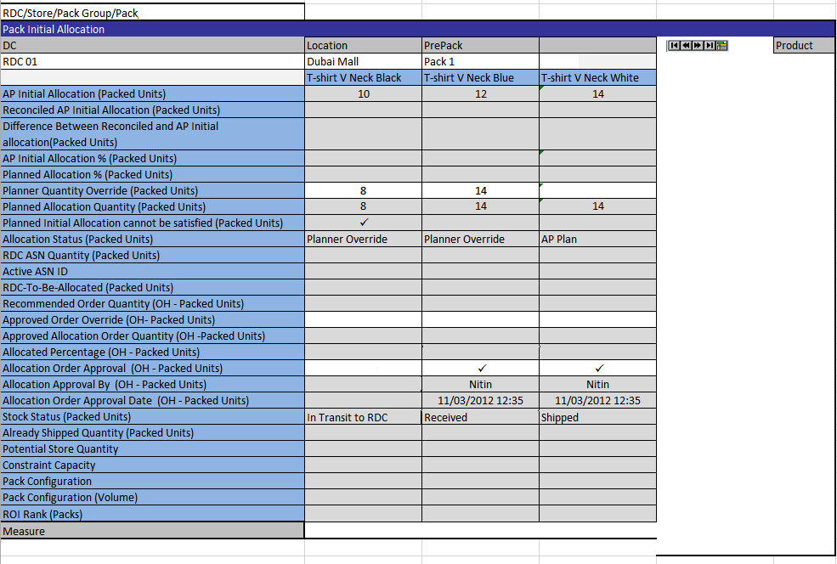
On-Hand View of Pack Initial Allocation
For the On-Hand view this worksheet contains the following measures:
- AP Initial Allocation (Packed Units): this measure displays the initial allocation quantity as entered in Assortment Planning (AP).
- Reconciled AP Initial Allocation (Packed Units): this measure displays the recommended initial quantity as calculated by the APX replenishment engine using the PO Quantity (minus the Holdback Quantity) as a top-level constraint.
- Difference between Reconciled and AP Initial allocation (Packed Units): For review purposes; the difference between Reconciled and AP Initial allocation to allow sorting for outliers.
- AP Initial Allocation % (Packed Units): For review purposes; the percentage of AP Initial Allocation for this Store across the RDC/Pack Group/Pack (RDC/SKU for Singles).
- Planned Allocation % (Packed Units): For review purposes; the percentage of (vi) for this Store across the RDC/PackGroup/Pack.
- Planner Quantity Override (Packed Units): APX users will be able to enter their overrides for the initial Allocation Quantity. APX should then reconcile the PO Quantity (minus the Holdback Quantity) with the override and create the final Planned Allocation Quantity measure below.
- Planned Allocation Quantity (Packed Units): As described above, this measure should contain the final allocation plan for the pack to be executed when stock arrives.
- Planned Initial Allocation cannot be satisfied (Packed Units): APX will flag this measure as True if the total quantities of (vi) for the PackGroup/Pack across all Stores in the RDC exceed the total PO quantity for the PackGroup/Pack planned to be received at the RDC.
- Allocation Status (Packed Units): APX will set this measure to the following status messages:
  - “AP Plan” if (vii) is the same as (i) for this RDC/Store/PackGroup/Pack
  - “Planner Override” if not
- RDC ASN Quantity (Packed Units): This measure will contain the total quantity shipped in the “active” ASN users are reviewing in the workbook.
- Active ASN ID: This will contain the ID of the Active ASN for the RDC/PO/PackGroup/Pack combination as interfaced in from WMS/ER
- RDC To-Be Allocated (Packed Units): The difference between the total Planned Allocation Quantity and In Transit from CDC (Packed Units).
- Recommended Order Quantity (OH - Packed Units): When Stock is received at the RDC APX will distribute the on-hand quantity as close as possible to the Planned Allocation Quantity following the Distribution Requirements described in Section 7.3 below. This measure will reflect the recommended order quantity for the allocation orders to be executed given the stock on hand.
- Approved Order Override (OH - Packed Units): After APX creates the Recommended Order Quantity based on stock on hand as described above, users will have the ability to override the quantity in this measure.
- Approved Allocation Order Quantity (OH - Packed Units): Given the Approved Order Override above, APX will reconcile the overrides with stock on hand and produce the final allocation order quantity in this measure. This is the quantity that will be exported to RMS.
- Allocation Order Approval (OH – Packed Units): APX users should check off this cell to release (xv) for export to RMS and execution.
- Allocation Order Approval By (OH – Packed Units): When (xvi) is checked off, this will store the user ID of the APX user approving the latest allocation order.
- Allocation Order Approval Date (OH – Packed Units): When (xvi) is checked off, this will store the date and time of approval of the latest allocation order.
- Stock Status (Packed Units): APX will set this measure to the following status messages:
  - “In Transit to RDC” if there are total ASN Quantities for this PackGroup/Pack in transit to the RDC. This status will apply to both Cross-Docked and On-Hand allocations.
  - “Received at RDC” if there any stock on hand reserved for Allocation for this PackGroup/Pack at the RDC. This status will only be valid for On-Hand allocation orders.
  - “Partially Approved” if (xv) has been approved and is less than (vii)
  - “Fully Approved” if (xv) has been approved and is the equal to (vii)
  - “Partially Shipped” if (xx) is non-zero and less than (vii). This status will apply to both Cross-Docked and On-Hand allocations.
  - “Fully Shipped” if (xx) is equal to (vii). This status will apply to both Cross-Docked and On-Hand allocations.
  - “Store Delayed” if the Store allocation quantity is being held at the RDC or CDC (see Section 7.2.7 below)
- Already Shipped Quantity (Packed Units): After (xv) is approved and RMS confirms its shipment to stores, the quantity of (xv) will be moved here. The respective quantity for cross-docked Allocation Orders will also be added.
- Potential Store Quantity: This measure will contain the sum of the Store Net Inventory for the SKU as well as a portion of the RDC Net Inventory based on the relative share of the demand forecast going forward.
- Constraint Capacity: This measure will contain the constrained capacity for the Constraint Group dimension of the Store.
- Pack Configuration: This measure will contain a string describing the pack size split, e.g. “1-2-2-1” will describe a 6-unit pack containing 4 sizes with the respective quantities per size.
- Pack Configuration (Volume): This measure will contain the size of the pack; for the example above this measure will be equal to 6.
- ROI Rank (Packs): This measure will contain the Store Rank per Pack Group based on ROI.
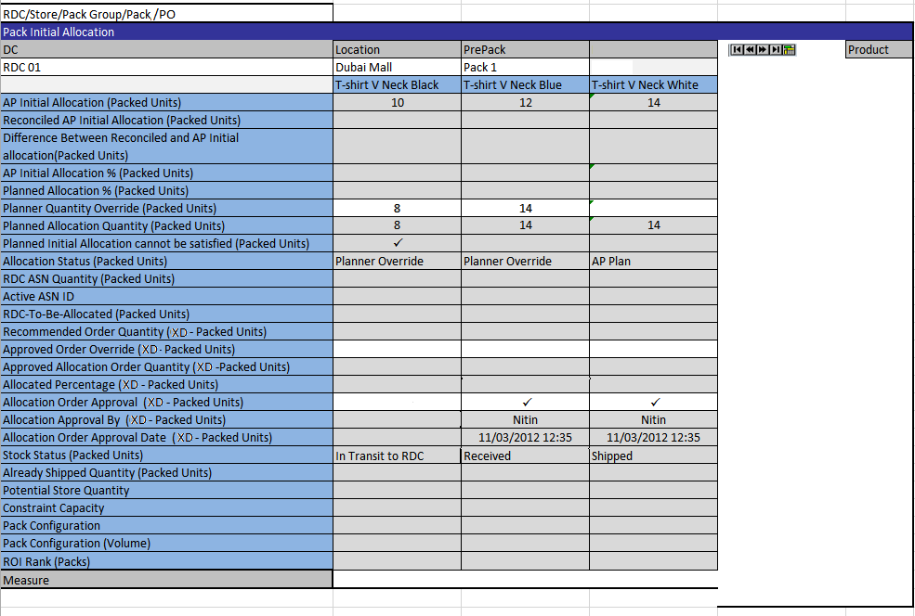

Cross-Docking View of Pack Initial Allocation
The Cross-Docking view of this worksheet will be identical to the On-Hand view with an equivalent set of measures tracking the quantity approved for cross-docking allocation and the user date that it was approved.

Singles Initial Allocation
This worksheet is exactly symmetrical to Packs Initial Allocation described above, instead considering stock and quantities at a SKU level instead of PackGroup/Pack. It will also allow for a Cross-Docking and On-Hand view of the allocation measures.
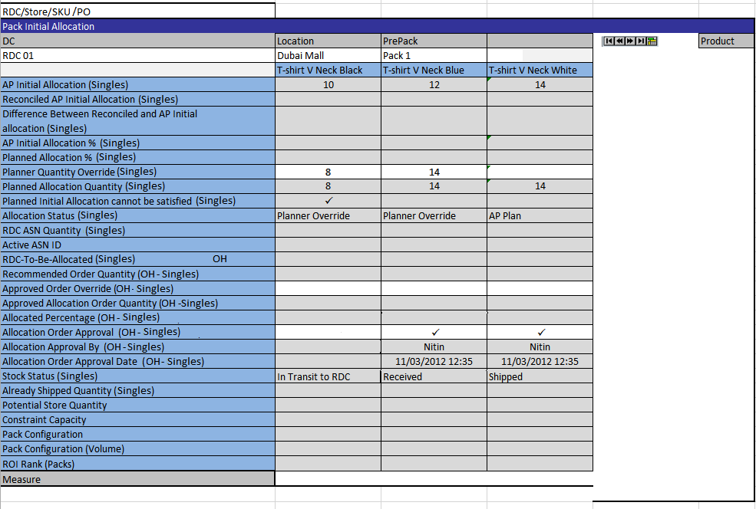
On-Hand View of Pack Initial Allocation

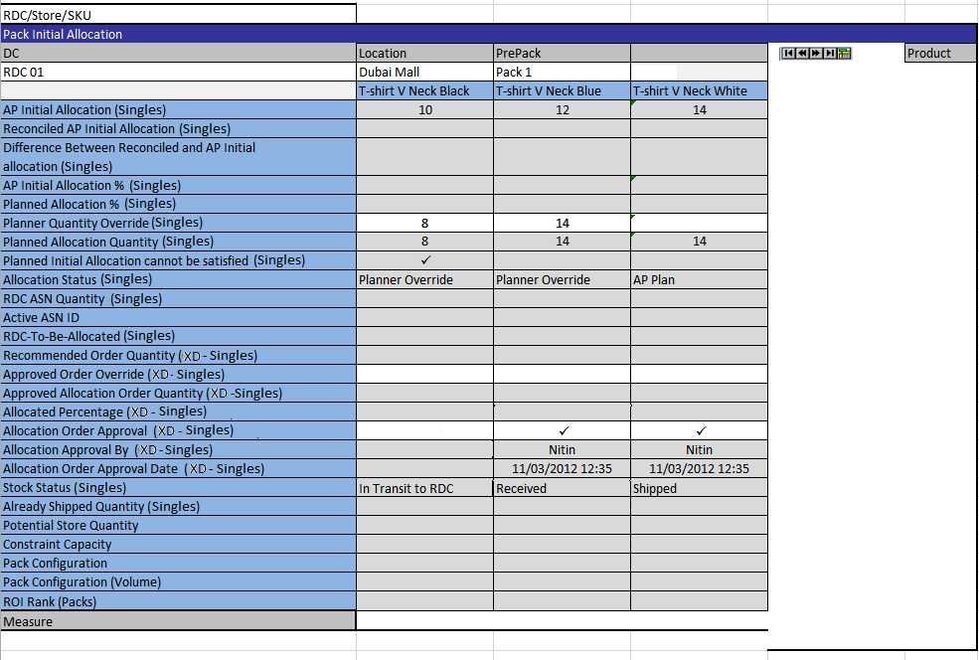
Cross-Docking View of Pack Initial Allocation

RDC Packs Review
This worksheet contains total views of Allocation quantities described in Section 7.2.1 above plus some stock on hand and PO information at the RDC/PO/Pack/PackGroup level.
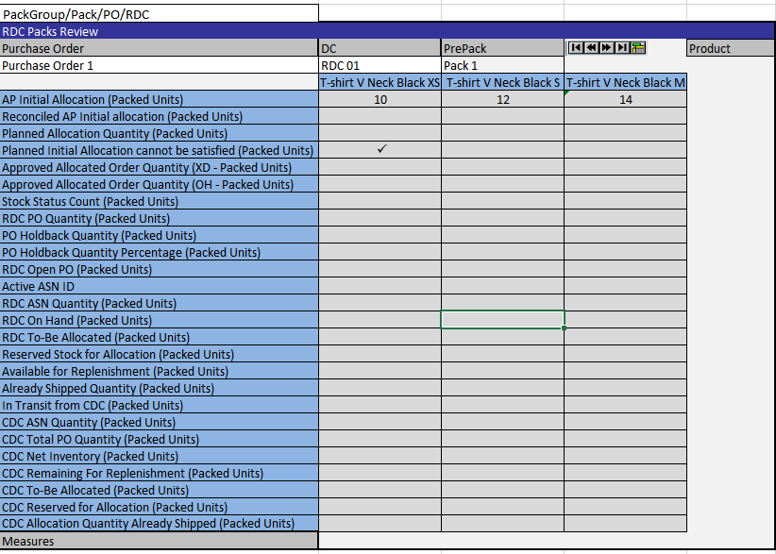
RDC Packs Review
This worksheet contains the following measures:
- AP Initial Allocation (Packed Units): The sum of AP Initial Allocation as defined in Section 7.2.1.
- Reconciled AP Initial allocation (Packed Units): this measure displays the recommended initial quantity as calculated by the APX replenishment engine using the parameters also shown in the Initial Allocation Parameters Worksheet (see Section Error: Reference source not foundError: Reference source not found).
- Planned Allocation Quantity (Packed Units): The sum of Planned Allocation Quantity (Packed Units) as defined in Section 7.2.1.
- Planned Initial Allocation cannot be satisfied (Packed Units): As in the same flag defined in Section 7.2.1.
- Approved Allocation Order Quantity (XD - Packed Units): The sum of Approved Allocation Order Quantities for Cross-Docked Allocation Orders.
- Approved Allocation Order Quantity (OH - Packed Units): The sum of Approved Allocation Order Quantities for On-Hand Allocation Orders.
- Stock Status Count (Packed Units): This measure will contain the set of Stock Statuses of the Stores below the RDC as those are defined in “Stock Status”, in Section 7.2.1 above.
- RDC PO Quantity (Packed Units): Total open PO quantities for this PackGroup/Pack destined for this RDC.
- PO Holdback Quantity (Packed Units): Total held-back PO quantities for this PackGroup/Pack destined for this RDC, computed as per Section 7.1.
- PO Holdback Quantity Percentage (Packed Units): Percentage of the PO quantity that will be held-back at the RDC.
- RDC Open PO (Packed Units): the quantity of all open Purchase Orders for the associated SKU.
- Active ASN ID: Same as in section 7.2.1.
- RDC ASN Quantity (Packed Units): Total ASN quantities for this PackGroup/Pack destined for this RDC.
- RDC On Hand (Packed Units): Total RDC On Hand for this PackGroup/Pack.
- RDC To-Be Allocated (Packed Units): The difference between the total Planned Allocation Quantity (Packed Units) and Approved Allocated Order Quantity (Packed Units) above.
- Reserved Stock for Allocation (Packed Units): Stock reserved for allocation for specific Stores; see Section 7.2.7 below.
- Available for Replenishment (Packed Units): Stock on hand at the RDC that is not otherwise reserved (allocation, cross-docking) and is thus available for replenishment.
- Already Shipped Quantity (Packed Units): The sum of Already Shipped Quantity (Packed Units) defined in Section 7.2.1.
- In Transit from CDC (Packed Units): Total in-transit stock to this RDC from its primary CDC.
- CDC ASN Quantity (Packed Units): Total ASN quantity for this PackGroup/Pack destined to the primary CDC (at CDC/PackGroup/Pack level).
- CDC Total PO Quantity (Packed Units): Total PO quantity for this PackGroup/Pack destined to the primary CDC (at CDC/PackGroup/Pack level).
- CDC On Hand (Packed Units): Net Inventory for this PackGroup/Pack at the primary CDC (at CDC/PackGroup/Pack level).
- CDC Remaining For Replenishment (Packed Units): Stock remaining for replenishment for this PackGroup/Pack at the primary CDC (at CDC/PackGroup/Pack level).
- CDC To-Be Allocated (Packed Units): The difference between Planned Allocation Quantity and Allocation RDC On Order.
- CDC Reserved for Allocation: Stock reserved for allocation to delayed stores for this PackGroup/Pack at the primary CDC (at CDC/PackGroup/Pack level).
- CDC Allocation Quantity Already Shipped (Packed Units): Already shipped delayed allocation quantities this PackGroup/Pack at the primary CDC (at CDC/PackGroup/Pack level).

RDC Singles Review
This worksheet is exactly symmetrical to RDC Packs Review described above, instead considering stock and quantities at a SKU level instead of PackGroup/Pack.
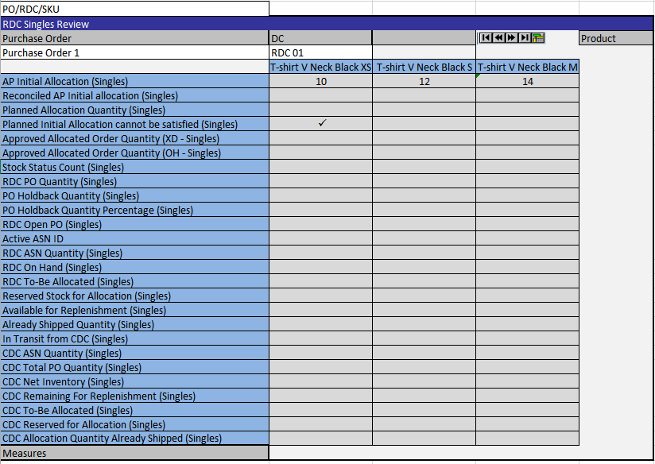
RDC Singles Review

Allocation Source Data
This worksheet includes low-level input data that are inputs to the allocation calculation, for review by the users. These measures have been discussed in previous sections (Sections 5, 10.5).
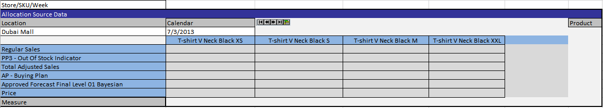

Store Inventory
This worksheet contains SKU/Store-level information on Net Inventory and the results of the APX Recommended Initial Allocation process.
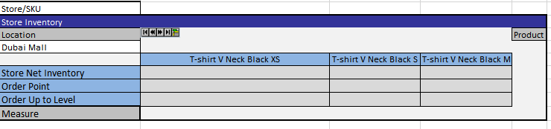
- Store Net Inventory: The amount of stock available to cover the need for the next order.
- Order Point: is the minimum number of units that is required to be on hand for the item. When the net available inventory falls below the order point, the item is replenished.
- Order up to level: is the maximum value to which a chosen replenishment method will raise the inventory.
Under most initial allocation conditions, the APX Recommended Initial Allocation quantity will be equal to the Order Up to Level measure above.

Store Allocation Parameters
This worksheet contains Store-level parameters that control Allocation behavior as discussed below.
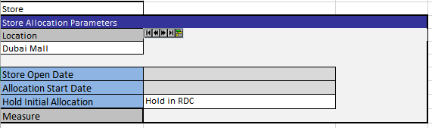
The following measures are available:
- Store Open Date: Interfaced from RMS (see Section 2.2.1) this is the available Store Open date. APX will not send allocation prior to this date.
- Allocation Start Date: this measure will define the eligible Allocation period for each Store.
- Hold Initial Allocation: APX users will be able to modify Allocation behavior using this setting, which has three allowed values (see paragraph vi b in Section 7.1):
  - “Do Not Hold”: When selected, stores with this setting will have their Planned Allocation Quantity incorporated in the Planned Allocation Quantity of their Primary RDC, so that the Allocation calculation can proceed as described in Section 7.1).
  - “Hold in RDC”: when selected, APX will reserve the Planned Allocation Quantity for this Store at RDC after allowing for the initial allocation of other stores under the same RDC but before making any other stock available for replenishment.
  - “Hold in CDC”: when selected, APX will reserve the Planned Allocation Quantity for this Store at CDC after allowing for the initial allocation of other stores under the same CDC but before making any other stock available for replenishment.

Packing Parameters
This worksheet contains the Cover Method setting at Store/Pack Group as discussed in Section 10.4.2).
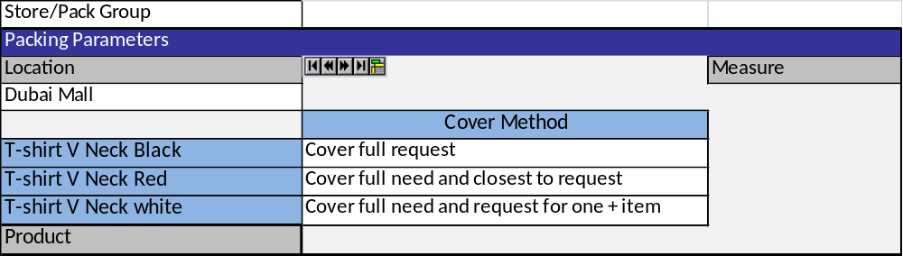

Distribution Requirements
Landmark requires that following receipt of PO stock the APX module of CPR will suggest Allocation Order quantities to the Landmark business users who will then review them and potentially release them for Allocation. These suggestions will be based on the CPR distribution process discussed below as per standard APX functionality.
Similarly, Landmark requires that CPR will suggest distribution quantities for the allocation stock for existing stores kept at the RDC, as well as for the held back allocation stock kept in the CDC/RDC until the new stores are able to receive or until these quantities are released and become available for replenishment to existing stores, in which case the quantities will be added to the replenishment stock of the corresponding CDC/RDC. CPR will suggest replenishment distribution quantities based on the need of the corresponding stores as per standard APX functionality.
Landmark also requires that CPR will suggest distribution quantities for the percentage of the PO quantity received in the CDC/RDC used for replenishment. The replenishment stock will be split among the RDCs/Stores served by the corresponding CDC/RDC (based on the Store Need for CDC→RDC replenishment or the Store ROIs for the RDC→Store replenishment) as per standard APX functionality. These flows are described in Section 7.3.
CPR will use two processing rounds to calculate the distribution of quantities to competing locations.
- Need (Order Point – Net Inventory) Cover round
- Request (Order up to Level – Net Inventory) Cover round
For each round, for each pack to-be allocated CPR will:
- Create a candidate store list based on:
  - Best fit Pack Type selection
  - Cover Method (See Section 10.4.2)
- Select champion store based on
  - Return On Investment
  - Need / Inventory Ratio
  - Cost
- Allocate the pack to the champion store and update inventory positions.
- Update candidate store list (based on the criteria mentioned in step 1) until the list is empty (all stores covered their need according to the selected cover method) or RDC/CDC is out-of-stock.
Best Fit Pack Selection: Initially, APX will calculate the absolute difference between Pack configuration and Need (Order Point – the same would apply for the Order Up to Level, depending on current processing round) to minimize misallocation. Then, APX will calculate the difference between Pack Quantity and the aforementioned need, in order to give under-allocation a priority as a tie breaker. Finally, APX will compare the absolute difference between normalized Pack Configuration and normalized Need in order to optimize the shape fit. APX will repeat the calculations for each available Pack.

Requirements and Decisions

Log # | Description
1 | Some Tiers to be skipped (Flows between all levels)  Extra Tiers are needed:  - Supplier > RDC  - CDC > Store  - CDC > CDC  apart from the the 3 Tiers :  - Tier 0: RDC > Store  - Tier 1: CDC > RDC  - Tier2: Supplier > CDC
6 | Demand substitution -> Covered by the constraint group in the allocation and replenishment process
37 | For new stores the quantities for these stores will be allocated, but only sent when the stores open > this will be handled in Store Allocation.  This means that we should keep these quantities in the CDC/RDC.
82 | Suggestion of the quantity that should be forwarded to the RDC from the CDC will be provided so that there are enough Holdback quantities in the CDC
188 | The receipt plan from AP for Fashion Items will not be used in APX. It should be available for review reasons, when AP is online.
308 | The initial allocation quantities for new stores can be kept both in the CDCs and RDCs
312 | Initial Allocation WB > Singles Initial allocation& Pack Initial Allocation WS > Recommended Order Quantity (Units):  APX will suggest the recommended order quantity based on the available stock on the RDC and the ROI of the stores
313 | Initial Allocation WB > Singles Initial allocation& Pack Initial Allocation WS:  The plan can be changed again after the partial shipment, but quantity cannot be lower than the shipped quantity. The Statuses have to be updated accordingly.
314 | Initial Allocation WB > Singles Initial allocation& Pack Initial Allocation WS: When the status is "Fully Shipped" no further override can be done
317 | In Initial Allocation WB > Allocation tab: Potential Store Quantity = {Sum[Store Net Inventory + (RDC Replenishment OH for SKUs where Allocation=0)_StoreShare]_ConstraintGroup/ Sum(capacity)_ConstraintGroup}
334 | Initial Allocation parameters and Replenishment parameters will be the common
212 | The frequency of the update of PO quantities should be weekly
402 | The Placeholder ID in the AP Excel template should contain the RDC or CDC Id to indicate where the store is scheduled to be created at and at which level the PO should send the stock to: PH_XXXX_YYYY where XXXX is the RDC/CDC ID (unique) and YYYY an arbitrary serial number for each placeholder store
404 | CDC->RDC transfers for allocation should be automatically sent (i.e. not included in any Alert calculation at Tier 1)
416 | Week to Season Mapping should be available in Initial Allocation, Replenishment & In-Season Review WBs
225 | The DCs will be preselected, but not prerranged (Initial Allocation Wizard)
109 | RDC calculated need could be reviewed in a WB reconciled with AP and LP apart from MFP
171 | CDC/RDC/Store Shipping and Receiving restrictions up to day level to be provided by RMS/ER
218 | The store open and Close date is not defined - recorded in ER accurately - we might need to define it by excel (template upload)
182 | For 365 products initial allocation does not exist
259 | A special worksheet should be available to enable the additional transportation cost set up in "Logistic PM" WB
263 | CDC and RDC "able to transfer" date should be defined at day level per CDC and RDC respectively in "Logistic PM" WB
260 | Pack Eligibility - 2.1.3 Store Pack Availability should be part of the initial allocation workflow. Planners will handle (set) pack eligibility
264 | Allocation End Date is not needed. Allocation Start Date will be set 3weeks before the Store Open Date which will be interfaced from ER. This is for new stores.
265 | "Able to receive" at store/day level should be available. True is the default value for all stores/days.
267 | Initial Allocation from RDC/CDC should NOT be considered distributable quantity for fallback scenarios. (Secondary/Tertiary CDC)
278 | See "Initial Allocation Flows" sheet
279 | The initial allocation stock for new stores should be kept at the higher possible level, CDC level.
290 | Grading should be part of the initial allocation process
291 | When both Buy Plan from AP and PO info from ER are in place, then automatic initial allocation process will run at night, but the initial allocation order will not be automatically approved.
293 | In initial allocation>Allocation Parameters>Store Open Date a new measure will be added "Hold initial allocation in CDC". When this is flagged, the initial allocation quantity for this store should be hold in the CDC. This will be flagged as true for new PH Stores
294 | The initial allocation quantities for existing stores are kept in the RDCs not in the CDCs
295 | The initial allocation quantities for new stores are kept in the CDCs or RDCs and should be kept there until the quantities are either allocated to the new stores or released to be used for replenishment to existing stores.
296 | Enable informal position for stores in Initial allocation WB.  Buy Plan will be created for these stores. Until AP comes online- the Buy Plan will be inserted from excel for these stores. The following convention will be used to indicate that the stores from excel AP are new: PHXXXX
356 | Holdback Quantity will be provided by AP and will be used to reconcile against in planned Allocation Qty in APX
418 | Initial allocation: for top ROI stores, send full Planned Allocation Quantity
441 | Initial allocation workflow will be split to Cross-docked (ASN based) and SOH-based Allocation
501 | We should not use SPO's Parking Percentages Excel Upload to calculate Holdback Quantities.
504 | The IA wizard needs to change to the following order:  1. DC  2. Phase ID (i.e. the list of unique Phase ID combinations for the options assorted below the DC)  3. Options (list of Options that have the Phase ID combinations selected in step 2)  4. Purchase Order (list of unique POs that are open for the selected Phase Id and the DC)
505 | A new attribute needs to be added to PackGroup level: "Allocation Status" which will have three possible values: "None, Partial, Full" determined by comparing the To-Be Allocated quantity with the Planned Allocation Quantity for a specific DC in the IA wizard.
506 | A new attribute needs to be added to the PO level: "Active ASNs" which will contain a comma-separated list of the Active ASN IDs across all PO options for a specific DC in the IA wizard.
525 | Allocation On Orders will always be considered executed (moved to In Transit)
532 | AP Initial Allocation is shown in both the Packs and Singles views: in reality it’s broken down in packs and singles but we’re showing the total plan twice. -> Agreed
534 | On-Hand stock is reserved for Allocation at the minimum quantity needed to cover the Planned Allocation given Open PO stock -> Confirmed
535 | Store Potential Quantity Measure will include CDC Share, Open PO
558 | Move allocation start date to initial allocation as read only (assign different permissions).

Assumptions

Log # | Description
5 | In transit time has low variance (3-4 days)
7 | 70% allocation by complex packs, 30% by singles
38 | Definition:  Holdback is the inverse of initial Allocation  Holdback = Total Quantity-Initial Allocation
58 | No capacity constraints need to be taken into consideration at store level. Any existing constraints are covered by the system
59 | No capacity constraints need to be taken into consideration at CDC and RDC level.
61 | No minimum constraints need to be taken into consideration
62 | No minimum time constraints need to be taken into consideration
87 | Pack IDs are created in RMS - (SKUs, quantities of SKUs )  Chronological order - including packs from different concepts
88 | If there is no transaction, there could be a complete delete of the pack
89 | If there is transaction for a pack, only when PO is deleted the pack can be deleted
126 | Each Concept has each own space constraints parameters
2 | The supplier to CDC lead time will be long enough to include the CFS variation in lead time
33 | LMG Definitions  Allocation: RDC > Store / CDC > RDC  Pre-distribution: the allocation done until the products are delivered by the vendors
34 | DC Splitting as presented in the demo maps the pre-distribution
72 | Buying Department through RMS makes a Purchasing Order assigned to the CDCs and the RCDs according to the MFP budget
73 | After the PO is shipped, the delivery CDC or RDC cannot be changed
154 | If the store-open date changes, the new open date should be available and be provided in order to adjust the allocation plan.  The availability of the Store-Open date should be confirmed from ER
174 | AP provides a Buy Plan at Option/Phase level  - Option -> SKU profile should be used (fed by SPO)  - at Option/Store/Phase level the Sales Qty (Units) will be delivered with Phase Start/End Week
223 | AP Buy Plan > PO Raised (4-6weeks)  PO Raised > PO re-distribution (3 months)  PO re-distribution> Initial Allocation (PO CDC)  Initial allocation >Earliest PO received (RDC) (2weeks)  PO Re-list > Earliest PO received (RDC)(2months)  Earliest PO received > Launch (4weeks)  (See Stock Flow Sheet)
266 | Lead time from CDC to RDC, from RDC to stores can be provided with a precision of 90% - 95%. Thus, lead time can be considered reliable.
268 | All data that are not interfaced from ER will be maintained in the Logistic parameters WB apart from Buy Plan, Store grade
261 | The default pack eligibility will be true for all packs all stores.
333 | For cartons pack ID will be provided from ER to APX
442 | Initial Allocation non-approved stock may be manually transferred (ASAP), reserved for new stores (Auto on Release) or become replenishment stock (Auto)
492 | Supplier can send packs that are not calculated as optimal by SPO.
533 | RDC Allocation Shipments and OH will include Cross-docked stock
440 | Cross-docked stock will appear as SOH and Shipment at the same time.

Replenishment Process
Landmark requires that the APX module of CPR will handle the replenishment stock distribution from CDCs to RDCs and from RDCs to Stores.
This Section describes the Landmark Replenishment process within the immediate and extended supply chain, the APX fit, and the Landmark Replenishment process within APX, given the supply chain constraints discussed in Section 6 and the distribution requirements discussed in Section 7.3.

Replenishment Process
During Functional Design, Landmark described their required functional process for RDC and Store Replenishment, how that process should be managed under certain conditions as well as a draft representation of how that process should be reflected within the APX workbooks of CPR.
Functionally, the Landmark Replenishment process can be split into the following categories, depending on Replenishment stock flow:
- CDC Replenishment Stock: According to the Replenishment process of APX a percentage of the PO quantity received in the CDC by the suppliers could be used for replenishment. The replenishment stock will be split among the RDCs served by each CDC based on the need of the corresponding stores. This stock will be sent from the CDCs to the RDCs as replenishment stock.
- RDC Replenishment Stock: According to the Replenishment process of APX a percentage of the PO quantity received in the RDC by the suppliers will be used for replenishment. This stock, alongside any replenishment stock sent from the CDCs will be split among the stores served by the RDC based on their ROIs.
Landmark requires that replenishment stock will be sent using Transfer Orders in all cases.
During Functional design, Landmark described certain conditions under which business users should focus attention on the Calculated Replenishment quantities, and either review the order quantities or treat replenishment stock differently, based on the particularities of each case. These conditions will be triggered by Alert rules that will be configured into CPR as per the requirements of Section 9 of the Functional Requirements Document. At a high-level, these alerts are, as follows:
- Alert Store Order Approval (Alert 1): In order to control the replenishment order quantity transferred from the RDCs to the corresponding Stores, a double-level alert that checks daily the replenishment quantity at a Pack Group/Store/RDC level is configured. This alert facilitates the users to monitor the replenishment process and reduces the volume of the orders quantities that have to be reviewed. Users should check the quantities when the related alert is raised and make the necessary adjustments in the Store Replenishment Workbook. The first-level alert is raised as a warning notice to the user that the replenishment quantity in the batch was greater than it should be, whereas the second level alert informs the user that the transfer order was stopped.
  - Alert Store Order Approval (Warning Flag) (Alert 1): For Fashion and Seasonal products, it is expected that the first alert will be raised if the ratio of the calculated replenishment quantity in the batch divided by the planned allocation quantity at a Pack Group/Store level exceeds a user defined threshold T1%. For Basic products, the calculated replenishment quantity of every Pack Group/Store combination is compared with a user defined threshold T2. If the first alert is not triggered, the Approved Replenishment Transfer Order is set equal to the quantity approved by the user in the Workbook the day before plus the new Calculated Replenishment Quantity in the batch. In case the Calculated Replenishment Quantity in the batch raises the Warning Flag, the transfer quantity will be set according to threshold T1 or T2 for Seasonal/Fashion and Basic products, respectively, plus the transfer order, if any, approved by the user in the Workbook the previous day, and the remaining of the calculated quantity will be ignored. The Warning Flag alert can be triggered up to X number of days in a row.
  - Alert Store Order Approval (Stop Flag) (Alert 1): Similarly, the Stop Flag reduces the user workload by focusing on the instances, in which the automatic Store Replenishment Order Approval is stopped and user intervention is required. If the Warning Flag is triggered for user-defined X days in a row, the Stop Flag will be raised. In this case, the replenishment transfer order in the batch was stopped and the first warning alert ceases to be triggered. Stop alert will run daily at a Pack Group/Store/RDC level except for non-working days.
  - RDC Order Approval (Alert 2): When it comes to Seasonal/Fashion products and the user-approved replenishment order quantity is zero, the ratio of the RDC calculated replenishment order quantity over the total need, calculated as the sum of the units sold in the stores corresponding to the RDC plus the Net Inventory of the RDC plus the Net Inventory of the Stores plus the CDC Net Inventory Share of the RDC plus the Total Open Purchase Order Quantity of the RDC plus the CDC Total Open Purchase Order Quantity Share of the RDC, will be constrained by a user defined threshold T and throw an alert whenever this threshold is exceeded. In this case, the transfer order will be stopped. For Basic products this alert will be raised when the approved replenishment order quantity is zero and the calculated order quantity becomes greater than the sum of threshold T2 of Store Order Approval Alert at Option/RDC level multiplied by a user value X%. Users should review the related quantities at CDC/RDC/Option level and make the necessary adjustments through RDC Replenishment Workbook discussed below.
- Fast Option (Alert 3): The possibility of fast sellers will be examined after item launch, once a week at RDC/Option. For Seasonal Basic & Fashion the sum of the forecast until the end of the plan after X weeks of sales divided with the sum of Net Inventory of Stores, the Net Inventory in the RDC, the CDC Share of the RDC and the Share of the Total Open Po Quantity of the RDC until the end of the plan will be compared with a threshold, to determine if a product is selling fast. In this case, users should review the raised alert at RDC/Option and make the necessary adjustments, either re-buying based on the PO Recommendation discussed below, or planning their next assortment.
- Slow Option (Alert 4): This is exactly symmetrical with the Fast Option, only considering the possibility of slow instead of fast selling. What-if scenarios based on Markdown timing and/or depth, to improve the Item’s Planned Exit Date will be available in PO Recommendation Workbook discussed below.
- CDC Out of Stock (Alert 10): Per Constraint Group, the sum of the Net Inventory of a store plus the RDC Net Inventory Share of this store plus the CDC Net Inventory Share of the store plus the CDC and RDC Total Open PO Quantities Share of the store divided by the store capacity per Constraint Group will be compared with a threshold.
- RDC Out of Stock (Alert 11): Per Constraint Group, the sum of the Net Inventory of a store plus the RDC Net Inventory Share of this store plus the RDC Total Open PO Quantities Share of the store divided by the store capacity per Constraint Group will be compared with a threshold. Furthermore, the "CDC out of stock" Alert should not be triggered.
- Basics Out-of-Stock (Alert 13): The possibility of running out-of-stock will be investigated for the Basic Items at Option/RDC level. The sum of the RDC PO Qty, the RDC Net Inventory, the CDC PO Qty Share at RDC, the CDC Stock On-Hand Share at RDC, and the NI at Stores will be compared with the sum of the forecast for a user-maintained number of weeks, in order to determine such risk. Users can then review the needed additional quantities in the In-Season Review Workbook and then arrange new Purchase Orders with their respective Buyer team.

Replenishment Methods and Parameters
The following replenishment parameters will be tuned in the Replenishment Parameters Maintenance Workbook:
- RDC Order Method: The Veltio APX module supports the same replenishment methods as RMS Replenishment and is design to use the same control parameters. These methods are:
- Min/Max is a simple, non-forecast-based replenishment method. Min & Max should be relative to sales for most effective settings.
- Time Supply is a stock-oriented replenishment method that utilizes the RDF demand forecast. Using this method the user rather than specifying an exact amount of stock, maintains a minimum and maximum amount in terms of days of supply.
- Dynamic: The goal of the Dynamic replenishment method is to replenish the quantity required to cover demand between replenishment opportunities and meet user specified customer service level. It is a statistical method that assumes the demand observes a normal distribution. The dynamic method minimizes the amount of safety stock on hand while meeting specified service levels. The time frame used to determine stock levels depends on the review time and lead time before stock levels in the location can be affected by an incoming shipment. Forecast accuracy is also important for this method. Products with high standard deviations require more stock to cover the deviations. The dynamic method also allows the user to reduce order frequency by ordering additional stock to cover demand beyond the replenishment cycle.
- Hybrid is a combination of Dynamic and Time Supply replenishment methods. The main difference between the Hybrid and Dynamic methods is the calculation of safety stock. In the Hybrid method, the safety stock is calculated using the same algorithm used in the Time Supply method.
- RDC Order Date: This is set to today’s date.
- RDC Review Time: Defines the time interval over which the user review takes place.
- TS & Hybrid – RDC TS Horizon: The time supply horizon number of days is used to calculate an average daily sales rate that is multiplied against the minimum time supply days and maximum time supply days to determine a min/max. This is useful if time supply days extend past the number of days with forecasted data. A replenishment order is made when the net available inventory reaches the minimum days of supply and the order quantity placed is based on the rate of sale from forecasted sales over the specified period (time supply horizon) and the maximum days of supply value.
- Hybrid – RDC Minimum Days of Safety Stock: The minimum number of days is used to determine the minimum stock level when the Hybrid Replenishment method is selected.
- Hybrid – RDC Maximum Days of Safety Stock: The maximum number of days determines the maximum stock level when the Hybrid Replenishment method is selected.
- TS – RDC Minimum Days of Supply: The minimum number of days is used to determine the minimum stock level when the Time Supply Replenishment method is selected.
- TS – RDC Maximum Days of Supply: The maximum number of days determines the maximum stock level when the Time Supply Replenishment method is selected.
- Dynamic – RDC Service Level: The service level percentage is used to calculate the necessary amount of safety stock when the Dynamic replenishment method has been selected. Higher service levels result in higher levels of safety stock.
- Dynamic – RDC Inventory Selling Days: The number of days an order should last when it arrives at its destination (based on forecast).
- Min/Max RDC Minimum Stock: Determines the minimum stock level when the Min/Max level is selected.
- Min/Max RDC Maximum Stock: Determines the maximum stock level when the Min/Max level is selected.
The replenishment methods available are controlled by the following parameters:
- Safety Stock: is the amount of stock that should be kept on hand in addition to forecast demand over review time. Safety stock mitigates the risk of out of stocks due to forecast variability. Safety stock can also mitigate risk of lead time uncertainty.
- Presentation Stock: is the amount of stock that must be on store shelves in order to make the merchandise fixture look attractive. Presentation stock is not expected to satisfy consumer demand, but it can be used to do so.
- Demo Stock: defines the number of units of the item required for demonstration purposes at a store.
Using these control parameters, any one of the replenishment methods described above will produce two main results, which in turn will determine the final replenishment order quantity:
- Order Point: is the minimum number of units that is required to be on hand for the item. When the net available inventory falls below the order point, the item is replenished.
- Order up to level: is the maximum value to which a chosen replenishment method will raise the inventory.

RDC Replenishment Workbook
During the CPR design sessions Landmark business users have drafted a RDC Replenishment Workbook for inclusion in the APX solution. This workbook makes use of standard APX replenishment functionality, while at the same time adapting the workflow to the overall Landmark workflow.
The workbook, as finally designed, contains four tabs (sections) each with several worksheets (windows), as follows:
- RDC Replenishment tab, with the following worksheets:
  - RDC Pack Replenishment Review, which allows the users to review ROI and replenishment quantities for complete packs at the CDC/Pack/RDC/PackGroup level.
  - RDC Singles Order Review, which allows the users to review ROI and replenishment quantities for singles at the RDC/CDC/SKU level.
  - Order Review, which allows the users to review ROI and replenishment quantities for both complete packs and singles at the RDC/CDC/SKU level.
  - RDC Order Approval Alert, which allows users to review alerted RDC/CDC/PackGroup combinations as proposed for replenishment by the APX engine and included in the workbook to be approved.
  - RDC/CDC out of Stock Alerts Review, which allows users to review Constraint Group/RDC/Store positions for which CDC and/or RDC out of stock alert has been triggered.
- RDC Pack Orders tab, with the following worksheets:
- CDC Inventory, which allows users to review CDC stock levels for complete packs, at CDC/Pack/PackGroup level.
  - RDC Pack Replenishment Review, which allows the users to review ROI and replenishment quantities for complete packs at the CDC/Pack/RDC/PackGroup level
  - Pack Order Approval, which allows users to review approval information and/or approve orders at RDC/Pack/Pack Group level.
  - Replenishment Source Data, which contains the same information as Allocation Source Data worksheet, Section 7.2.5.
- RDC Singles Orders tab, with the following worksheets:
- CDC Singles Inventory, which allows users to review CDC singles stock levels at CDC/SKU level
  - RDC Singles Order Review, which allows the users to review ROI and replenishment quantities for singles at the CDC/RDC/SKU level.
  - Singles Order Approval, which allows users to review approval information and/or approve orders at RDC/SKU level.
  - Replenishment Source Data, which contains the same information as Allocation Source Data worksheet, Section 7.2.5.
- Replenishment Parameters tab, with the following worksheets:
- RDC Cover Method/Source CDC 1, which contains Logistics parameters affecting the APX Calculated Replenishment Quantities at the RDC/Pack Group level.
- CDC to RDC lead time, which contains CDC/RDC level information on the lead time needed for CDC to RDC transfer.
- Cost, which contains the Cost information at SKU/Territory level
- Pack Eligibility, which contains Pack eligibility information at RDC/Pack/Pack Group level.
- Pack Configuration, which will contain pack configuration details at Pack/Pack Group level.
- Calculation Parameters, which includes parameters used by the replenishment methods to calculate the order point and order up to level quantities at SKU/RDC
- Calculation Results, which includes the APX replenishment calculation results at alongside Min/Max constraints at SKU/RDC level

RDC Pack Replenishment Review
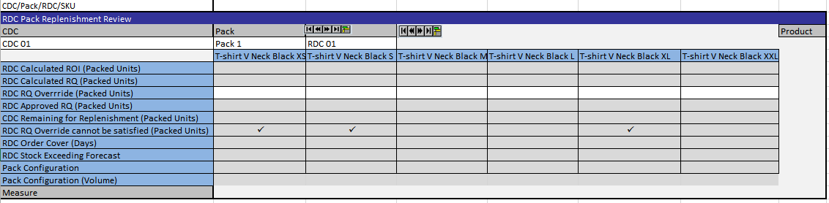
Figure 8-15 RDC Pack Replenishment Review
This worksheet contains the following measures:
- RDC Calculated ROI (Packed Units): this measure displays the ROI of the Calculated Replenishment Quantity for complete packs.
- RDC Calculated RQ (Packed Units): this measure displays the Replenishment quantities for complete packs as calculated by the APX replenishment engine using the parameters also shown in the Replenishment Parameters Worksheet (see Section 10.4.3).
- RDC RQ Override (Packed Units): APX users will be able to enter their overrides for the Calculated Replenishment Quantity for complete packs. APX should then reconcile the overrides with stock on hand for complete packs and create the Approved Replenishment Quantity measure below.
- RDC Approved RQ (Packed Units): As described above, this measure should contain the replenishment quantity for complete packs, after reconciliation.
- CDC Remaining for Replenishment (Packed Units): Stock for complete packs used for replenishment purposes only is shown here.
- RDC RQ Override cannot be satisfied (Packed Units): when RQ Override is non-zero and there is no stock for complete packs left in the immediate supply chain (CDC serving the RDC) to satisfy the requested quantity, this flag will be raised.
- RDC Order Cover (Days): This measure displays the time period in days that Store Net Inventory minus Forecast at Pack-group/DC should cover.
- RDC Stock Exceeding Forecast: This flag will be raised in case the total net inventory of the RDC and the Stores belonging to it exceed Store Time-Phased COQ (Total Units).
- Pack Configuration: this measure displays complex pack configuration details at Pack/Pack Group level. Complex Pack configuration will be part of the incoming PO information.
- Pack Configuration (Volume): this measure will display complex pack configuration volume details at Pack/Pack Group level. Complex Pack configuration will be part of the incoming PO information.

RDC Singles Order Review
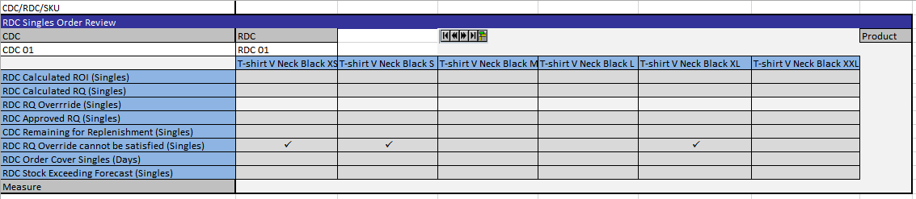
Figure 8-16 RDC Singles Order Review
This worksheet contains the following measures:
- RDC Calculated ROI (Singles): this measure displays the ROI of the Calculated Replenishment Quantity for singles.
- RDC Calculated RQ (Singles): this measure displays the Replenishment quantities for singles as calculated by the APX replenishment engine using the parameters also shown in the Replenishment Parameters Worksheet (see Section 10.4.3).
- RDC RQ Override (Singles): APX users will be able to enter their overrides for the Calculated Replenishment Quantity for singles. APX should then reconcile the overrides with stock on hand for singles and create the Approved Replenishment Quantity measure below.
- RDC Approved RQ (Singles): As described above, this measure should contain the replenishment quantity for singles, after reconciliation.
- CDC Remaining for Replenishment (Singles): Stock for singles used for replenishment purposes only is shown here.
- RQ Override cannot be satisfied (Singles): when RQ Override is non-zero and there is no stock for singles left in the immediate supply chain (CDC serving the RDC) to satisfy the requested quantity, this flag will be raised.
- RDC Order Cover Singles (Days): This measure displays the time period in days that Store Net Inventory minus Forecast at SKU/DC should cover Orders Review.
- RDC Stock Exceeding Forecast (Singles): This flag will be raised in case the total net inventory of the RDC and the Stores belonging to it exceed Store Time-Phased COQ (Total Units).

Orders Review
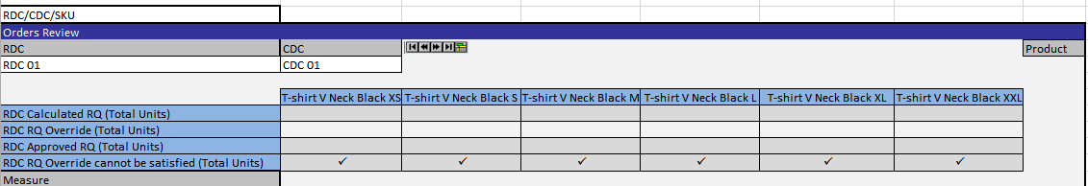
Figure 8-17 Orders Review
This worksheet contains the following measures:
- RDC Calculated RQ (Total Units): this measure displays the Replenishment quantities for both complete packs and singles as calculated by the APX replenishment engine using the parameters also shown in the Replenishment Parameters Worksheet (see Section 10.4.3).
- RDC RQ Override (Total Units): APX users will be able to review their total overrides for the Calculated Replenishment Quantity for both complete packs and singles, as entered in the Pack Order Review and Singles Order Review Worksheets respectively. .
- RDC Approved RQ (Total Units): As described above, this measure should contain the replenishment quantity for both complete packs and singles, after reconciliation. This is the quantity that will be exported to RMS.
- RDC RQ Override cannot be satisfied (Total Units): when RQ Override is non-zero and there is no stock for both complete packs and singles left in the immediate supply chain (CDC serving the RDC) to satisfy the requested quantity, this flag will be raised.

RDC Order Approval Alert
This worksheet enables users to check in which PackGroup/RDC/CDC positions the “Alert RDC Order Approval” measure is triggered for the alerted Pack Group.

RDC/CDC out of Stock Alerts Review
This worksheet contains two measures, for review purposes only:
- Alert RDC Out of Stock: At Store/ConstraintGroup/RDC level, RDC Out of Stock alert compares current inventory at the RDC with store capacity. When the stock level at the RDC falls below a user defined threshold, the user will be notified by the RDC Out of Stock Alert that RDC is potentially running out of stock.
- CDC Out of Stock: At Store/ConstraintGroup/RDC level, CDC Out of Stock alert compares current inventory at the CDC with store capacity. When the stock level at the CDC falls below a user defined threshold, the user will be notified by the CDC Out of Stock Alert that CDC is potentially running out of stock.

CDC Inventory
This worksheet contains CDC stock levels for complete packs at CDC/Pack/PackGroup level, for review purposes by the APX users.
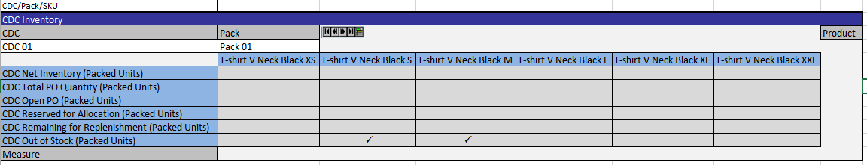
Figure 8-18 CDC Inventory
This worksheet contains the following measures:
- CDC Net Inventory (Packed Units): this measure displays the Inventory levels for complete packs, available to cover need for the next order.
- CDC Total PO Quantity (Packed Units): Total PO quantity for this PackGroup/Pack destined to the primary CDC, at CDC/PackGroup/Pack level.
- CDC Open PO (Packed Units): the total quantity of all open Purchase Orders for the associated PackGroup/Pack.
- CDC Reserved for Allocation (Packed Units): this measure displays stock for complete packs, reserved for Allocation purposes.
- CDC Remaining for Replenishment (Packed Units): likewise, stock for complete packs used for replenishment purposes only is shown here.
- CDC Out of Stock (Packed Units): a flag is raised when CDC is out of stock, considering stock for complete packs used for replenishment purposes only.

Pack Order Approval
This worksheet contains allows users to review approval information and/or approve orders at RDC/Pack/Pack Group level
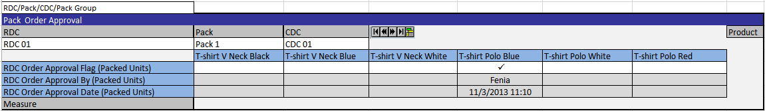
Figure 8-19 Pack Order Approval
This worksheet contains the following measures:
- RDC Order Approval Flag (Packed Units): approved orders for complete packs should have this flag set to true, unless an alert is raised for the order in which case users should check off this cell to release “Approved RQ” (Packed Units) for export to RMS and execution.
- RDC Order Approval By (Packed Units): When Order Approval flag (Packed Units) is checked off, this will store the User Id of that approved the latest Replenishment Quantity (Packed Units).
- RDC Order Approval Date (Packed Units): When Order Approval flag (Packed Units) is checked off, this will store the date and time of approval of the latest Replenishment Quantity (Packed Units).

RDC Pack Replenishment Review
This worksheet contains the same information as outlined in Section 8.2.1.

Replenishment Source Data
This worksheet contains the same information as outlined in Section 7.2.5.

CDC Singles Inventory
This worksheet is exactly symmetrical to CDC Inventory described above, however considering stock and quantities at a SKU level instead of Pack Group/Pack level.

Singles Order Approval
This worksheet is exactly symmetrical to Pack Order Approval described above, however considering orders at a SKU level instead of Pack Group/Pack level.

RDC Singles Order Review
This worksheet is a copy of RDC Singles Order Review Worksheet, described in section 8.2.2.

Replenishment Source Data
This worksheet is a copy of Replenishment Source Date, described in section 8.2.9.

RDC Cover Method/Source CDC 1
This worksheet contains the RDC primary source CDC and the RDC Cover Method at the Pack Group/RDC level.

CDC to RDC Lead Time
This worksheet contains the CDC to RDC Lead Time Logistic Parameter discussed in Section 10.4.2, affecting the APX Calculated Replenishment Quantities at the RDC/Pack Group level.

Cost
This worksheet shows Cost in AED at SKU/Territory level, used in the ROI calculation.
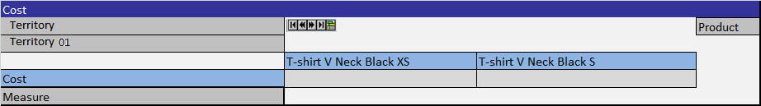
Figure 8-20 Cost

Pack Eligibility
This worksheet contains Pack eligibility information (discussed in Section 10.4.2) at RDC/Pack/Pack Group level. Available packs can be specified at Pack Group/RDC level.
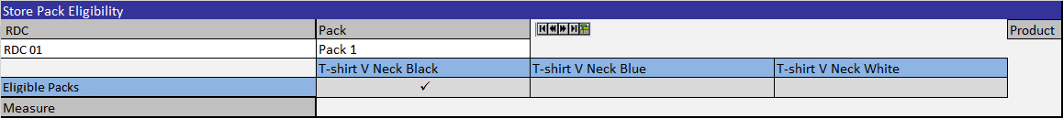
Figure 8-21 Pack Eligibility

Pack Configuration
This worksheet will contain complex pack configuration details at Pack/Pack Group level. Complex Pack configuration will be part of the PO information.
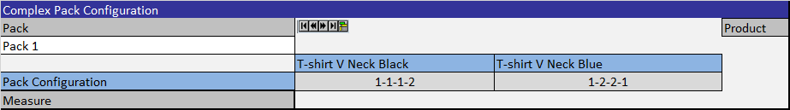
Figure 8-22 Pack Configuration

Calculation Parameters
This worksheet contains parameters controlling the APX Calculated Replenishment Quantities. These parameters as described in Section 8.1.1 above, all defined at the RDC/SKU intersection and are all read-only.

Calculation Results
This worksheet contains the APX replenishment calculation results at alongside Min/Max constraints at SKU/RDC level.
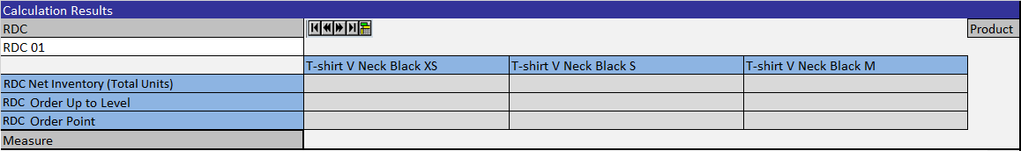
Figure 8-23 Calculation Results
- RDC Net inventory: is the net inventory of the RDC for the SKU, read-only.
- RDC Order Point: is the minimum number of units that is required to be on hand for the item. When the net available inventory falls below the order point, the item is replenished, read-only.
- RDC Order up to level: is the maximum value to which a chosen replenishment method will raise the inventory, read-only.

Store Replenishment Workbook
Landmark business users have also drafted a Store Replenishment Workbook for inclusion in the APX solution. This workbook also makes use of standard APX replenishment functionality, while at the same time adapting the workflow to the overall Landmark workflow.
The workbook contains four tabs (sections) each with several worksheets (windows), as follows:
- Store Replenishment tab, with the following worksheets:
  - Pack Replenishment Review, which allows the users to review ROI and replenishment quantities for complete packs at the RDC/Pack/Store/PackGroup level
  - Singles Order Review, which allows the users to review ROI and replenishment quantities for singles at the RDC/Store/SKU level
  - Order Review, which allows the users to review ROI and replenishment quantities for both complete packs and singles at the RDC/Store/SKU level
  - Store Order Approval Alerts, which allows users to review Store Order Approval Alerts for exceptional items at a Pack Group/Pack/RDC level, with a dual functionality of a warning (to review and resolve) and a stopping (to stop transfer orders) flag
- Store Pack Orders tab, with the following worksheets:
- RDC Inventory, which allows users to review RDC pack stock levels at RDC/Pack/PCGR level
  - Pack Replenishment Review, which allows the users to review ROI and replenishment quantities for complete packs at the RDC/Pack/Store/PCGR level
  - Pack Order Approval, which allows users to review approval information and/or approve orders at Pack/Store/Pack Group level.
  - Calculation Results, which contains the APX replenishment calculation results alongside Min/Max constraints at SKU/Store level
- Replenishment Source Data, which includes low-level input data that are inputs to the replenishment calculation, for review by the users
- Store Singles Orders tab, with the following worksheets:
- RDC Singles Inventory, which allows users to review RDC singles stock levels at RDC/SKU level
  - Singles Order Review, which allows the users to review ROI and replenishment quantities for singles at the RDC/Store/SKU level
  - Singles Order Approval, which allows users to review approval information and/or approve orders at Store/SKU level
  - Calculation Results, which contains the APX replenishment calculation results alongside Min/Max constraints at SKU/Store level
- Replenishment Source Data, which includes low-level input data at Day/SKU/Store that are inputs to the replenishment calculation, for review by the users
- Replenishment Parameters tab, with the following worksheets:
- Logistics Parameters, which contains Logistics parameters affecting the APX Calculated Replenishment Quantities at the Pack Group/Store level
- Pack Eligibility, which contains Pack eligibility information at Store/Pack/Pack Group level
- Pack Configuration, which will contain complex pack configuration details at Pack/Pack Group level
- Calculation Parameters, which includes parameters used by the replenishment methods to calculate the order point and order up to level quantities at SKU/Store level

Pack Replenishment Review
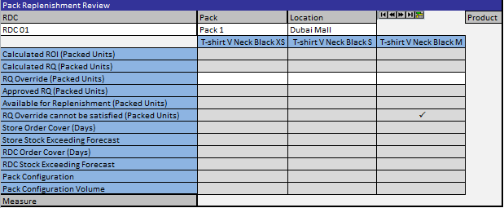
Figure 8-24 Pack Replenishment Review

This worksheet contains the following measures:
- Calculated ROI (Packed Units): this measure displays the calculated ROI as calculated by the APX Replenishment engine at a Pack Group/Store/RDC level.
- Calculated RQ (Packed Units): this measure displays the Replenishment quantities as calculated by the APX replenishment engine using the parameters also shown in the Replenishment Parameters Worksheet (see Section 10.4.3).
- RQ Override (Packed Units): APX users will be able to enter their overrides for the Calculated Replenishment Quantity for complete packs. APX should then reconcile the overrides with stock on hand for packs at the RDC and create the Approved Replenishment Quantity measure below.
- Approved RQ (Packed Units): As described above, this measure should contain the replenishment quantity for complete packs, after reconciliation.
- Available for Replenishment (Packed Units): this measure displays the remaining quantity in packed units that is available for store replenishment at the immediate RDC level.
- RQ Override cannot be satisfied (Packed Units): when RQ Override is non-zero and there is no stock left in the immediate supply chain (RDC serving the Store) to satisfy the requested quantity, this flag will be raised.
- Store Order Cover (Days): This measure displays the number of days that the Replenishment Order Quantity will cover, according to the System estimated Forecast, at Pack Group/Store/RDC level.
- Store Stock Exceeding Forecast: If the Replenishment Order Quantity exceeds the System estimated Forecast for the remaining Forecast Horizon (Basic Items) or the remaining period of the current Season (Fashion/Seasonal Basic Items), this flag will be raised at Pack Group/Store/RDC level.
- RDC Order Cover (Days): This measure displays the number of days that the Replenishment Order Quantity will cover, according to the System estimated Forecast, at Pack Group/RDC level.
- RDC Stock Exceeding Forecast: If the Replenishment Order Quantity exceeds the System estimated Forecast for the remaining Forecast Horizon (Basic Items) or the remaining period of the current Season (Fashion/Seasonal Basic Items), this flag will be raised at Pack Group/RDC level.
- Pack Configuration: This measure will contain a string describing the pack size split, e.g. “1-2-2-1” will describe a 6-unit pack containing 4 sizes with the respective quantities per size. This measure is displayed at Pack Group/Pack level.
- Pack Configuration (Volume): This measure will contain the size of the pack; for the example above this measure will be equal to 6. This measure is displayed at Pack Group/Pack level.

Singles Order Review
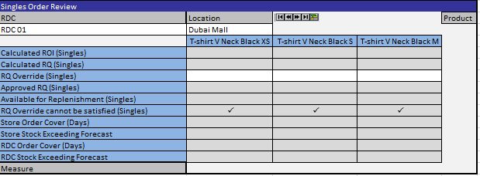
Figure 8-25 Singles Order Review

This worksheet contains the following measures:
- Calculated ROI (Singles): this measure displays the calculated ROI for Singles as calculated by the APX Replenishment engine at a SKU/Store/RDC level.
- Calculated RQ (Singles): this measure displays the Replenishment quantities for singles as calculated by the APX replenishment engine using the parameters also shown in the Replenishment Parameters Worksheet (see Section 10.4.3).
- RQ Override (Singles): APX users will be able to enter their overrides for the Calculated Replenishment Quantity for singles. APX should reconcile the overrides with stock on hand for Singles at the RDC and create the Approved Replenishment Quantity measure below.
- Approved RQ (Singles): As described above, this measure should contain the replenishment quantity for singles, after reconciliation.
- Available for Replenishment (Singles): this measure displays the remaining quantity in singles that is available for store replenishment at the immediate RDC level.
- RQ Override cannot be satisfied (Singles): when RQ Override is non-zero and there is no stock for singles left in the immediate supply chain (RDC serving the Store) to satisfy the requested quantity, this flag will be raised.
- Store Order Cover Singles (Days): This measure displays the number of days that the Replenishment Order Quantity in Singles will cover, according to the System estimated Forecast, at SKU/Store/RDC level.
- Store Stock Exceeding Forecast (Singles): If the Replenishment Order Quantity in Singles exceeds the System estimated Forecast for the remaining Forecast Horizon (Basic Items) or the remaining period of the current Season (Fashion/Seasonal Basic Items), this flag will be raised at SKU/Store/RDC level.
- RDC Order Cover Singles (Days): This measure displays the number of days that the Replenishment Order Quantity in Singles will cover, according to the System estimated Forecast, at SKU/RDC level.
- RDC Stock Exceeding Forecast (Singles): If the Replenishment Order Quantity in Singles exceeds the System estimated Forecast for the remaining Forecast Horizon (Basic Items) or the remaining period of the current Season (Fashion/Seasonal Basic Items), this flag will be raised at SKU/RDC level.

Order Review
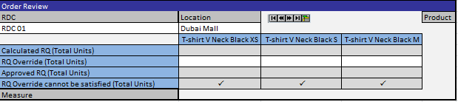
Figure 8-26 Order Review
This worksheet contains the following measures:
- Calculated RQ (Total Units): this measure displays the Replenishment quantities for both complete packs and singles as calculated by the APX replenishment engine using the parameters also shown in the Replenishment Parameters Worksheet (see Section 10.4.3).
- RQ Override (Total Units): APX users will be able to review their overrides for the Calculated Replenishment Quantity for both complete packs and singles. , as entered in the Pack and Singles Order Approval Worksheets mentioned above.
- Approved RQ (Total Units): As described above, this measure should contain the replenishment quantity for both complete packs and singles, after reconciliation. This is the quantity that will be exported to RMS.
- RQ Override cannot be satisfied (Total Units): when RQ Override is non-zero and there is no stock for both complete packs and singles left in the immediate supply chain (RDC serving the Store) to satisfy the requested quantity, this flag will be raised.

Store Order Approval – Alert
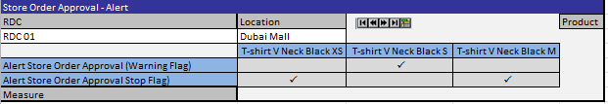
Figure 8-27 Store Order Approval - Alert
This worksheet contains the following measures:
- Alert Store Order Approval (Warning Flag): this measure displays the alert store order approval warning flag, as described in section 9.1
- Alert Store Order Approval (Stop Flag): this measure displays the alert store order approval stop flag, as described in section 9.1

RDC Inventory
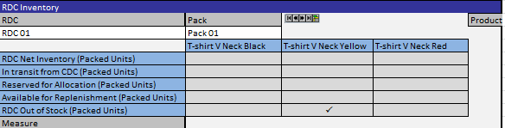
Figure 8-28 RDC Inventory
This worksheet contains the following measures:
- RDC Net Inventory (Packed Units): this measure displays the Inventory levels for complete packs, available to cover need for the next order.
- In transit from CDC (Packed Units): Total in-transit stock to this RDC from its primary CDC.
- Reserved for Allocation (Packed Units): this measure displays stock for complete packs, reserved for Allocation purposes.
- Available for Replenishment (Packed Units): likewise, stock for complete packs used for replenishment purposes only is shown here.
- RDC Out of Stock (Packed Units): set to True when (iv) is zero.

Pack Order Approval
This worksheet is exactly symmetrical to Pack Order Approval described above, instead considering orders at a Store level instead of RDC.
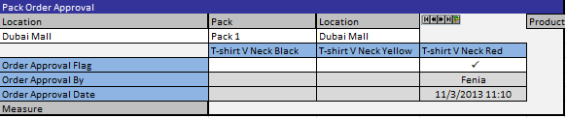
Figure 8-29 Pack Order Approval

Calculation Results
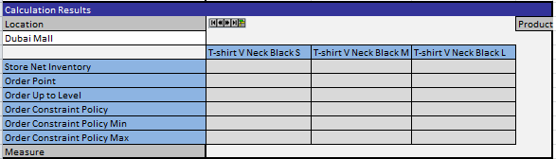
Figure 8-30 Calculation Results
This worksheet contains the following measures:

- Store Net Inventory: the amount of stock available to cover the need for the next order
- Order Point: The minimum number of units you want on hand for the item. When the net available inventory falls below the order point, the item is replenished
- Order up to Level: the amount that the net available inventory should be raised up to.
- Order Constraint Policy: APX users will be able to modify distribution behavior using this setting, which has two allowed values:
  - Min/Max Against distribution quantity: if selected, then (ii) = Max((ii),(i)+(v)) and (iii)=Min((iii),(i)+(vi))
  - Min/Max Against to-be-inventory: if selected, then (ii) = Max((ii),(v)) and (iii)=Min((iii),(vi))
- Order Constraint Policy Min: the Min quantity used in (iv)
- Order Constraint Policy Max: the Max quantity used in (iv)

RDC Singles Inventory
This worksheet is exactly symmetrical to RDC Singles Inventory described above, instead considering stock at a SKU level instead of PackGroup/Pack.
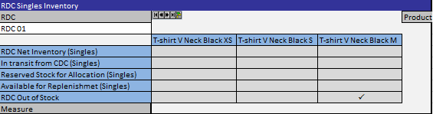
Figure 8-31 RDC Singles Inventory

Singles Order Approval
This worksheet is exactly symmetrical to Singles Order Approval described above, instead considering orders at a Store level instead of RDC.
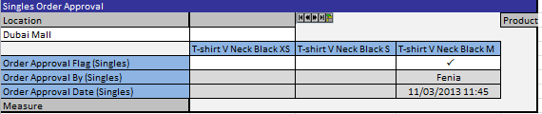
Figure 8-32 Singles Order Approval

Logistic Parameters
This worksheet will display a set of Logistic Parameters at a Pack Group/Store level, as described in section 10.4.2, that will affect the APX Replenishment Engine results.
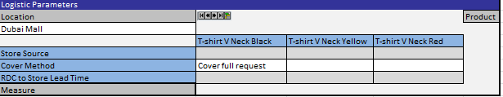
Figure 8-33 Logistic Parameters

Pack Eligibility
This worksheet is exactly symmetrical to Pack Eligibility described above, instead considering pack eligibility at a Store level instead of RDC.
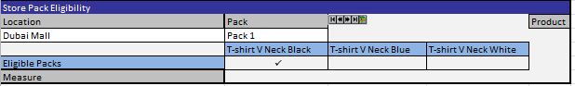
Figure 8-34 Pack Eligibility

Pack Configuration
This worksheet is exactly symmetrical to Pack Configuration described above.
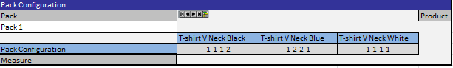
Figure 8-35 Pack Configuration

Replenishment Source Data
This worksheet is exactly symmetrical to Replenishment Source Data described above, instead considering data at a Store level instead of RDC.
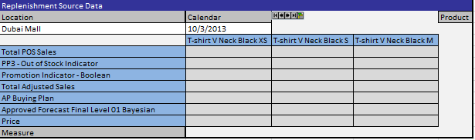
Figure 8-36 Replenishment Source Data

Calculation Parameters
This worksheet is exactly symmetrical to Calculation Parameters described above, instead considering parameters at a Store level instead of RDC.
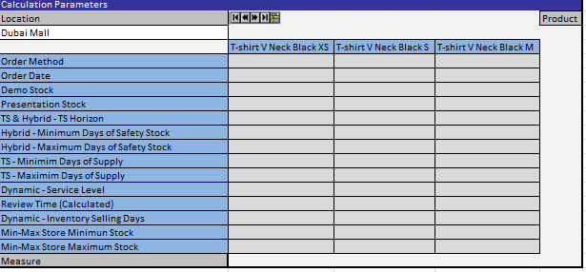
Figure 8-37 Calculation Parameters

In Season Review
During CPR Functional Design, Landmark described certain misallocation conditions with their associated risks and discussed the possibility of mitigating such risks. In particular, Landmark expressed the necessity to mitigate the risks of Fast and/or Slow selling fashion items after Item launch, as well as fast selling basic items.
In case of Fast Selling, Landmark requires that business users should be able to review the related alert at RDC/Option and make the necessary adjustments, either re-buying based on a PO Recommendation done using APX functionality, or planning their next assortment. The Slow Selling case is exactly symmetrical with Fast Selling, only considering the possibility of slow instead of fast selling. What-if scenarios based on Markdown timing and/or depth, to improve the Item’s Sell out Date will be available to accommodate this requirement. Basics out of stock alert will be also available for fast selling basic items, with functionality symmetrical to that of the fast option alert, the only difference being that forecast horizon will be used in calculations instead of product lifecycle, which is not defined for basic items.To this end, Landmark described a draft representation of how that process should be reflected within the APX workbooks of CPR. Landmark business users have drafted an In Season Review Workbook for inclusion in the APX solution. This workbook makes use of standard APX functionality, while at the same time adapting the workflow to the overall Landmark workflow.
The workbook, as drafted, contains one tab (Section) with several worksheets (windows), as follows:
- In-Season Review tab, with the following worksheets:
  - RDC Parameters, which allows the users to review trading activity at RDC/SKU level and stock levels in the extended supply chain for that particular SKU/RDC, Exit and Sell Out dates, and specify a cover horizon to include in the PO Recommendation.
  - Over/Under Stock Review, which allows the users to review the level of over/under allocated quantity (units), for each SKU/STR combination.
  - RDC Target Date Validation, which allows the users to review the RDC target date, defined as the last date that the stock needs to reach the RDC, in order to prevent under stock in the corresponding stores.
  - CDC Target Date Validation, which allows the users to review the CDC target date, defined as the last date that the stock needs to reach the CDC, in order to prevent under stock in the corresponding stores.
  - Store Parameters, which allows the users to review low-level input data that are inputs to the replenishment calculation, modify the timing and/or depth of Markdowns and review the updated What-if Forecast.
  - PO Recommendation which allows users to review the PO Recommendation that was based on the under allocated quantity for the cover horizon as described above..
  - PO Recommendation Alerts Review, which allows users to check whether the related alerts (fast/slow option, stock level monitoring), have been triggered for a particular RDC/Option combination.

RDC Parameters
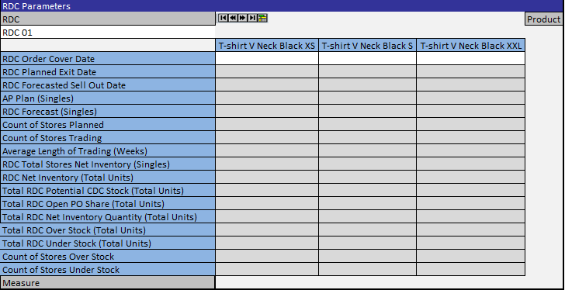
Figure 8-38 RDC Parameters

This worksheet contains the following measures:
- RDC Order Cover Date: this measure displays the end date of the time period that the total RDC stock quantity should cover.
- RDC Planned Exit Date: this measure displays the AP Planned Exit Date.
- RDC Forecasted Sell Out Date: this measure displays the Forecasted Sell Out Date, based on the total RDC stock quantity for the item’s cover horizon..
- AP Plan (Singles): this measure displays the AP Buy Plan at RDC/SKU level.
- RDC Forecast (Singles): this measure displays the Total Forecast at RDC/SKU level.
- Count of Stores Planned: the number of stores planned at RDC/SKU level since season start.
- Count of Stores Trading: the number of stores trading at RDC/SKU level since season start.
- Average Length of Trading (weeks): the average length (in weeks) of the stores trading since season start, at RDC/SKU level.
- RDC Total Stores Net Inventory (Singles): the sum of the net inventory (at SKU level) of all stores under the RDC.
- RDC Net Inventory (Total Units): the available RDC stock to cover the next order, at RDC/SKU level.
- Total RDC Potential CDC Stock (Total Units): the CDC stock share at SKU/RDC level, meaning the amount of CDC stock on hand that is expected for that specific SKU/RDC.
- Total RDC Open PO Share (Total Units): the total quantity of all open Purchase Orders for the associated SKUs, calculated as a sum of open Purchase Orders at the current RDC level plus the amount of all CDC open Purchase Orders that is expected for that specific SKU/RDC.
- Total RDC Net Inventory Quantity: The total available RDC stock to cover the next order, at RDC/SKU level. Approximated by the sum of RDC Net Inventory, RDC Total Stores Net Inventory, Total RDC Open PO Share and Total RDC Potential CDC Stock.
- Total RDC Over Stock: the total over allocated quantity for the associated SKU/RDC.
- Total RDC Under Stock: the total under allocated quantity for the associated SKU/RDC.
- Count of Stores Over Stock: the number of over allocated stores, until Order Cover Date.
- Count of Stores Under Stock: the number of under allocated stores, until Order Cover Date.

Over/Under Stock Review
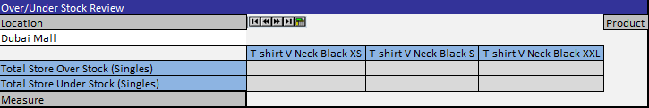
Figure 8-39: Over/Under Stock Review

This worksheet contains information on over/under allocated stock quantities at SKU/STR level. This worksheet contains the following measures:
- Total Store Over Stock (Singles): the total over allocated quantity for the associated SKU/Store.
- Total Store Under Stock (Singles): the total under allocated quantity for the associated SKU/Store.

RDC Target Date Validation
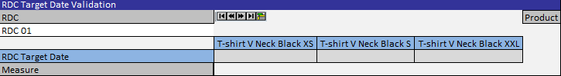
Figure 8-40: RDC Target Date Validation

This worksheet contains a single measure, RDC Target Date, which shows the last date for the stock to reach an RDC for a particular SKU, in order to prevent stock outages in the stores served by this RDC.

CDC Target Date Validation
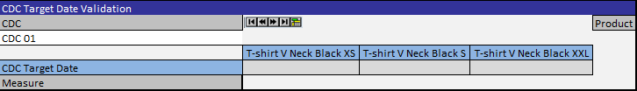
Figure 8-41: CDC Target Date Validation

This worksheet contains a single measure, CDC Target Date, which shows the last date for the stock to reach a CDC for a particular SKU, in order to prevent stock outages in the stores served by this CDC.

Store Parameters
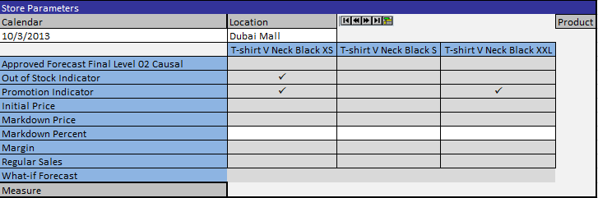
Figure 8-42 Store Parameters
This worksheet contains low-level input data at Week/SKU/Store that are inputs to the replenishment calculation, a writable Markdown Percent measure allowing business users to modify the timing and/or depth of Markdowns and review the updated What-if Forecast.
- Approved Forecast: The approved RDF forecast, read-only.
- Out Of Stock Indicator: Indicates an outage of stock, read-only.
- Promotion Indicator: Indicates a promotion, read-only.
- Initial Price: The item price at retail, read–only.
- Markdown Price: The item price at markdown, performed on the fly, within the Workbook, read–only.
- Markdown Percent: The markdown percent, chosen on the fly within the Workbook, writable. By changing this value, users can see the markdown price and margin calculation and the effect of price on the forecast in the What-if Forecast measure.
- Margin: The price margin, read-only.
- Regular Sales: The real regular sales, read-only.
- What-if Forecast: The calculated what-if forecast, read-only real, calculated by the Promotional Self Lift Forecast Special Expression.

PO Recommendation
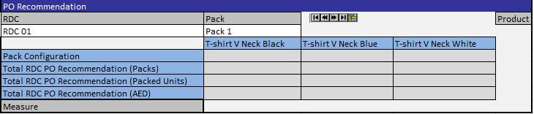
Figure 8-43: PO Recommendation
This worksheet contains the following measures:
- Pack Configuration: This measure will contain a string describing the pack size split, e.g. “1-2-2-1” will describe a 6-unit pack containing 4 sizes with the respective quantities per size.
- Total RDC PO Recommendation (Packs): This measure will contain the PO Recommended Quantity, in Packs, at RDC/Pack/PackGroup level.
- Total RDC PO Recommendation (Packed Units): This measure will contain the PO Recommended Quantity, in Total Units, at RDC/Pack/PackGroup level.
- Total RDC PO Recommendation (AED): This measure will contain the cost of the PO Recommended Quantity, in AED, at RDC/Pack/PackGroup level.

In-Season Review Alerts

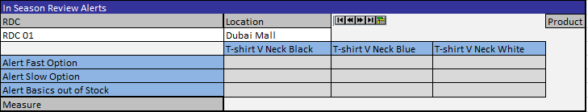
Figure 8-44: In Season Review Alerts
This worksheet will contain all three Alert Indicators related to In-Season Review workbook (Fast Option, Slow Option, Basics out of Stock) at Option/RDC level, available for review purposes.

Stock Flows
In the APX process the stock flows that will be handled are (Figure 8-45 Stock Flows):
- from the Supplier to the CDC
- from the Supplier to the RDC
- from the CDC to the RDC
- from the Secondary CDC to the RDC
- from the Tertiary CDC to the RDC
- from the RDC to the store
- from the store to the RDC

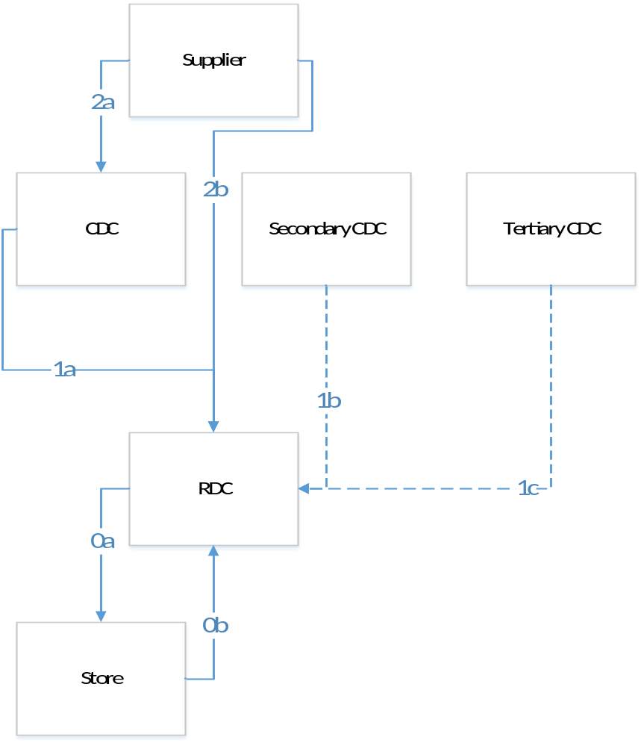
Figure 8-45 Stock Flows

Supplier to CDC (2.a)
The supplier will send to the CDCs the pre-allocated and crossed-docked stock, the held back allocation stock for new stores and the replenishment stock.

Pre-allocated and cross-docked stock (out of scope)
The PO in-Transit quantities in RMS from the Supplier to the CDC include the quantities that will cross-dock to the RDCs. This quantity will be ignored by APX as SOH and when shipped to RDC. The PO in-Transit quantities in ER from the Supplier to the CDC define separately the quantity that will be kept in the CDC, and the Allocation quantities that will cross-dock to the RDCs.

Held back allocation stock for new stores at CDC
According to the Initial Allocation process of APX a percentage of the PO quantity received in the CDC will be held back as allocation stock for the new stores that will open. The held back allocation stock will be kept in the CDC,
- Until the new stores are able to receive. The held back allocation stock will be shipped via separate Allocation Order.
Or
- Until these quantities are released and become available for replenishment to existing stores. The quantities will be added to the replenishment stock of the CDC and processed normally.

Replenishment
According to the Replenishment process of APX a percentage of the PO quantity received in the CDC by the suppliers could be used for replenishment. The replenishment stock will be split among the RDCs served by each CDC based on the need of the corresponding stores.

Supplier to RDC (2.b)
The supplier will send to the RDCs allocation stock for existing and new stores and replenishment stock.

Allocation for existing stores
According to the Initial Allocation process of APX a percentage of the PO quantity received in the RDC will be sent as allocation stock to the existing stores.

Allocation for new stores from RDC
According to the Initial Allocation process of APX a percentage of the PO quantity received in the RDC will be held back as allocation stock for the new stores that will open. The held back allocation stock will be kept in the RDC,
- Until the new stores are able to receive. The held back allocation stock will be shipped via separate, manual Allocation Order.
Or
- Until these quantities are released and become available for replenishment to existing stores.

Replenishment
According to the Replenishment process of APX a percentage of the PO quantity received in the RDC by the suppliers will be used for replenishment. The replenishment stock will be split among the stores served by the RDC based on their ROIs.

CDC to RDC (1.a)
The CDC will send to the RDC either released allocation stock for new stores, or replenishment stock.

Released allocation for new stores
According to the Initial Allocation process of APX a percentage of the PO quantity received in the CDC will be sent as allocation stock to new stores. When the new stores are ready to receive, the Held back allocation stock will be released from the CDC and sent to corresponding RDCs of the new stores. This stock will be sent via the regular transfer order process, but will be added to the Reserved for Allocation stock of the RDCs.

Replenishment
The replenishment stock during the Replenishment process of APX will be split among the RDCs served by each CDC based on the need of the corresponding stores. This stock will be sent from the CDCs to the RDCs as replenishment stock.

Secondary CDC to RDC (1.b)
Only replenishment stock will be transferred from the secondary CDC to the RDC. During the replenishment process, if a SKU is out-of-stock in a store, in the corresponding RDC, and in the primary CDC of the RDC, while in the secondary CDC of the RDC this SKU is available in any pack, the best-fit pack will be first transferred from the secondary CDC to the corresponding RDC of the store for this SKU.

Tertiary CDC to RDC (1.c)
Replenishment stock can be transferred by the tertiary CDC to the RDC. During the replenishment process, if a SKU is out-of-stock in a store, in the corresponding RDC and in the primary and secondary CDCs of the RDC, while in the tertiary CDC of the RDC this SKU is available in any pack, the best-fit pack will be first transferred from the tertiary CDC to the corresponding RDC of the store for this SKU.

RDC to store (0.a)
The stores can receive from the RDC allocation and replenishment stock.

Allocation
According to the Initial Allocation process of APX a percentage of the PO quantity received in the RDC will be sent as allocation stock to existing stores via the Allocation Order mechanism.

Replenishment
The replenishment stock during the Replenishment process will be split among the stores served by each RDC based on their ROIs and sent to the stores as Replenishment stock via the Transfer Order mechanism.

Store to RDC (0.b)
The singles that are returned to the RDCs from the stores will be added to the Replenishment stock of the RDCs. APX will see this as a correction on the SOH quantities of the stores and their respective RDC.

Requirements and Decisions

Log # | Description
11 | When the CDC and RDC stock is exhausted, a request for an order will be recommended
18 | Fallback scenario: when the DC stock for a pack group is exhausted, a secondary and a tertiary DC should be defined
63 | If a SKU is out-of-stock in a store and in the corresponding RDC:  1. if the primary CDC for the RDC has pack availability, the pack is first transferred to the corresponding RDC of the store for this pack and then to the store.  2. If in the primary CDC the pack is out of stock and in the secondary CDC of the RDC this pack is available, the pack is first transferred to the corresponding RDC of the store for this pack and then to the store.  3. If the secondary CDC for the RDC is out of stock and in the tertiary CDC for the RDC this pack is available, the pack is first transferred to the corresponding RDC of the store for this pack and then to the store.  (See Stock Transition sheet)
64 | The stock flows between the levels are:  - Supplier > CDC  - Supplier > RDC  - CDC > RDC  - RDC > Store  No other flows will be handled by the system.  (See Stock Transition sheet)
66 | Singles stock appears in all levels up to PO
93 | The CDC and RDC need calculation in Pre-Distribution step will be estimated in units/$
169 | Margin needs to show when the price is changed as a what-if in the Store Replenishment Workbook
213 | Customer orders are out of APX scope
269 | Cover Method should be in replenishment Parameters Management WB only
307 | Projected exit date in the RDC should be available in the Replenishment process
310 | Profit in AED for ROQ and AOQ from CDC to RDC
335 | Replenishment parameters will be set at SKU/Store, default for Subclass/Store
342 | Shoe Mart-Shoe Express: A flag should be available at replenishment parameters to indicate that replenishment can only be done in singles
507 | Add "CDC Total PO Quantity" to the RDC Replenishment WB
537 | Store Order Cover (Store Replenishment): Should compare Store NI vs forecast at Pack-group/Store/DC
538 | RDC Cover should be added in Store Replenishment: compare RDC NI + Sum of Store NI vs the aggregated store demand stream (simulation)
539 | Add RDC cover in RDC replenishment calculated with two different RDC NI: as-is and after AOQ is received. In both cases it should compare RDC NI against the aggregated store demand stream (simulation)
408 | When the Approved Order quantity is less than the Alert threshold for Tier 1, and the new calculated OQ in the batch is higher but still less than the threshold, the new OQ should be sent
456 | Store Replenishment: default replenishment method should be hybrid.
460 | Store Replenishment: round to the nearest pack up
461 | Store Replenishment. Add PQD to Pack Order Review to include only products with RDC Stock on Hand
462 | Store Replenishment: RQ Override Units to be prefilled, then editable and manually approved (Initially RDC RQ Override to be set equal to RDC Calculated RQ).
463 | Store Replenishment: Change Pack Order Review label to Pack Replenishment Review.
464 | Store/RDC Replenishment: Move Replenishment Source Data WS to Store Pack/Singles Order Tab
465 | Store Replenishment: Add Calculated ROI (Packed Units) to Store Pack Order Review WS. Remove Approved ROI from RDC Replenishment.
466 | Add Stock in transit for packs and singles to Store Replenishment and Open PO Quantities to RDC Replenishment.
470 | Add forward cover in days (at Option/Store level) based on system forecast and Net Inventory, to Pack Order Review.
472 | PO Rec: Change measure labels: Potential Warehouse stock -> Potential CDC stock, Promotion variable price -> Price.
473 | PO Rec: Include count of stores planned in RDC Parameters.
474 | Parameter setting for PO (calendar horizon) and alert to be set separately.
488 | Change price by percentage. (Add markdown percentage measure and change price according to that.)
490 | Add both original price and markdown price to Store Parameters.
477 | In Replenishment WB show pack configuration as text and volume, as in Initial Allocation.
513 | Show over/under stock per Option/Store in the PO Rec WB
514 | Show count of over- and under-stocked Stores under each RDC in the PO Rec WB
515 | Add a Total NI quantity per RDC in the WB: Store NI + RDC NI + CDC OH split
517 | Add RDC and CDC Target dates in the PO Rec WB: latest date for the stock to reach the RDC/CDC in order to prevent any stock outages
518 | Add Margin ( (price-cost)/price) at the Option/Store/Week level in the WB, using Cost 2
519 | Split the PO Rec WB into two versions: Central and Territory: the latter should not contain the Margin measure or the PO value measure
556 | Replenishment Parameters WB: Replenishment parameters should be at sku/store level.
557 | Set up Allocation Start Date as Parameter (writable).

Assumptions

Log # | Description
8 | Flowback from the stores are 10% of the total product quantity
9 | Returns of the costumers are very few
53 | In CFS the packing of the products does not change , CFS just forwards them to the CDCs and the RDCs
65 | One style can be provided by multiple Suppliers
96 | Returns of store stock to the DCs are grouped in cartons at department level (Max). The cartons will be added to DCs stock. The replenishment of these cartons will not be handled by APX
97 | Replenishment Parameter data is available (Min, Max are common, Cut-off at subclass store level) and will be provided to Veltio to initialize the system. The source system should be identified (probably excel)
103 | The RDC receives packs and break them down into singles that are sent to the stores
67 | Transfers between countries will only be done manually and do not need to be handled in the system
68 | At the moment:  - Stock hold in CDC less than 10%  - Stock hold in RDC 30% - 40%  - Stock in Store 50% - 60%
69 | No store to store transfers need to be handled in the system
70 | The single left overs of pack Orders from the Supplier are sent to LMG as separate PO
71 | Single Pos will not be sent to multiple Suppliers
74 | PO shipped flag is available in ER. It comes to RMS from the SCP (from RMS to the ER)
75 | There are 2-3 drops within the lifecycle of the product
77 | The PO is not considered official until it is entered in RMS
83 | CDC>RDC 7 days  RDC>stores 2-7 days
84 | For each RDC there is a primary CDC per category  A secondary CDC and a tertiary CDC exists for some RDCs.  This information is available in RMS-not updated frequently (yearly)
85 | PO header info is: supplier, earliest and latest Shipment Date, Receipt Status  Not available: Shipping Method, Freight Forward Date, Expected Receipt Date
105 | Stock on hand based on hard count should be provided to the system at all Tiers.
257 | The sourcing from CDC to RDC is at pack group/RDC level.  The sourcing from RDC to store is at pack group/store level.  For those concepts that work with SKUs pack groups will be SKUs.
134 | The customer orders (special pull requests) will not be handled by APX
136 | Non tradable products do not need to be handled by APX
207 | The CDC Inventory should be provided at a standard cut-off every day
226 | APX will not handle BOL (Bill on Landing)
237 | Splash has Purchase Orders with products from different Departments within the same Group
454 | LMI probably has shared CDC/s for concepts.
476 | Currently, Interface List includes Total PO Quantity. A separate feed including Open PO quantity (meaning not yet received) will be added to Interface List.
494 | In small territories, stock is directly replenished from CDC to Stores (LMI).
524 | Replenishment orders will get executed by WMS in 24 hours; if they are not, APX will re-consider the quantity for future orders.
563 | Prerequisites for UAT stock transitions  - 1 Department (confirmed by business)  - LMI/Jebel Ali CDC serving 3 territories (UAE, Bahrain, Qatar)  - 5 concepts (Max, Splash, Shoemart,ShoeExpress,LifeStyle)  - LMI CDC secondary for Shoemart
564 | Currently CDC keeps 5-10% of stock. Mainly CDC stock cross docked to RDCs.

Alerts
APX will make use of the following Alerts to allow users to focus attention on certain conditions based on rules that will be defined in this Section.
A workbook will be developed, Alert Parameter Maintenance, which will enable customizing the values associated with the alerts, such as thresholds.
Detailed here are the alerting conditions, as well as the name of each alert.

Store Order Approval

Alert 1 | Fashion and Seasonal Basics | Basics
Description | The Calculated Replenishment Transfer Order quantity divided by the Planned Allocated quantity will be compared with a threshold T1. | The Calculated Replenishment Transfer Order quantity will be compared with a threshold T2.
Formula | Calculated Replenishment OQ/Planned AQ> T1% | Calculated Replenishment OQ> T2
Level | Option/Store/RDC
Default Parameters Level | Subclass/Territory
Override Parameters Level | Option/Store
Frequency | Daily (Stop alert will be stopped on non-working days)
Action | If the Replenishment Quantity raises an alert, only the quantity up to the threshold should be sent until X number of days in a row of the raised alert. After X days the transfer orders will be stopped.

RDC Order Approval

Alert 2 | Fashion and Seasonal Basics | Basics
Description | The Approved Replenishment Transfer Order quantity is zero  AND  The Calculated Replenishment Transfer Order quantity over the sum of the units that have been sold at stores corresponding to the RDC + the NI in the RDC + the NI in stores + CDC NI Share of the RDC + RDC Open PO quantities + CDC Open PO Share of the RDC is compared with a threshold T%. | The Approved Replenishment Transfer Order quantity is zero  AND  The Calculated Replenishment Transfer Order is compared with the sum of threshold T2 of "Store Order Approval" alert at Option/RDC level multiplied with an X%.
Formula | Approved Replenishment OQ = 0  AND  [Calculated Replenishment OQ/(Sales Sum + Store NI + RDC NI + CDC NI Share of the RDC + RDC Open PO Quantity + CDC Open PO Share of the RDC)] >T% | Approved Replenishment OQ = 0  AND  Replenishment OQ > [Sum(T2 of Store Order Approval)_RDC/Option] * X%
Level | Option/RDC/CDC
Default Parameters Level | Subclass/RDC
Override Parameters Level | Option/RDC
Frequency | Daily
Action | The Transfer Orders will be stopped.

Fast Option

Alert 3 | Fashion and Seasonal Basics | Basics
Description | For Seasonal & Fashion items the sum of the forecast until the end of the plan after X weeks of sales divided by the sum of the Net Inventory in Stores, the Net Inventory in the RDC, the CDC Net Inventory Share of the RDC, the RDC Open PO quantities and the CDC Share of the Open PO quantities of the RDC will be compared with a threshold T%. | NA
Formula | [Sum (Forecast till the plan end)/Sum(Store NI + RDC NI + CDC NI Share of RDC + RDC Open PO Quantity + CDC Open PO Share of the RDC)]_after X weeks of sales > T% | NA
Level | Option/RDC
Default Parameters Level | Subclass/RDC
Override Parameters Level | Option/RDC
Frequency | Once per Week
Action | Review

Slow Option

Alert 4 | Fashion and Seasonal Basics | Basics
Description | For Seasonal & Fashion items the sum of the forecast until the end of the plan after X weeks of sales divided by the sum of the Net Inventory in Stores, the Net Inventory in the RDC, the CDC Net Inventory Share of the RDC, the RDC Open PO quantities and the CDC Share of the Open PO quantities of the RDC will be compared with a threshold T%. | NA
Formula | [Sum (Forecast till the plan end)/Sum(Store NI + RDC NI + CDC NI Share of RDC + RDC Open PO Quantity + CDC Open PO Share of the RDC)]_after X weeks of sales < T% | NA
Level | Option/RDC
Default Parameters Level | Subclass/RDC
Override Parameters Level | Option/RDC
Frequency | Once per Week
Action | Review

Late Receipt At RDC

Alert 5 | Fashion and Seasonal Basics | Basics
Description | N weeks before launch if the Net Inventory of the RDC is less than the total to-be allocated quantities for existing stores and delayed stores with stock held back at RDC, an alert will be raised. | NA
Formula | (RDC NI < Total RDC To-Be Allocated Quantities)_X weeks before the On Sale Date | NA
Level | Option/RDC
Default Parameters Level | Subclass/RDC
Override Parameters Level | Option/RDC
Frequency | Daily
Action | Review

New Item

Alert 7 | Fashion and Seasonal Basics | Basics
Description | If there is a new Item with no Sales history and no forecast across the Concept, an alert will be raised.
Formula | Sales of the Option = 0 & Forecast of the Option = 0
Level | Option
Default Parameters Level | NA
Override Parameters Level | NA
Frequency | Weekly
Action | Review

New Store

Alert 8 | Fashion and Seasonal Basics | Basics
Description | If a new store is introduced, an alert should be raised to inform the user.
Formula | NA
Level | Store
Default Parameters Level | NA
Override Parameters Level | NA
Frequency | Weekly
Action | Review

High Forecast For Basics

Alert 9 | Fashion and Seasonal Basics | Basics
Description | NA | Sum of the System Forecast for next X weeks over Last Year Sales for the same X weeks will be compared with a threshold
Formula | NA | Sum(System Forecast for next X weeks)/Sum(Sales LY for same X weeks) > T%
Level | Option/Store
Default Parameters Level | Subclass/Territory
Override Parameters Level | Option/Store
Frequency | Weekly
Action | Review

CDC Out Of Stock

Alert 10 | Fashion and Seasonal Basics | Basics
Description | Per Constraint Group the sum of the Net Inventory of a store plus the RDC Net Inventory Share of this store plus the CDC Net Inventory Share of the store plus the CDC and RDC Total Open PO Quantities Share of the store divided by the store capacity per Constraint Group will be compared with a threshold.
Formula | [Sum(NI of store + RDC NI Share of store + CDC NI Share of store + CDC and RDC Total Open PO Quantities Share of store)_ConstraintGroup/(Total Store Constraint Capacity)_ConstraintGroup] < T%
Level | Store/ConstraintGroup
Default Parameters Level | Store/ConstraintGroup
Override Parameters Level | NA
Frequency | Daily
Action | Review

RDC Out of Stock

Alert 11 | Fashion and Seasonal Basics | Basics
Description | Per Constraint Group the sum of the Net Inventory of a store plus the RDC Net Inventory Share of this store plus the RDC Total Open PO Quantities Share of the store divided by the store capacity per Constraint Group will be compared with a threshold  AND  Alert "CDC out of stock" has not been triggered.
Formula | [Sum(NI of store + RDC NI Share of store + RDC Total Open PO Quantities Share of store)_ConstraintGroup/(Total Store Constraint Capacity)_ConstraintGroup] < T%
Level | Store/ConstraintGroup
Default Parameters Level | Store/ConstraintGroup
Override Parameters Level | NA
Frequency | Daily
Action | Review

New Allocation Required

Alert 12 | Fashion and Seasonal Basics | Basics
Description | Per Constraint Group if the sum of the Store Net inventory plus the RDC Replenishment OH Store Share for SKUs where the total to-be allocated quantities is zero divided by the total store capacity of the Constraint Group  is lower than a threshold  AND  The sum of the total to-be allocated quantities at the RDC is more than 0  AND  Alert "CDC out of stock" has not been triggered  AND  Alert "RDC out of stock" has not been triggered, an alert will be raised.
Formula | [Sum(Store Net Inventory + Store Share of RDC Replenishment OH for SKUs where Allocation=0)_ConstraintGroup/(Total Store Constraint Capacity)_ConstraintGroup] < T%  AND  (Total RDC To-Be Allocated Quantities) > 0
Level | Store/ConstraintGroup
Default Parameters Level | Store/ConstraintGroup
Override Parameters Level | NA
Frequency | Daily
Action | Review

Basics Out Of Stock

Alert 13 | Fashion and Seasonal Basics | Basics
Description | NA | The sum of the Net Inventory of stores plus the Net Inventory of the RDC plus the CDC Net Inventory Share of the RDC plus the Open PO Quantity of the RDC plus the CDC Open PO Quantity Share of the RDC will be compared with the sum of the forecast for the next X weeks
Formula | NA | (Net Inventory of stores + RDC Net Inventory + CDC Net Inventory Share of the RDC + RDC Open PO Quantity + CDC Open PO Quantity Share of the RDC) < Sum (Forecast)_for X weeks
Level | Option/RDC
Default Parameters Level | Subclass/RDC
Override Parameters Level | Option/RDC
Frequency | Weekly
Action | Review

Allocation Held Back Stock

Alert 14 | Fashion and Seasonal Basics | Basics
Description | The number of weeks that the Total RDC or CDC Allocation Stock at store level is held back will be compared with a user defined threshold, which will be given as a percentage in weeks of the product's lifecycle. | NA
Formula | (Store delayed) & (Today > X percent (weeks) of product's lifecycle) & Stock Reserved for Allocation at RDC or CDC > 0 | NA
Level | Option/Store
Default Parameters Level | Subclass/Territory
Override Parameters Level | Option/Store
Frequency | Weekly
Action | Review

Requirements and Decisions

Log # | Description
157 | If there is a new Item with no Sales history, no forecast or Buy Plan across concept, an alert will be raised. If a new store is introduced an alert should be raised to inform the user.
192 | An alert should be raised that informs that we are running out of stock. The promotional forecast should be checked in order to meet the planners expectations > Covered by Fast Alert
274 | When a PO is cancelled and the initial allocation is cancelled automatically, an alert is not needed
280 | The projected Lifecycle versus the distributed stock should be compared and trigger an alert > covered by Fast and Slow Option alerts
289 | 3weeks before launch if the received quantity is less than the initial allocation quantity, maybe an alert should be raised
306 | An alert should be raised that takes into consideration the capacity constraints of stores for the orders > covered by "CDC out of stock", "RDC out of stock" and "New Allocation required" alerts
315 | "Alerts" Sheet
471 | Basics out of Stock alert at option/RDC. Need to be able to see at RDC.
486 | Description: In initial allocation, if stock is held back for delayed stores (either at CDC or RDC) for more than X percent (weeks) of the product's lifecycle, raise an alert.  Formula: (Store delayed) & (Today > X percent (weeks) of product's lifecycle) & Stock Reserved at RDC or CDC  Level: PCGR/Store  Frequency: Daily  Parameters Level: PCGR/RDC
512 | Add Open PO Quantity to the Alert 2 calculation
536 | Store Order Approval Alert will be stopped on non-working days
549 | Alert 10  - Add Open PO Quantity  - Use RDC NI instead of OH
550 | Alert 11  - Add Open PO Quantity  - Use RDC NI instead of OH
551 | Alert 12  - Do not add Open PO Quantity
552 | Alert 13  - Add Open PO Quantity
553 | Alert 14  - Frequency: Weekly

Workflow
The CPR workflow can be divided across the two main modules included in the solution, i.e. Oracle Retail Demand Forecasting (RDF) and Veltio Allocation, Packing and Execution (APX). Thus, the overall process includes two main sub-processes: the Demand Forecasting process (10.1) and the Allocation and Replenishment process (10.2). The partitioning level and the workbooks that will appear in the local and master domains are described in Section 10.3. The parameters settings are specified in Section 10.4.

Demand Forecasting process
For the forecast approval workflow, actions can be split across the IT/Batch group, which for Landmark will be LMIT, the Forecasters and the Power Users. Each role will have different responsibilities within every step as described in Figure 10-46. The detailed description each step of the Forecasting process workflow is available in the Oracle Retail Demand Forecasting User Guide. In addition to the base Oracle functionality, CPR will also contain custom workbooks:
- The Forecasting and the Preprocessing parameters will be defined in detail in the CPR Configuration Specification Document (CSD).
- Alerts Parameters as defined by Landmark are described in Section 9.
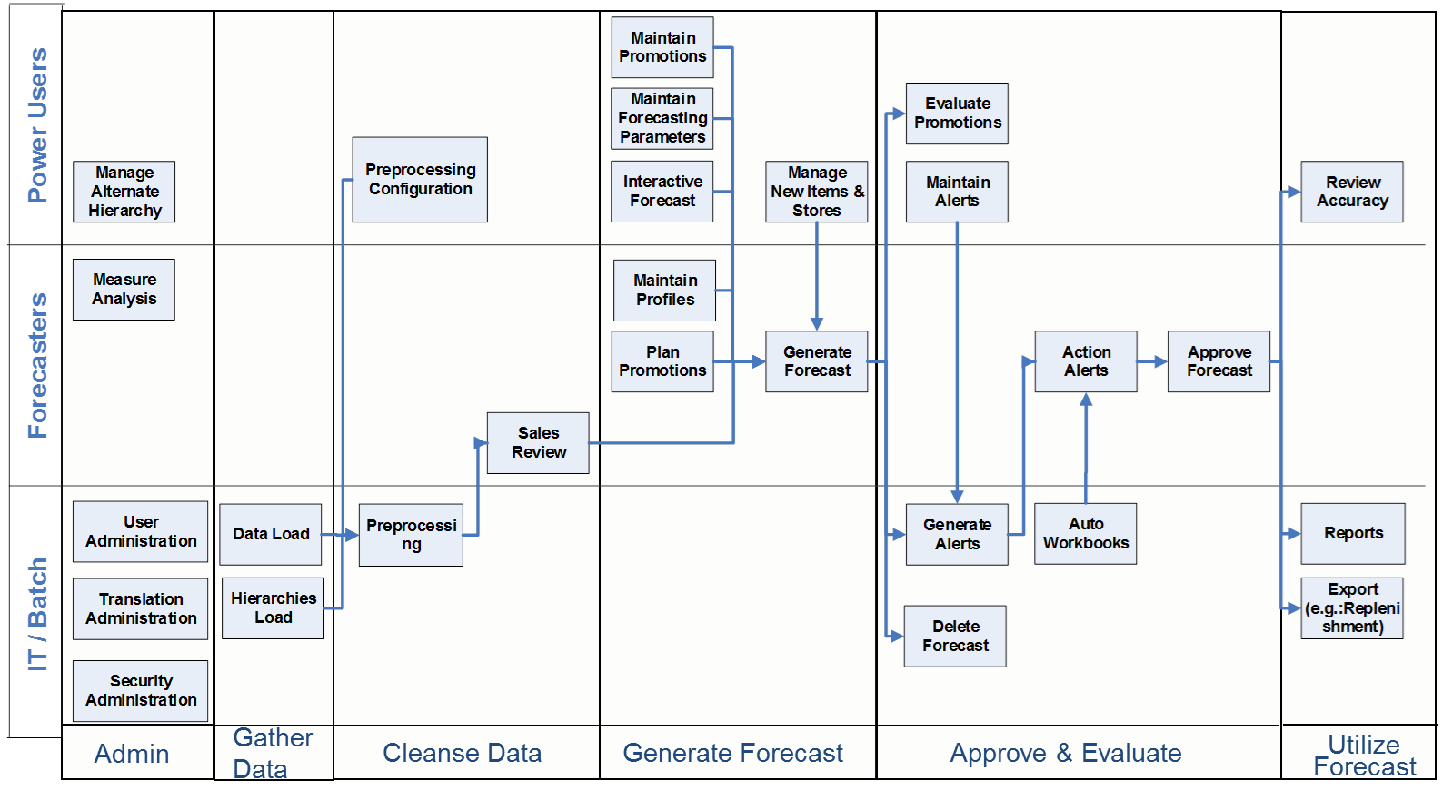
Figure 10-46 Demand Forecasting Process

Allocation and Replenishment Workflow
The APX workflow could be divided into: a) the administration task assigned to the IT department of Landmark, b) the initial allocation of the stores that is done both at Central and at Territory level, c) the replenishment from the CDCs to the RDCs (Tier 1) and, d) the replenishment from the RDCs to Stores (Tier 0) (Figure 10-47 Allocation and replenishment workflow).
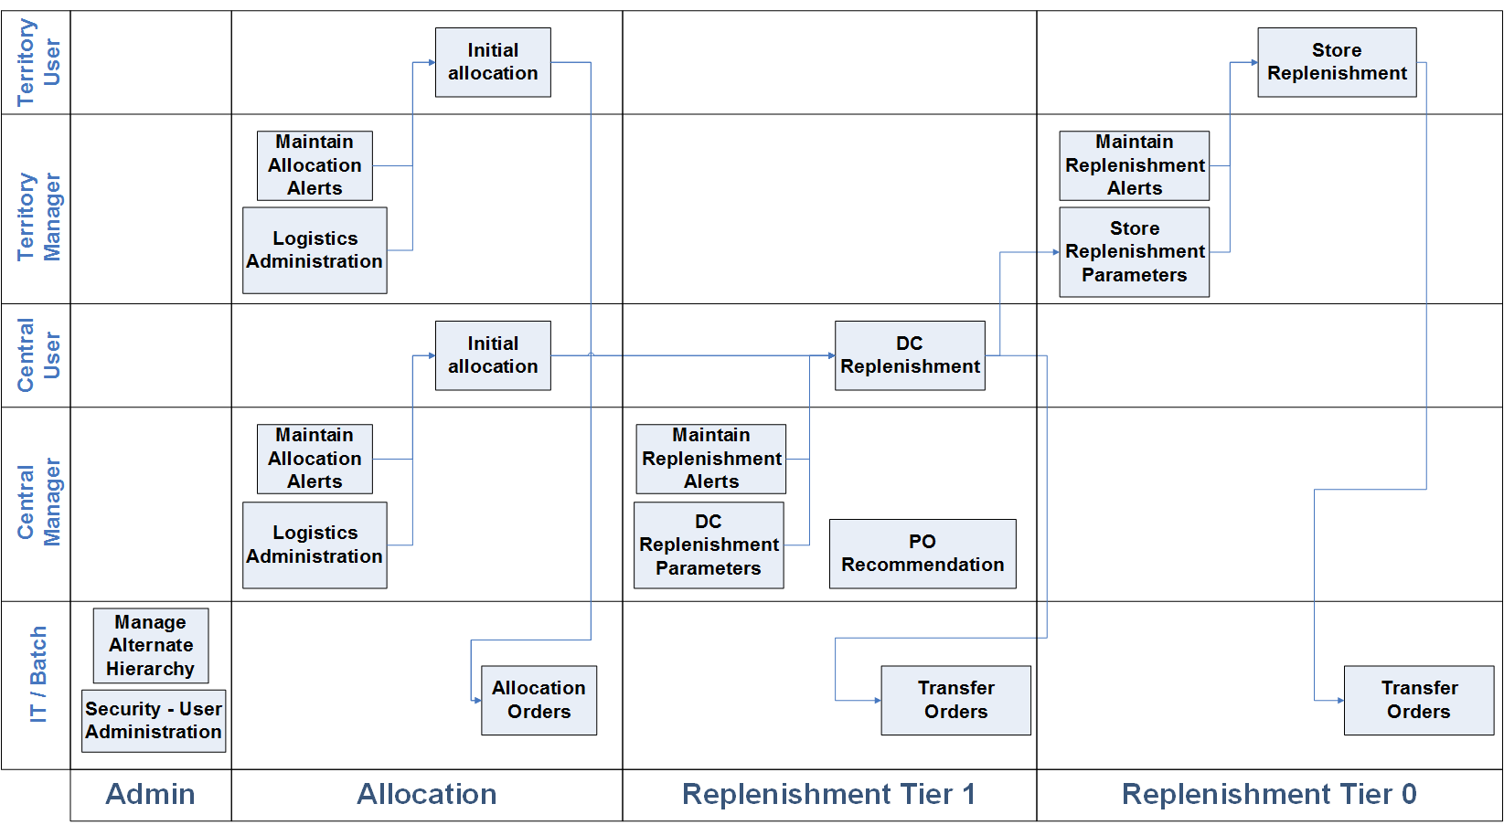
Figure 10-47 Allocation and replenishment workflow

The IT department of Landmark will be responsible for setting and maintaining the security parameters and the alternate hierarchies of APX. LMIT will also be authorized to add or delete the authorized system users, create or delete user groups, and edit the user profiles.
Landmark has defined two groups of business roles: Central and Territory teams. Both groups will be involved in the allocation process. The managers at Central and Territory level will maintain the allocation alerts (Section 9) as well as control the logistic parameters (10.4). The Central users will define the initial allocation quantities that will be sent from the CDCs to the RDCs and from the RDCs to Stores, while the Territory users will only handle the initial allocations from the RDC to the stores by following the APX allocation process (Section 7). The result of the allocation process will be the allocation orders created by a night batch process.
The Central managers and users will handle the replenishment process from the CDCs to the RDCs (Tier 1) through the RDC Replenishment Workbook. The DC replenishment parameters (10.4) and the alerts (Section 9) will be under the Central managers’ responsibilities. The Central users will define the replenishment quantities at Tier 1 according to which the transfer orders will be raised by a night batch process (Section 8).
In the replenishment process the PO recommendation step will enable Landmark to mitigate the risks of Fast and/or Slow selling products after Item launch (Section Replenishment Process –Section 8).
The Territory managers and users will handle the replenishment process from the RDCs to the stores (Tier 0) through the Store Replenishment Workbook. The store replenishment parameters (10.4) and the alerts will be under the Territory managers’ responsibilities (see Section 9). The Territory users will define the replenishment quantities at Tier 0 according to which the transfer orders will be raised by a night batch process (see Section 8.3).
The user Roles and the access right that they will have in the Allocation and Replenishment workflow can be seen below in Table 10-6 User Roles.

 | Allocation | Allocation Parameters Maintenance | Replenishment | Replenishment  Parameters Maintenance
Central Manager | Yes | Yes | CDC → RDC | Yes
Central User | Yes | No | CDC → RDC | No
Territory Manager | Yes | Yes | RDC → Store | Yes
Territory User | Yes | No | RDC → Store | No
Table 10-6 User Roles

Workbooks and partitioning
While RPAS-based applications can perform many calculations rapidly, they may experience performance degradation when a single domain environment contains too much data. RPAS uses a type of domain structure, called Global Domain in which data is stored in different physical disk partitions, called domains. It is a combination of:
- Multiple Local domains, which store most of the data.
- A single Master domain which is mainly used for administration tasks.
The benefits of this structure are the scalability, the performance, the contention avoidance, and the centralized configuration and administration.
The process of dividing and storing domain data in different physical disk partitions is called domain partitioning. For CPRthe level on which the domain portioning is defined is the group level of the main branch of the product hierarchy (Figure 10-48).
The partitioned measures have as base intersection equal or below than the partition dimension and are distributed in the local domains. The non-partitioned measures have as base intersection higher than the partition dimension or are scalar. The non-partitioned measures are stored in the master domain.
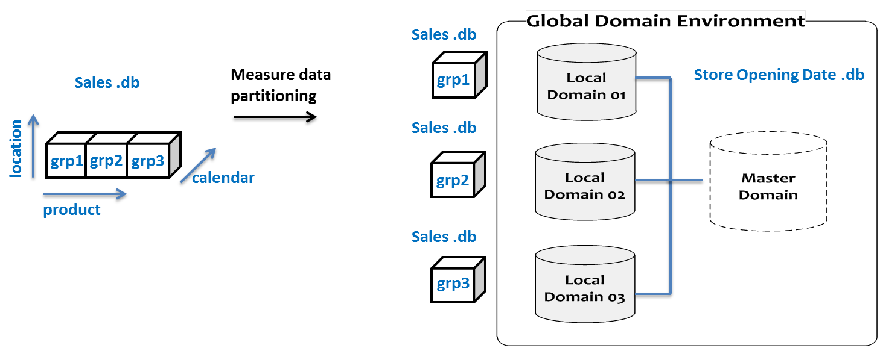
Figure 10-48 Global Domain Environment
In the Oracle Retail Demand Forecasting User Guide the domains that the workbooks will appear are defined.
Landmark has requested the domain limitations for the APX workbooks shown in Table 10-7 below.

Workbook | Master Domain | Local Domain
Parameter Workbooks | ☑ | ☑
Initial Allocation | ☒ | ☑
Store Replenishment | ☒ | ☑
RDC Replenishment | ☒ | ☑
PO Recommendation | ☒ | ☑
Table 10-7 APX Workbooks

Parameter Settings
During CPR Functional Design the parameters of every step were discussed and the levels that they will be defined were decided.

Forecast and Preprocessing Parameters
The Forecast and the Preprocessing Parameters will be defined at SKU/Store level, while their default value will be set at Subclass/RDC level. The detailed list of the forecasting and preprocessing parameters will be defined in the CPR Configuration Specification Document.

Logistic Parameters
Landmark requires that a sourcing measure will define the secondary and the tertiary Central Distribution Center from which a specific Regional DC is supplied as fall back scenarios (see Section 8.5). The sourcing measures will be defined in the Logistics Parameters Workbook. The Lead Time for every source CDC-RDC and source RDC-store combination will be also defined as a Logistic Parameter.
Currently, Landmark requires that the APX module of CPR will handle the following sourcing flows for each tier:
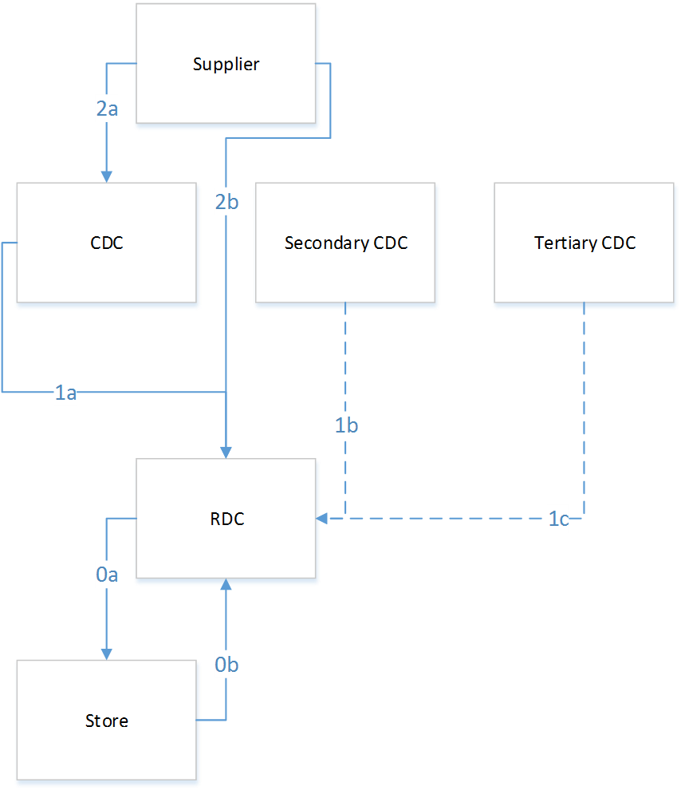
Figure 10-49 Sourcing Flows

Landmark requires that specific Size Packs should be allocated to specific countries (e.g. Turkey stores should get only "Turkey" packs). A measure will specify the Available Packs for each Store, thus restricting pack availability by location.
As discussed during the design sessions, Landmark suggests that the Store Open and Close dates are not defined (recorded in ER accurately) and will need to be updated by Landmark business users ahead of the CPR go-live.
Landmark also requires that Shipping and Receiving restrictions up to day level will be maintained by CPR business users in the Logistics Parameters Maintenance Workbook. In particular, "Store Not Able to Receive" at Store/Day level will be available, while "CDC Not Able to Ship" and "RDC Not Able to Receive - Ship" date will be defined at Day/RDC/CDC and Day/RDC, respectively.
Min/Max constraints will also be used by Landmark to ensure presentation stock availability and physical constraints respectively. Min/Max constraints in APX will be considered against Allocation or To-Be inventory, restricting the allocation quantities to the specified min/max. These parameters will also be maintained in Logistic Parameters Workbook.
Finally, three options will be available in APX to consider a candidate store has its need covered for a specific pack, as per standard APX functionality:
- Cover full request: Store Inventory must be equal or higher than Request for all SKUs of the Pack.
- Cover full need and closest to request: Store Inventory must be equal or higher than Need for all SKUs of the Pack AND over/under against the request for all SKUs in the Pack must be minimal.
- Cover full need and request for one more item(s): Store Inventory must be equal or higher than Need for all SKUs of the Pack AND Store Inventory must be equal or higher than Request for 1 or more item(s) in the Pack.
This option will be maintainable by SKU/PackGroup in the Logistic Parameters Workbook.
The Logistic Parameters that will be also appear in the RDC and the Store Replenishment Workbooks (Section 8.2 & Section 8.3) in Logistic Parameters Worksheets are the Source, the Lead Time and the Cover Method. Only Cover method will be editable at these worksheets.

Replenishment Parameters
The Allocation and Replenishment parameters will be common and will be defined at SKU/Store level, while their default value will be at Subclass/Store. Some potential Calculation parameters are presented in Table 10-8.

Calculation Parameters
Order Method
Order Date
Demo Stock
Presentation Stock
TS & Hybrid –TS Horizon
Hybrid – Minimum Days of Safety Stock
Hybrid – Maximum Days of Safety Stock
TS – Minimum Days of Supply
TS – Maximum Days of Supply
Dynamic –Service Level
Review Time
Dynamic – Inventory Selling Days
Min-Max Store Minimum Stock
Min-Max Store Maximum Stock
Table 10-8 Allocation and Replenishment Parameters
Some of the defined parameters will be available for review reasons in the RDC and Store Replenishment workbook in the Calculation Parameters worksheet (Sections 8.2.19, 8.3.14).
Section 8.1.1 above describes the replenishment methods and the parameters that control them.

Sales Review
A Sales Review Workbook will be added to the RDF configuration to allow users to review and possibly modify historical demand data.
The Sales Review workbook should allow users to select the calendar, location and product positions they wish to review using a standard RDF wizard. They should also be able to select any additional measures they would like to see. After they have completed these steps, the workbook including all the worksheets and measures will be shown.
The Sales Review Workbook will contain the following measures:
- Regular Sales, read-only.
- Clearance Sales, read-only.
- Promotional Sales, read-only.
- Daily Cloning History (see Section 5.7), read-only.
- Total POS Sales, read-only.
- Daily Historical Baseline, read-only.
- PP1 – Non-Typical Day Indicator, a writable Boolean flag at SKU/Store/Day level.
- PP1 – Adjustment, read-only.
- PP2 – Adjustment, read-only.
- PP3 – Out of Stock indicator, a Boolean flag at SKU/Store/Day (see Section 4.3).
- PP3 – Adjustment, read-only.
- PP4 – Adjustment, read-only.
- Promotion indicator, which will be true if the SKU/Store day is under any promotion, excluding holidays and events, read-only.
- Total Preprocessing Adjustments (sum of the PP1-PP4 adjustments), read-only.
- User-Made Adjustments, writeable
- Daily Total Adjusted Sales, defined as the sum of the above sales measures, writeable. It should be noted, any changes made to this measure will adjust the User-Made Adjustments measure accordingly.
- Approved Forecast Final Level 01 Bayesian, read-only.

Performance Evaluation
Two workbooks will be developed dedicated to the review of the KPIs. Based on the nature of the KPIs, they will be available either in the Supply Chain KPI Review workbook or the Financial KPI Review workbook. KPI numbers 1 to 6 will be in the Supply Chain KPI Review Workbook and KPI number 7-10 will be in the Financial KPI Review Workbook. For more details please refer to the Performance Target Document.

Log # | Description
318 | Basics: Calculate the forecast error for each SKU/store over (the CDC to RDC lead time + RDC to store lead time) when compared with actual sales (cleaned for outages)  Keep the KPI history for 13 weeks  Territory and Central
319 | Fashion: the forecast snapshot generated X weeks after on sales date will be compared with actual sales until the end of the lifecycle at SKU/Store  Territory and Central
320 | Fashion + Seasonal: Sales/[(Closing Stock of the RDC and Stores at the end of the trading season) + Sales] at Option/RDC  Territory and Central
321 | Fashion + Seasonal: (Sales until MD date)/[(Closing Stock of the RDC and Stores on the MD date) + (Sales until MD date)] at Option/RDC  Territory and Central
322 | Fashion + Seasonal: option/Store  Lost Sales at Full price period compared with the full price preprocessed sales  Territory and Central
323 | Profit margin during full price period based on Cost 2 at option/RDC  Central
324 | Total profit margin based on Cost 2 at option/RDC  Central
325 | Markdown profit margin based on Cost 2 at option/RDC  Central
326 | Weeks of Cover:  Basics: Subclass/RDC/week - on Sunday  Sum(RDC SOH + Stores OH + CDC OH Share) /Sum(Forecast for X weeks)  Keep the KPI history for 26 weeks  Territory and Central
500 | KPI 9: Do not include Closing Stock  KPIs 7,8,9:Display in %
541 | Difference between Forecast and Actual values Fashion (%)  - This measure will be calculated the cumulative difference from Season Start to Today
542 | Sell – through Complete Lifecycle Fashion/Seasonal (%)  - This measure will be calculated post-season.  - The value of the total closing stock will be calculated in the daily batch.
543 | Full Price Sell – through Fashion/Seasonal (%)  - This measure will be calculated at the start of markdown  - The value of the Markdown Closing Stock will be calculated in the daily batch.
544 | When calculating Weeks of Cover APX should not take into account any Open PO (not yet received) quantities
545 | The KPI “Difference between Forecast and Actual values Fashion (%)” will be configured for Fashion items only (not seasonal basics).
546 | The FRD requires that the financial KPIs will be calculated for both Basic and Fashion/Seasonal items. The Profit Margin markdown will not be calculated (skipped) for Basic items.
547 | The Financial KPIs will be displayed in percentages.
548 | The store stock should not be taken into account as a loss in the calculation of profit margin in Financial KPIs.
Table 10-9

Security Permissions
The position-level security views are used to grant or deny access to positions for individual users, user groups, or all users. Position-level security is set for a specific dimension of a hierarchy (other than calendar). During CPR Functional Design Landmark defined that for the product hierarchy the security level will be defined by group, by territory for the location hierarchy, by RDC for the RDC hierarchy and by CDC for the CDC hierarchy.

Requirements and Decisions

Log # | Description
112 | The WBs that the Grade dynamic hierarchy will be available should be defined
151 | The Approval process of the TO will be in the APX process and will not be approved in RMS
184 | The Initial allocation parameters for new 365 products that will be copied by Like 365 existing products are: Promotional Effects, Sales
332 | Logistic parameters will be set at Option/Store, default subclass/RDC
329 | A Financial KPIS wb and a Supply Chain KPIs WB will be created including the KPIs defined
335 | Replenishment parameters will be set at SKU/Store, default for Subclass/Store
336 | Parameter Workbook in Master + Local Domain
337 | Initial Allocation WB Local domain
338 | Store replenishment WB Local domains
339 | RDC Replenishment WB Local domains
340 | PO Recommendation WB Local domains
341 | Partitioning at group level
227 | Attributes at option and packgroup level of the product hierarchy are not needed
247 | Need to see Target Sell through % alongside forecast in the Scorecard
282 | Cost and Margin should not be visible to territory users
304 | User Roles and access right are defined as described in sheet "User Roles"  Product Security is defined by group  Store Security is defined by Territory  RDC Security is defined by RDC  CDC Security is defined by CDC
311 | Central Users manage the Initial Allocation from RDC > Store and CDC>RDC  Territory Users manage the Initial allocation from RDC > Store
328 | Territory users must not be able to see Supplier labels.  Only supplier ID should be taken  from ER for APX. Where ever supplier is present only ID will be used.
239 | Max and Splash Planners should be able to plan across Groups
240 | Shoe Express Planners should be able to Plan for the whole Concept.
243 | Babyshop planners can work across groups, but this is an exception
244 | Homecentre planners work across groups regularly
245 | LMI planners work across departments
246 | Lifestyle planners work across departments
254 | Multiple groups and one PO possible
336 | Parameter Workbook in Master + Local Domain
337 | Initial Allocation WB Local domain
338 | Store replenishment WB Local domains
339 | RDC Replenishment WB Local domains
340 | PO Recommendation WB Local domains
341 | Partitioning at group level
559 | Territory users should not have access to calculated ROI (Initial Allocation, Replenishment).
567 | User role template to be provided and filled by LMG. Veltio will then assign user rights and roles before UAT. For example only Central Users must have access to CDC to RDC Replenishment.
569 | Autoworkbook Build functionality will not be used in the CPR Project.

Risks
This Section will address the potential risks inherent in the functional requirements of the CPR Solution as described by Landmark during Functional Design and articulated in the Functional Requirements Document. This approach will aim to identify risks specific to several aspects of the CPR Solution such as Data Integration, Process Integration, Parameters Tuning and Oracle Retail Product-Specific risks.
Given the functional requirements of the CPR Solution detailed in the previous sections as well as implementation and availability considerations, the following are Solution aspects that we believe may undermine the overall process stability, accuracy and integrity (in approximate order of importance):
- Pricing History: Landmark IT cannot provide historical pricing and promotional information. This severely impacts the potential accuracy for markdown forecasts and what-if analysis within CPR. Pricing (and secondarily, promotional) history is needed for at least the length of sales history, i.e. as above 14-16 months.
- Product Type: Landmark requires that a separate Forecasting approach will be used per Product Type (see Section 5). These Product Types will come as UDAs from RMS with the following values: a) Basic Items b) Seasonal Basics and c) Fashion Items. Currently there is no such UDA in RMS, however Season Codes do exist and Landmark IT should streamline a process to convert these Season Codes to Product Types, using the aforementioned values. Forecasting approaches functionality may become inevitable in absence of such information.
- RDF 13.4 Enhancements (Pricing): Forecasting will leverage functional enhancements introduced in Oracle Retail Demand Forecasting 13.4, such as Non Linear Variables used in Pricing. Since this is a just-released feature of RDF, any related instabilities may influence Forecasting accuracy.
- Non-Recent Data: Landmark IT will provide several interfaces using non-recent data, using 3-day old (T-3) and 2-day old data (T-2). For instance, Daily Sales will be T-3 (possibly T-2), Shipments and Receipts in all Tiers will be T-2. This necessitates that a projection of the missing values should be done by APX which may severely impact system timeliness and accuracy as well as potential business benefit.
- IT pre-allocation through CDC: Within the current Landmark business process, the Supplier will send to the CDCs pre-allocated and crossed-docked stock. The PO data quantities imported into CPR from ER/RMS include the quantities that will cross-dock to the RDCs while the PO in-Transit quantities in ER from the Supplier to the CDC define separately the quantity that will be kept in the CDC, and the Allocation quantities that will cross-dock to the RDCs. Therefore, APX will need Shipments, Receipts, and Pre-allocated Stock feed at CDC in order to have proper visibility of the CDC stock: lack of these feeds may become major risk on the APX distribution process accuracy out of CDCs.
- Sales and Stock Correction: Landmark described certain conditions under which Sales and Stock Correction may apply (for instance, missed sales records, stock correction upon PO Cancellation, Pack to Singles transition registration in RMS etc.). We assume that interfaced measures will include any corrections needed. Exclusion of such corrections from the interfaced measures may become a major risk on the data integrity of the system and the accuracy of the produced allocation and transfer orders.
- Outgoing TO integration: The APX module of CPR will export Order Quantities to RMS using a template provided by Landmark IT. A serial will be generated by RMS for each Order, at the time of upload. Any disruptions in this process may lead to Order rejection and become a risk on data integrity.
- AP Integration: Assortment Planning will be part of Landmark Phase 2 (as articulated in Landmark Merchandise Planning and Optimization Solution Road Map). Assortment Planning Integration with APX may highlight alignment issues, such as Assortment Planning Assortment Pyramid fit with CPR Product Types, Allocation Restrictions fit and In-Season use overlap between Assortment Planning and the APX module of CPR.
- Parameter Optimization: Before any meaningful forecasts can be run, it is necessary to carry out forecast optimization within the system. This is a regular and necessary part of all RDF implementations. It involves a structured exercise where the system parameters are adjusted following detailed data analysis. Apart from that, since Alert-based management constitutes a core aspect of the CPR solution, any related parameter optimization should be part of the Post Go Live activities when live data feed is available and meaningful scenarios can be run.
- Seasonal behaviors: there may be some seasonal behaviors (e.g. warm-weather, back-to-school) that will be removed from the baseline demand by the Baseline Calculation process (section 5.2). Depending on the nature of these patterns and the source level forecast strategy used in the ‘Baseline’ process, this removal may introduce a forecast inaccuracy to the baseline demand.

